UNITED STATES

SECURITIES AND EXCHANGE COMMISSION

Washington, D.C. 20549

SCHEDULE 13D

Under the Securities Exchange Act of 1934

Sono Group N.V.

(Name of Issuer)

Ordinary shares, par value of €0.06 per share

(Title of Class of Securities)

N81409109

(CUSIP Number)

c/o Dr. Holger Ellers

Dentons GmbH

Wirtschaftsprüfungsgesellschaft Steuerberatungsgesellschaft

Markgrafenstraße 33

10117 Berlin

Germany

+49 30 26473 175

(Name, Address and Telephone Number of Person Authorized to Receive Notices and Communications on Behalf of Filing Persons)

Copy to:

Walter Van Dorn

Dentons US LLP

1221 Avenue of the Americas

New York, NY 10020-1089

Telephone: (212) 768-6985

(Name, Address and Telephone Number of Person Authorized to Receive Notices and Communications)

June 5, 2024

(Date of Event which Requires Filing of this Statement)

If the filing person has previously filed a statement on Schedule 13G to report the acquisition that is the subject of this Schedule 13D, and is filing this schedule because of §§240.13d-1(e), 240.13d-1(f) or 240.13d-1(g), check the following box. ☐

Note: Schedules filed in paper format shall include a signed original and five copies of the schedule, including all exhibits. See § 240.13d-7(b) for other parties to whom copies are to be sent.

The remainder of this cover page shall be filled out for a reporting person’s initial filing on this form with respect to the subject class of securities, and for any subsequent amendment containing information which would alter disclosures provided in a prior cover page. The information required on the remainder of this cover page shall not be deemed to be “filed” for the purpose of Section 18 of the Securities Exchange Act of 1934 (“Act”) or otherwise subject to the liabilities of that section of the Act but shall be subject to all other provisions of the Act (however, see the Notes).

CUSIP No. N81409109


- NAME OF REPORTING PERSON I.R.S. IDENTIFICATION NO.

Bambino 255. V V UG (haftungsbeschränkt)

- CHECK THE APPROPRIATE BOX IF A MEMBER OF A GROUP

(a) ☐ (b) ☐

- SEC USE ONLY

- SOURCE OF FUNDS OO

- CHECK IF DISCLOSURE OF LEGAL PROCEEDINGS IS REQUIRED PURSUANT TO ITEMS 2(D) OR 2(E)

☐

- CITIZENSHIP OR PLACE OF ORGANIZATION Germany

  - SOLE VOTING POWER


NUMBER OF |  | 13,306,249 Shares
NUMBER OF | 8. | SHARED VOTING POWER
SHARES | 8. | SHARED VOTING POWER
BENEFICIALLY |  | 0
OWNED BY |  | 0
EACH | 9. | SOLE DISPOSITIVE POWER
REPORTING | 9. | SOLE DISPOSITIVE POWER
PERSON |  | 13,306,249 Shares
WITH |  | 13,306,249 Shares
      - SHARED DISPOSITIVE POWER 0
  - AGGREGATE AMOUNT BENEFICIALLY OWNED BY EACH REPORTING PERSON 13,306,249 Shares
  - CHECK IF THE AGGREGATE AMOUNT IN ROW (11) EXCLUDES CERTAIN SHARES ☐

  - PERCENT OF CLASS REPRESENTED BY AMOUNT IN ROW (11)

12.24% (1)

  - TYPE OF REPORTING PERSON OO - Limited Liability Company

- The percentage of class of securities beneficially owned by the Reporting Persons is based on a total of 108,711,643 shares (being the sum of 105,711,643 ordinary shares and 3,000,000 high voting shares) of the Issuer outstanding as a single class as of June 5, 2024, assuming conversion of all high voting shares into ordinary shares. Holders of high voting shares are entitled to twenty-five votes per high voting share on all matters submitted to them for vote. The voting power of the shares beneficially owned represent 7.36% of the total outstanding voting power. The percentage of voting power is calculated by dividing the voting power beneficially owned by the Reporting Persons by the voting power of all of the Issuer’s outstanding ordinary shares and high voting shares as a single class as of June 5, 2024.
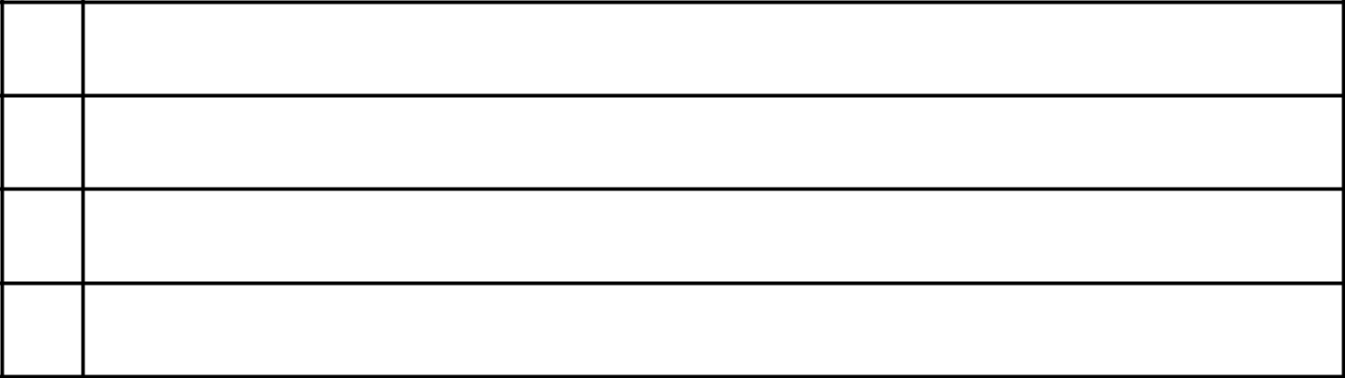

2

Item 1. Security and Issuer

The issuer of the shares is Sono Group N.V., a public company with limited liability under Dutch law (naamloze vennootschap) (the “Issuer”). The Issuer’s shares consist of ordinary shares with a par value of €0.06 per share (the “Ordinary Shares”) and high voting shares (the “High Voting Shares”). Each holder of Ordinary Shares is entitled to one vote per Ordinary Share and each holder of High Voting Shares is entitled to twenty-five votes per High Voting Share on all matters submitted to them for vote. High Voting Shares are convertible at any time by the holder thereof into Ordinary Shares on a one-for-one basis. Ordinary Shares are not convertible into High Voting Shares under any circumstances.

The address of the principal executive offices of the Issuer is Waldmeisterstraße 93, 80935 Munich, Germany; its telephone number is +49 (0)89 4520 5818.

Item 2. Identity and Background

This Statement is being filed by Bambino 255. V V UG (haftungsbeschränkt) (the “Reporting Person”). The principal address of the Reporting Person is c/o Dentons GmbH Wirtschaftsprüfungsgesellschaft Steuerberatungsgesellschaft, Markgrafenstraße 33, 10117 Berlin, Germany. The principal business of the reporting person is the acquisition, sale, holding and managing of investments in companies for its own account and on a fiduciary basis, as well as the fiduciary management of assets and/or contracts, except transactions or activities that require a license under the German Banking Act (KWG), as well as trade and utilization of assets.

The Reporting Person has not, during the last five years, been (i) convicted in a criminal proceeding (excluding traffic violations or similar misdemeanors); or (ii) a party to a civil proceeding of a judicial or administrative body of competent jurisdiction and as a result of such proceeding was or is subject to a judgment, decree or final order enjoining future violations of, or prohibiting or mandating activities subject to, federal or state securities laws or finding any violation with respect to such laws.

Item 3. Source and Amount of Funds or Other Consideration

The Reporting Person acquired the 13,306,249Ordianry Shares reported herein as beneficially owned pursuant to the Sale and Transfer Agreement (as defined below) in connection with the Transactions (as defined below) at an aggregate purchase price of approximately $109,046 (converted from Euro to U.S. dollars based on the European Central Bank’s daily exchange rate reported on February 1, 2024, which was €1.00 = $1.0814). The source of funds of the Reporting Person for the acquisition for the 13,306,249 Ordinary Shares reported herein was funds paid from the insolvency estate of Sono Motors GmbH, as provided for in the insolvency plan of Sono Motors GmbH, as approved by its creditors on December, 21, 2023, and confirmed by court order of the local court of Munich (Amtsgericht München) on the same day.

Item 4. Purpose of Transaction

The Issuer entered into certain investment-related agreements (the “Yorkville Agreements”), effective November 20, 2023, between the Issuer and YA II PN, Ltd. (“Yorkville”), pursuant to which Yorkville committed to provide financing to the Issuer subject to the satisfaction of certain conditions precedent. The aim of the Yorkville Agreements and the transactions contemplated therein (the “Transactions”) was the restructuring of the Issuer and Sono Motors GmbH, the Issuer’s sole Subsidiary (collectively, the “Companies”), in connection with the Companies’ respective self-administration proceedings in Germany. On January 31, 2024, the Issuer withdrew its application for its preliminary self-administration proceedings, and on the same day held an extraordinary general meeting of shareholders (“EGM”) at which George O’Leary was appointed as the sole current member of the Issuer’s management board. The Subsidiary subsequently exited its self-administration proceedings on February 29, 2024.

As a condition to the willingness of Yorkville to enter into the Yorkville Agreements and the Transactions, Laurin Hahn and Jona Christians – the Issuer’s co-founders and former co-CEOs (collectively, the “Founders”) – entered into a Shareholders Commitment Letter, effective as of November 20, 2023 (the “Shareholders Commitment Letter”) with the Issuer and the Subsidiary. Under the terms of the Shareholders Commitment Letter, the Founders undertook to sell and transfer, in the aggregate, 17,306,251 Ordinary Shares and all of their High Voting Shares in the Issuer to the Issuer and/or the new members of the management board to be appointed for the Issuer.

3

Pursuant to the terms of the Yorkville Agreements and in connection with the Transactions, the Founders entered into respective Sale and Transfer Agreements, each dated February 1, 2024 (collectively, the “Sale and Transfer Agreement”), with SVSE LLC, a limited liability company formed under the laws of the State of Delaware (“SVSE”), the Reporting Person and the Issuer, pursuant to which the Founders, in the aggregate, sold and transferred (i) 17,306,251 Ordinary Shares and all of their High Voting Shares to SVSE and (ii) 13,306,249 Ordinary Shares to the Reporting Person as reported herein.

In connection with the Transactions, changes in the Issuer’s supervisory board were implemented, with two new members appointed at the EGM following the resignation on the same day of all of the Issuer’s former supervisory board members.

Item 5. Interest in Securities of the Issuer

- – (b)The responses to Rows 7 through 13 of the cover page of this Schedule 13D that relate to the aggregate number and percentage of shares (including but not limited to footnotes to such information) are incorporated herein by reference.

- Except as set forth in this Schedule 13D, the Reporting Person has not effected any transactions with respect to the shares of the Issuer during the past 60 days.

- The Reporting Person is party to a trust agreement, pursuant to which it is obliged to forward the net proceeds from the realization of certain assets (including the Ordinary Shares) to the insolvency practitioner appointed as supervisor of the insolvency plan of Sono Motors GmbH, for distribution to the insolvency creditors of Sono Motors GmbH in accordance with the insolvency plan.

- Not applicable.

Item 6. Contracts, Arrangements, Understandings or Relationships with Respect to Securities of the Issuer

The information set forth in Items 3, 4, and 5 are hereby incorporated by reference in their entirety.

To the best knowledge of the Reporting Person, other than described in Items 3, 4, and 5 and this Item 6, there are no other contracts, arrangements, understandings or relationships (legal or otherwise) between the Reporting Person and any other person with respect to any securities of the Issuer, including, but not limited to, transfer or voting of any of the securities, finder’s fees, joint ventures, loan or option arrangements, puts or calls, guarantees of profits, division of profits or loss, or the giving or withholding of proxies, including any securities pledged or otherwise subject to a contingency, the occurrence of which would give another person voting power or investment power over such securities, other than standard default and similar provisions contained in loan agreements.

Item 7. Material to Be Filed as Exhibits

Exhibit No. Description

Exhibit 99.1 Sale and Transfer Agreement, dated February 1, 2024, by and among Jona Christians, Bambino 255. V V UG, SVSE LLC and Sono Group N.V.
Exhibit 99.2 Sale and Transfer Agreement, dated February 1, 2024, by and among Laurin Hahn, Bambino 255. V V UG, SVSE LLC and Sono Group N.V.

4

SIGNATURE

After reasonable inquiry and to the best of my knowledge and belief, I certify that the information set forth in this statement is true, complete and correct.

Dated: June 14, 2024

Signature:

Bambino 255. V V UG (haftungsbeschränkt)

By: | /s/ Holger Ellers
Name: | Holger Ellers
Title: | Managing Director

5

Exhibit 99.1

Sale and transfer agreement

regarding shares in

Sono Group N.V.

Dated 1 February 2024

This agreement (the "Agreement") is made on 1 February 2024

Parties

- Jona Christians (the "Transferor");

- Bambino 225. V V UG, c/o Dentons GmbH Wirtschaftsprüfungsgesellschaft Steuerberatungsgesellschaft, Markgrafenstraße 33, 10117 Berlin, Germany, as the transferee designated by Mr. Ivo-Meinert Willrodt (the "Transferee 1");

- SVSE LLC, a limited liability company formed under the laws of the State of Delaware, United States of America, registered with the Department of State under number 3005183, as the transferee(s) designated by the Company (the "Transferee 2” and, jointly with the Transferee 1, the “Transferees”); and

- Sono Group N.V., a company incorporated under Dutch law (naamloze vennootschap) and registered with the Dutch chamber of commerce under number 80683568 (the "Company").

The above parties to this Agreement are collectively referred to as the "Parties" and individually as a "Party".

Background

- Reference is made to the envisaged restructuring of the Company and Sono Motors GmbH (jointly the "Sono Group") through the implementation of certain restructuring steps as set out in inter alia the restructuring agreement between Sono Group N.V. and YA II PN Ltd., to be entered into on or about the date hereof (the “Restructuring Agreement”), to allow the Sono Group to exit from insolvency proceedings in Germany (the "Restructuring" and the transactions in connection therewith and/or arising therefrom jointly the "Transactions").

- At the date of this Agreement, the Transferor holds:

  - 1,421,053 high-voting shares in the capital of the Company, each with a nominal value of EUR 1.50 (the "HV Shares"); and

  - 14,316,447 ordinary shares in the capital of the Company, each with a nominal value of EUR 0.06 (the "Ordinary Shares"),

(jointly, the "Shares").

- As part of the Restructuring and the Transactions, it is envisaged that the Transferor will sell and transfer, inter alia, the Shares to the Transferee 1 and the Transferee 2 as set out in detail in the commitment letter dated 17 November 2023 by, inter alia, the Transferor to the Company and Sono Motors GmbH (the “Commitment Letter”).

It is agreed:

- Definitions and interpretation

1.1 In this Agreement, unless the context otherwise requires, the provisions of this clause 1 apply.

1.2 In this Agreement, unless otherwise specified:

- reference to a gender includes all genders;

- reference to a person includes reference to any individual, company, corporation, foundation, association, any other legal person, partnership, joint venture or any governmental authority;

- reference to "include" or "including" is treated as a reference to "include without limitation" or "including without limitation";

- reference to "writing" or "written" means any method of reproducing words in a legible and non-transitory form, including e-mail;

- reference to any action, remedy, method or form of proceedings, court or any other legal concept or matter is a reference to the Dutch legal concept or matter or to the legal concept or matter which most closely resembles the Dutch legal concept or matter as interpreted in a Dutch law context; and

- reference to a clause is a reference to a clause schedule of this Agreement.

1.3 Headings are for convenience of reference only and do not affect the interpretation of any provision of this Agreement.

- Sale, purchase and transfer

2.1 Subject to the terms and conditions of this Agreement, the Transferor hereby sells and transfers the following Shares to the following transferees:

- to the Transferee 1:

  - 6,118,749 ordinary shares in the capital of the Company, each with a nominal value of EUR 0.06 (the "Ordinary Shares 1" or the "Shares 1"),

which are hereby purchased and accepted by the Transferee 1; and

- to the Transferee 2:

  - the HV Shares; and

  - 8,197,698 ordinary shares in the capital of the Company, each with a nominal value of EUR 0.06 (the "Ordinary Shares 2" and jointly with the HV Shares, the "Shares 2"),

which are hereby purchased and accepted by the Transferee 2.

2.2 The Shares are transferred to the Transferee 1 and the Transferee 2, respectively, free and clear from any mortgage, pledge, lien (retentierecht), retention of title (eigendomsvoorbehoud), any other registered obligation (kwalitatieve verplichting), personal right of enjoyment or use or right to acquire, usufruct, attachment, right of first refusal or other restriction on transfer, any restriction on voting or any other third party right or security interest of any kind, or any agreement to create any of the foregoing and together with all rights attached to them, and further in accordance with the provisions of clause 4.

2.3 The Company hereby acknowledges the transfer of the HV Shares effected by this Agreement and shall register the same in its register of shareholders.

- Consideration

3.1 The consideration for the Shares 1 and the Shares 2 amounts to EUR 0.003 per Share, i.e., EUR 47,212.5 in the aggregate (incl.

VAT, if any) (the "Purchase Price").

3.2 The Purchase Price shall be paid by the Transferee 1 exclusively at the time, in the partial amounts and out of the funds as provided for in paragraph 3.1 (c) of the Commitment Letter, and without any deduction, withholding, set-off or suspension, in cash to the Transferor to the following bank account in name of the Transferor:

OMITTED

- Completion of Transfer of Ordinary Shares

4.1 The Transferor hereby irrevocable and unconditionally covenants and warrants towards the Transferee 1 to instruct AST Financial

- AMERICAN STOCK TRANSFER & TRUST COMPANY (in future doing business as Equiniti Trust Company, LLC) as transfer agent and registrar to transfer the Ordinay Shares 1 to a security account as to be notified by the Transferee 1 in writing to the Transferor after the date of this Agreement.

4.2 The Transferor hereby irrevocable and unconditionally covenants and warrants towards the Transferee 2 to instruct AST Financial

- AMERICAN STOCK TRANSFER & TRUST COMPANY (in future doing business as Equiniti Trust Company, LLC) as transfer agent and registrar to make the following security account transfers on the date of this Agreement:

the Ordinary Shares 2 are to be transferred to the following nominee securities account of the Transferee 2: OMITTED

4.3 Forthwith after giving such instruction, the Transferor will provide the Transferees with written evidence that the transfer and delivery of the Ordinary Shares 1 and the Ordinary Shares 2, as referred to in clause 4.1 has occurred.

4.4 The Transferor hereby represents and warrants to each of the Transferees that any further formalities or (legal) acts which must be complied with or performed for a transfer of the full and unencumbered title to the Ordinary Shares 1 and the Ordinary Shares 2 to the Transferee 1 or, respectively, the Transferee 2, shall be complied with or performed forthwith. The Company shall, insofar as necessary, fully cooperate to effect the transfer.

4.5 The Transferor hereby grants full and irrevocable power of attorney to each of the Transferees and the Company, to each of them severally, with the power of substitution, to comply with all formalities and perform all (legal) acts referred to in clause 4.3 or other rules applicable to the Ordinary Shares 1 and/or the Ordinary Shares 2 must be complied with or performed for a transfer of the full and unencumbered title to the Ordinary Shares 1 to the Transferee 1 and the Ordinary Shares 2 to the Transferee 2.

- Transfer restriction

The share transfer restrictions provided for in article 16.1 of the Company’s articles of association (containing a prior approval system) do not apply, as the management board of the Company has granted its written approval to the contemplated transfer of the HV Shares, as evidenced by a written resolution of the management board of the Company, a copy of which has been attached to this Agreement as Annex 1, and as approved by a resolution of the supervisory board of the Company, a copy of which has been attached to this Agreement as Annex 2.

- Warranties

6.1 The Transferor hereby represents and warrants to each of the Transferees and the Company that, on the date hereof, the following is correct:

- The Transferor has full and unencumbered title to the Shares 1 and the Shares 2 and is fully authorised to transfer the Shares 1 and the Shares 2 to the Transferee 1 and the Transferee 2 respectively.

- The Shares 1 and the Shares 2 are not subject to rights of third parties or obligations to transfer to third parties or claims based on contracts of any nature.

6.2 The Transferor hereby represents and warrants that it has the legal right and full power and authority (including all necessary consents, authorisations, confirmations, permissions, certificates, approvals, authorities or other corporate action as may be required) to provide and perform the obligations and undertakings contained in this Agreement (as applicable) which when executed will constitute legal, valid and binding obligations on the Transferor.

6.3 Each Transferee hereby represents and warrants that it has the legal right and full power and authority (including all necessary consents, authorisations, confirmations, permissions, certificates, approvals, authorities or other corporate action as may be required) to provide and perform the obligations and undertakings contained in this Agreement (as applicable) which when executed will constitute legal, valid and binding obligations on the Transferees.

6.4 The Transferees understand that the Shares have not been registered under the U.S. Securities Act and may not be offered or sold in the United States or to U.S. persons unless the Shares are registered under the U.S. Securities Act, or an exemption from the registration requirements of the U.S. Securities Act is available. The Transferees further understand that the Shares will be “restricted securities” within the meaning of Rule 144(a)(3) under the Securities Act, and Transferees understands that the certificates or book-entries representing the Shares will contain a legend or notation in respect of such restrictions. The Transferees agree not to sell, transfer, pledge, hypothecate or otherwise dispose of all or any part of the Shares unless, prior thereto, (a) a registration statement covering such Shares shall be effective under the Securities Act and the transaction shall be qualified under applicable state law or (b) the transaction is exempt from the registration requirements under the Securities Act and the qualification requirements under applicable state law. Transferees further understand that the Shares may not be transferred within 40 calendar days from the closing of the sale pursuant to this Agreement.

6.5 Any certificates representing the Shares shall have endorsed thereon legends substantially as follows (and any book-entries representing the Shares shall have similar notations) and Transferees specifically acknowledge, and agree to comply with, these legends:

“THESE SHARES HAVE NOT BEEN REGISTERED UNDER THE SECURITIES ACT OF 1933. THE SHARES MAY NOT BE SOLD, TRANSFERRED OR ASSIGNED IN THE ABSENCE OF AN EFFECTIVE REGISTRATION STATEMENT FOR THESE SHARES UNDER THE SECURITIES ACT OF 1933 OR UNLESS SUCH SALE, TRANSFER, OR ASSIGNMENT IS EXEMPT FROM REGISTRATION THEREUNDER.”

“PRIOR TO THE EXPIRATION OF FORTY DAYS FROM THE LATER OF (1) THE DATE ON WHICH THESE SHARES WERE FIRST OFFERED AND (2) THE DATE OF DELIVERY OF THESE SHARES, THESE SHARES MAY NOT BE OFFERED, SOLD OR DELIVERED WITHIN THE UNITED STATES OR TO A U.S. PERSON (AS DEFINED IN REGULATION S UNDER THE SECURITIES ACT) EXCEPT PURSUANT TO AN EXEMPTION FROM REGISTRATION UNDER THE SECURITIES ACT AND, IN EACH CASE, IN ACCORDANCE WITH ALL APPLICABLE SECURITIES LAWS OF ANY OTHER JURISDICTION. THE HOLDER HEREOF, BY

ACQUIRING THIS SECURITY, REPRESENTS AND AGREES FOR THE BENEFIT OF THE ISSUER AND THE GUARANTOR THAT IT WILL NOTIFY ANY TRANSFEREE OF THIS SECURITY FROM IT OF THE RESALE RESTRICTIONS REFERRED TO ABOVE.”.

- Lock-up

The Transferee 2 submits to the same rules that apply to the Transferors pursuant to paragraph 4 of the Commitment Letter with regard to the Shares 2 after the acquisition. The parties agree that in the event of a shortening or cancellation of the lock-up period for Transferee 2, the lock- up for the Transferors agreed in the Commitment Letter shall also be cancelled.

- General Provisions

8.1 Each Party shall, at its own expense, sign and execute such documents and perform such further acts as the other Parties may reasonably request from time to time to give full effect to, and give each Party the full benefit of, this Agreement. The Company shall bear the costs arising in connection with paragraph 4.3 of this Agreement.

8.2 Each Party shall pay its own costs and expenses in connection with the preparation, execution and completion of this Agreement and of any ancillary agreement, except as provided otherwise in this Agreement or as otherwise specifically agreed in writing after the date of this Agreement. All stamp, transfer, real estate transfer, registration, sales and other similar taxes or duties, levies or charges in connection with the sale and/or transfer of the Shares 1 and/or the Shares 2 shall be paid by the Transferee.

8.3 This Agreement shall be treated as strictly confidential and shall not, without your prior written consent, be disclosed in whole or in part to any person, other than to your employees, directors, professional advisers and financing sources, in each case on a confidential basis; provided, however, that any Party, any party to the Commitment Letter and/or any Third Party Beneficiary (as defined in the Commitment Letter) shall be entitled to disclose this Agreement in whole or in part: (i) if required by any mandatory law, regulation or other rules (including, but not limited to, stock exchange regulations; (ii) as any Party, any party to the Commitment Letter and/or any Third Party Beneficiary deem necessary in connection with the insolvency proceedings regarding the Company and/or Sono Motors GmbH.

8.4 No variation of this Agreement shall be effective unless in writing and signed by or on behalf of all Parties.

8.5 If any provision in this Agreement shall be held to be illegal, invalid or unenforceable, in whole or in part, the provision shall apply with whatever deletion or modification is necessary so that the provision is legal, valid and enforceable and gives effect to the commercial intention between the Parties. To the extent it is not possible to delete or modify the provision, in whole or in part then such provision or part of it shall, to the extent that it is illegal, invalid or unenforceable, be deemed not to form part of this letter and the legality, validity and enforceability of the remainder of this Agreement shall, subject to any deletion or modification made under this paragraph, not be affected.

8.6 Except as explicitly stated otherwise in this Agreement, each of the Parties waives its rights, if any, to in whole or in part annul, rescind or dissolve this Agreement. Each of the Parties waives its rights to request in whole or in part the annulment, rescission, dissolution or cancellation of this Agreement.

- Governing law and jurisdiction

9.1 This Agreement shall be governed by German law (excluding CISG); provided, however, that the transfer of the Shares 1 and the Shares 2 shall be governed by Dutch law.

9.2 The courts of Munich, Germany, have non-exclusive jurisdiction to settle any dispute arising out of or in connection with this Agreement (including a dispute relating to any non-contractual obligation arising out of or in connection with this Agreement).

(signature page follows)

Signature page

On behalf of the Transferor
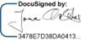

Name: J. Christians

Date: 01 February 2024 | 9:03 AM GMT

On behalf of the Transferee 1

Name: D. Schoene

Date:

On behalf of the Transferee 2
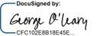

Name:G. O'Leary

Date: 31 January 2024

On behalf of the Company

Name: G. O'Leary

Date: 31 January 2024

Signature page

On behalf of the Transferor

Name: J. Christians

Date:

On behalf of the Transferee 1
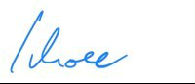

Name: D. Schoene

Date: 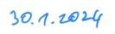

On behalf of the Transferee 2

Name:G. O'Leary

Date: 31 January 2024

On behalf of the Company

Name: G. O'Leary

Date: 31 January 2024

Annex 1

Approval management board of the Company

[Inserted separately]

MANAGEMENT BOARD RESOLUTIONS

BY UNANIMOUS CONSENT WITHOUT HOLDING A MEETING

THE UNDERSIGNED:

- Laurin Sinan Paul Hahn (Laurin);

- Jona Johannes Christians (Jona);

- Markus Ferdinand Volmer; and

- Torsten Kiedel,

forming all managing directors (the Managing Directors) and therefore the entire management board (the Management Board) of:

Sono Group N.V., a public company ('naamloze vennootschap'), with its statutory seat in Amsterdam (office address: 8093 5 Munich, Waldmeisterstrasse 76) and registered with the Trade Register held by the Chamber of Commerce for the Netherlands under number 80683568 (the Company),

WHEREAS:

- pursuant to article 20.8 of the articles of association of the Company, included in a notarial deed of amendment of the articles of association, executed before a substitute of Paul Cornelis Simon van der Bijl, civil law notary in Amsterdam, the Netherlands, on 17 November 2021 (the “Articles”), the Management Board is entitled to adopt resolutions in writing (instead of at a meeting), provided that all Managing Directors are familiar with the resolution to be passed and none of them objects to this decision- making process;

- the Company has agreed to enter into a restructuring, pursuant to which the Company will execute certain transactions (the “Restructuring”);

- Laurin inter alia holds the following shares in the capital of the Company:

  - 1,578,947 high-voting shares in the capital of the Company, each with a nominal value of EUR 1.50 (the "Laurin HV Shares"); and

  - 16,296,053 ordinary shares in the capital of the Company, each with a nominal value of EUR 0.06;

2

- Jona inter alia holds the following shares in the capital of the Company:

  - 1,421,053 high-voting shares in the capital of the Company, each with a nominal value of EUR 1.50 (the "Jona HV Shares"); and

  - 14,316,447 ordinary shares in the capital of the Company, each with a nominal value of EUR 0.06;

- as part of the Restructuring, Laurin and Jona will sell and transfer the said shares in the capital of the Company, as follows: Laurin

- to Bambino 225. V V UG, c/o Dentons GmbH Wirtschaftsprüfungsgesellschaft Steuerberatungsgesellschaft, Markgrafenstraße 33, 10117 Berlin, Germany, as the transferee designated by Mr. Ivo-Meinert Willrodt (the "Transferee 1"): 7,187,500 ordinary shares in the capital of the Company, each with a nominal value of EUR 0.06; and

- to SVSE LLC, a limited liability company formed under the laws of the State of Delaware, United States of America, registered with the Department of State under number 3005183, as the transferee(s) designated by the Company (the “Transferee 2”:

  - the Laurin HV Shares; and

  - 9,108,553 ordinary shares in the capital of the Company, each with a nominal value of EUR 0.06,

Jona

- to the Transferee 1:

  - 6,118,749 ordinary shares in the capital of the Company, each with a nominal value of EUR 0.06; and

- to the Transferee 2:

  - the Jona HV Shares; and

  - 8,197,698 ordinary shares in the capital of the Company, each with a nominal value of EUR 0.06;

HEREBY RESOLVE:

3

- To approve the said transfers of the Laurin HV Shares and the Jona HV Shares to the Transferee 1 in accordance with article 16.1 of the Articles.

- To the extent required, to approve the establishment of a right of pledge on the Laurin HV Shares and the Jona HV Shares by the Tranferee 2 for the benefit of YA II PN Ltd. (the Pledgee);

- To approve the (conditional) transfer of the voting rights related to the Laurin HV Shares and the Jona HV Shares to the Pledgee;

(IV) That the Company will execute the applicable sale and transfer agreements and the deeds of pledge;

AND HEREBY:

- Confirm that to the best of their knowledge the Company is not a party to any proceeding before the Enterprise Chamber

(Ondernemingskamer), that the Enterprise Chamber has not given any order, directly or indirectly affecting the Company and the Management Board has not adopted any resolution in respect of the merger (fusie) or division (juridische splitsing) of the Company.

(VI)

Confirm that the approval of the Supervisory Board for the subject resolution has been granted in accordance with article 20.9 sub (f) of the Articles.

(VII)

Confirm that the Pledgee and Dentons Europe LLP may rely on these resolutions.

This Management Board Resolution may be entered into in any number of counterparts and by the signatories in separate counterparts, each of which, when executed, shall be an original, but all counterparts shall together constitute one and the same instrument. Each signatory may deliver a signed copy of this Management Board Resolution by fax or as PDF and any such copy shall be deemed to be an original for all purposes.

This Management Board Resolution may be signed electronically.

Signature page follows.

SIGNATURE PAGE TO THE BOARD RESOLUTION

Signed on the dates as mentioned below the signatures.
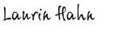

L.S.P. Hahn

Date: 30.01.2024
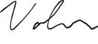

- Christians Date: 30.01.2024

M.F. Volmer |  | T. Kiedel
Date: 30.01.2024 |  | Date: 30.01.2024

Annex 2

Approval supervisory board of the Company

[Inserted separately]

1

Supervisory board resolutions by unanimous consent without holding a meeting

THE UNDERSIGNED:

- David Dodge; and

- Christopher Schreiber,

jointly the supervisory directors (Supervisory Directors) and forming the Supervisory Board (the Supervisory Board) of:

Sono Group N.V., a public company ('naamloze vennootschap'), with its statutory seat in Amsterdam (office address: 8093 5 Munich, Waldmeisterstrasse 76) and registered with the Trade Register held by the Chamber of Commerce for the Netherlands under number 80683568, (the Company),

WHEREAS:

- pursuant to article 26.8 of the articles of association of the Company, included in a notarial deed of amendment of the articles of association, executed before a substitute of Paul Cornelis Simon van der Bijl, civil law notary in Amsterdam, the Netherlands, on 17 November 2021 (the Articles), the Supervisory Board is entitled to adopt resolutions in writing (instead of at a meeting), provided that all Supervisory Directors are familiar with the resolution to be passed and none of them objects to this decision- making process;

- The Supervisory Board has considered the resolutions (a copy of which is attached hereto (Annex), adopted by the Management Board (the Management Board Resolutions);

- Capitalised terms used herein shall, unless otherwise defined herein, have the meaning given to such terms in the Management Board Resolutions (as defined below); and

- Each member of the Supervisory Board has considered the Management Board Resolutions.

HEREBY RESOLVE:

2

To approve the Management Board Resolutions.

AND HEREBY:

Confirm that Dentons Europe LLP and DLA Piper Netherlands N.V. may rely on these resolutions.

This Supervisory Board Resolution may be entered into in any number of counterparts and by the signatories in separate counterparts, each of which, when executed, shall be an original, but all counterparts shall together constitute one and the same instrument.

Each signatory may deliver a signed copy of this Supervisory Board Resolution by fax or as PDF and any such copy shall be deemed to be an original for all purposes.

This Supervisory Board Resolution may be signed electronically.

Signature page follows.

Signature page to the Supervisory Board resolutions by unanimous consent without holding a meeting of Sono Group N.V., signed on the dates mentioned below the signatures.

David Dodge |  | Chris Schreiber
Date: 1 February 2024 |  | Date: 1 February 2024
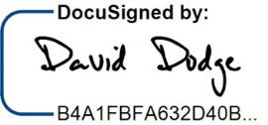
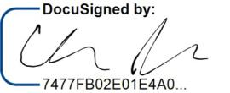

ANNEX – MANAGEMENT BOARD RESOLUTIONS

[Separate document]

Exhibit 99.2

Sale and transfer agreement

regarding shares in

Sono Group N.V.

Dated 1 February 2024

This agreement (the "Agreement") is made on 1 February 2024

Parties

- Laurin Hahn (the "Transferor");

- Bambino 225. V V UG, c/o Dentons GmbH Wirtschaftsprüfungsgesellschaft Steuerberatungsgesellschaft, Markgrafenstraße 33, 10117 Berlin, Germany, as the transferee designated by Mr. Ivo-Meinert Willrodt (the "Transferee 1");

- SVSE LLC, a limited liability company formed under the laws of the State of Delaware, United States of America, registered with the Department of State under number 3005183, as the transferee(s) designated by the Company (the "Transferee 2” and, jointly with the Transferee 1, the “Transferees”); and

- Sono Group N.V., a company incorporated under Dutch law (naamloze vennootschap) and registered with the Dutch chamber of commerce under number 80683568 (the "Company").

The above parties to this Agreement are collectively referred to as the "Parties" and individually as a "Party".

Background

- Reference is made to the envisaged restructuring of the Company and Sono Motors GmbH (jointly the "Sono Group") through the implementation of certain restructuring steps as set out in inter alia the restructuring agreement between Sono Group N.V. and YA II PN Ltd., to be entered into on or about the date hereof (the “Restructuring Agreement”), to allow the Sono Group to exit from insolvency proceedings in Germany (the "Restructuring" and the transactions in connection therewith and/or arising therefrom jointly the "Transactions").

- At the date of this Agreement, the Transferor holds:

  - 1,578,947 high-voting shares in the capital of the Company, each with a nominal value of EUR 1.50 (the "HV Shares"); and

  - 16,296,053 ordinary shares in the capital of the Company, each with a nominal value of EUR 0.06 (the "Ordinary Shares"),

(jointly, the "Shares").

- As part of the Restructuring and the Transactions, it is envisaged that the Transferor will sell and transfer, inter alia, the Shares to the Transferee 1 and the Transferee 2 as set out in detail in the commitment letter dated 17 November 2023 by, inter alia, the Transferor to the Company and Sono Motors GmbH (the “Commitment Letter”).

It is agreed:

- Definitions and interpretation

1.1 In this Agreement, unless the context otherwise requires, the provisions of this clause 1 apply.

1.2 In this Agreement, unless otherwise specified:

- reference to a gender includes all genders;

- reference to a person includes reference to any individual, company, corporation, foundation, association, any other legal person, partnership, joint venture or any governmental authority;

- reference to "include" or "including" is treated as a reference to "include without limitation" or "including without limitation";

- reference to "writing" or "written" means any method of reproducing words in a legible and non-transitory form, including e-mail;

- reference to any action, remedy, method or form of proceedings, court or any other legal concept or matter is a reference to the Dutch legal concept or matter or to the legal concept or matter which most closely resembles the Dutch legal concept or matter as interpreted in a Dutch law context; and

- reference to a clause is a reference to a clause schedule of this Agreement.

1.3 Headings are for convenience of reference only and do not affect the interpretation of any provision of this Agreement.

- Sale, purchase and transfer

2.1 Subject to the terms and conditions of this Agreement, the Transferor hereby sells and transfers the following Shares to the following transferees:

- to the Transferee 1:

  - 7,187,500 ordinary shares in the capital of the Company, each with a nominal value of EUR 0.06 (the "Ordinary Shares 1" or the "Shares 1"),

which are hereby purchased and accepted by the Transferee 1; and

- to the Transferee 2:

  - the HV Shares; and

  - 9,108,553 ordinary shares in the capital of the Company, each with a nominal value of EUR 0.06 (the "Ordinary Shares 2" and jointly with the HV Shares, the "Shares 2"),

which are hereby purchased and accepted by the Transferee 2.

2.2 The Shares are transferred to the Transferee 1 and the Transferee 2, respectively, free and clear from any mortgage, pledge, lien (retentierecht), retention of title (eigendomsvoorbehoud), any other registered obligation (kwalitatieve verplichting), personal right of enjoyment or use or right to acquire, usufruct, attachment, right of first refusal or other restriction on transfer, any restriction on voting or any other third party right or security interest of any kind, or any agreement to create any of the foregoing and together with all rights attached to them, and further in accordance with the provisions of clause 4.

2.3 The Company hereby acknowledges the transfer of the HV Shares effected by this Agreement and shall register the same in its register of shareholders.

- Consideration

3.1 The consideration for the Shares 1 and the Shares 2 amounts to EUR 0.003 per Share, i.e., EUR 53,625 in the aggregate (incl.

VAT, if any) (the "Purchase Price").

3.2 The Purchase Price shall be paid by the Transferee 1 exclusively at the time, in the partial amounts and out of the funds as provided for in paragraph 3.1 (c) of the Commitment Letter, and without any deduction, withholding, set-off or suspension, in cash to the Transferor to the following bank account in name of the Transferor:

OMITTED

- Completion of Transfer of Ordinary Shares

4.1 The Transferor hereby irrevocable and unconditionally covenants and warrants towards the Transferee 1 to instruct AST Financial

- AMERICAN STOCK TRANSFER & TRUST COMPANY (in future doing business as Equiniti Trust Company, LLC) as transfer agent and registrar to transfer the Ordinay Shares 1 to a security account as to be notified by the Transferee 1 in writing to the Transferor after the date of this Agreement.

4.2 The Transferor hereby irrevocable and unconditionally covenants and warrants towards the Transferee 2 to instruct AST Financial

- AMERICAN STOCK TRANSFER & TRUST COMPANY (in future doing business as Equiniti Trust Company, LLC) as transfer agent and registrar to make the following security account transfers on the date of this Agreement:

the Ordinary Shares 2 are to be transferred to the following nominee securities account of the Transferee 2: OMITTED

4.3 Forthwith after giving such instruction, the Transferor will provide the Transferees with written evidence that the transfer and delivery of the Ordinary Shares 1 and the Ordinary Shares 2, as referred to in clause 4.1 has occurred.

4.4 The Transferor hereby represents and warrants to each of the Transferees that any further formalities or (legal) acts which must be complied with or performed for a transfer of the full and unencumbered title to the Ordinary Shares 1 and the Ordinary Shares 2 to the Transferee 1 or, respectively, the Transferee 2, shall be complied with or performed forthwith. The Company shall, insofar as necessary, fully cooperate to effect the transfer.

4.5 The Transferor hereby grants full and irrevocable power of attorney to each of the Transferees and the Company, to each of them severally, with the power of substitution, to comply with all formalities and perform all (legal) acts referred to in clause 4.3 or other rules applicable to the Ordinary Shares 1 and/or the Ordinary Shares 2 must be complied with or performed for a transfer of the full and unencumbered title to the Ordinary Shares 1 to the Transferee 1 and the Ordinary Shares 2 to the Transferee 2.

- Transfer restriction

The share transfer restrictions provided for in article 16.1 of the Company’s articles of association (containing a prior approval system) do not apply, as the management board of the Company has granted its written approval to the contemplated transfer of the HV Shares, as evidenced by a written resolution of the management board of the Company, a copy of which has been attached to this Agreement as Annex 1, and as approved by a resolution of the supervisory board of the Company, a copy of which has been attached to this Agreement as Annex 2.

- Warranties

6.1 The Transferor hereby represents and warrants to each of the Transferees and the Company that, on the date hereof, the following is correct:

- The Transferor has full and unencumbered title to the Shares 1 and the Shares 2 and is fully authorised to transfer the Shares 1 and the Shares 2 to the Transferee 1 and the Transferee 2 respectively.

- The Shares 1 and the Shares 2 are not subject to rights of third parties or obligations to transfer to third parties or claims based on contracts of any nature.

6.2 The Transferor hereby represents and warrants that it has the legal right and full power and authority (including all necessary consents, authorisations, confirmations, permissions, certificates, approvals, authorities or other corporate action as may be required) to provide and perform the obligations and undertakings contained in this Agreement (as applicable) which when executed will constitute legal, valid and binding obligations on the Transferor.

6.3 Each Transferee hereby represents and warrants that it has the legal right and full power and authority (including all necessary consents, authorisations, confirmations, permissions, certificates, approvals, authorities or other corporate action as may be required) to provide and perform the obligations and undertakings contained in this Agreement (as applicable) which when executed will constitute legal, valid and binding obligations on the Transferees.

6.4 The Transferees understand that the Shares have not been registered under the U.S. Securities Act and may not be offered or sold in the United States or to U.S. persons unless the Shares are registered under the U.S. Securities Act, or an exemption from the registration requirements of the U.S. Securities Act is available. The Transferees further understand that the Shares will be “restricted securities” within the meaning of Rule 144(a)(3) under the Securities Act, and Transferees understands that the certificates or book-entries representing the Shares will contain a legend or notation in respect of such restrictions. The Transferees agree not to sell, transfer, pledge, hypothecate or otherwise dispose of all or any part of the Shares unless, prior thereto, (a) a registration statement covering such Shares shall be effective under the Securities Act and the transaction shall be qualified under applicable state law or (b) the transaction is exempt from the registration requirements under the Securities Act and the qualification requirements under applicable state law. Transferees further understand that the Shares may not be transferred within 40 calendar days from the closing of the sale pursuant to this Agreement.

6.5 Any certificates representing the Shares shall have endorsed thereon legends substantially as follows (and any book-entries representing the Shares shall have similar notations) and Transferees specifically acknowledge, and agree to comply with, these legends:

“THESE SHARES HAVE NOT BEEN REGISTERED UNDER THE SECURITIES ACT OF 1933. THE SHARES MAY NOT BE SOLD, TRANSFERRED OR ASSIGNED IN THE ABSENCE OF AN EFFECTIVE REGISTRATION STATEMENT FOR THESE SHARES UNDER THE SECURITIES ACT OF 1933 OR UNLESS SUCH SALE, TRANSFER, OR ASSIGNMENT IS EXEMPT FROM REGISTRATION THEREUNDER.”

“PRIOR TO THE EXPIRATION OF FORTY DAYS FROM THE LATER OF (1) THE DATE ON WHICH THESE SHARES WERE FIRST OFFERED AND (2) THE DATE OF DELIVERY OF THESE SHARES, THESE SHARES MAY NOT BE OFFERED, SOLD OR DELIVERED WITHIN THE UNITED STATES OR TO A U.S. PERSON (AS DEFINED IN REGULATION S UNDER THE SECURITIES ACT) EXCEPT PURSUANT TO AN EXEMPTION FROM REGISTRATION UNDER THE SECURITIES ACT AND, IN EACH CASE, IN ACCORDANCE WITH ALL APPLICABLE SECURITIES LAWS OF ANY OTHER JURISDICTION. THE HOLDER HEREOF, BY

ACQUIRING THIS SECURITY, REPRESENTS AND AGREES FOR THE BENEFIT OF THE ISSUER AND THE GUARANTOR THAT IT WILL NOTIFY ANY TRANSFEREE OF THIS SECURITY FROM IT OF THE RESALE RESTRICTIONS REFERRED TO ABOVE.”.

- Lock-up

The Transferee 2 submits to the same rules that apply to the Transferors pursuant to paragraph 4 of the Commitment Letter with regard to the Shares 2 after the acquisition. The parties agree that in the event of a shortening or cancellation of the lock-up period for Transferee 2, the lock- up for the Transferors agreed in the Commitment Letter shall also be cancelled.

- General Provisions

8.1 Each Party shall, at its own expense, sign and execute such documents and perform such further acts as the other Parties may reasonably request from time to time to give full effect to, and give each Party the full benefit of, this Agreement. The Company shall bear the costs arising in connection with paragraph 4.3 of this Agreement.

8.2 Each Party shall pay its own costs and expenses in connection with the preparation, execution and completion of this Agreement and of any ancillary agreement, except as provided otherwise in this Agreement or as otherwise specifically agreed in writing after the date of this Agreement. All stamp, transfer, real estate transfer, registration, sales and other similar taxes or duties, levies or charges in connection with the sale and/or transfer of the Shares 1 and/or the Shares 2 shall be paid by the Transferee.

8.3 This Agreement shall be treated as strictly confidential and shall not, without your prior written consent, be disclosed in whole or in part to any person, other than to your employees, directors, professional advisers and financing sources, in each case on a confidential basis; provided, however, that any Party, any party to the Commitment Letter and/or any Third Party Beneficiary (as defined in the Commitment Letter) shall be entitled to disclose this Agreement in whole or in part: (i) if required by any mandatory law, regulation or other rules (including, but not limited to, stock exchange regulations; (ii) as any Party, any party to the Commitment Letter and/or any Third Party Beneficiary deem necessary in connection with the insolvency proceedings regarding the Company and/or Sono Motors GmbH.

8.4 No variation of this Agreement shall be effective unless in writing and signed by or on behalf of all Parties.

8.5 If any provision in this Agreement shall be held to be illegal, invalid or unenforceable, in whole or in part, the provision shall apply with whatever deletion or modification is necessary so that the provision is legal, valid and enforceable and gives effect to the commercial intention between the Parties. To the extent it is not possible to delete or modify the provision, in whole or in part then such provision or part of it shall, to the extent that it is illegal, invalid or unenforceable, be deemed not to form part of this letter and the legality, validity and enforceability of the remainder of this Agreement shall, subject to any deletion or modification made under this paragraph, not be affected.

8.6 Except as explicitly stated otherwise in this Agreement, each of the Parties waives its rights, if any, to in whole or in part annul, rescind or dissolve this Agreement. Each of the Parties waives its rights to request in whole or in part the annulment, rescission, dissolution or cancellation of this Agreement.

- Governing law and jurisdiction

9.1 This Agreement shall be governed by German law (excluding CISG); provided, however, that the transfer of the Shares 1 and the Shares 2 shall be governed by Dutch law.

9.2 The courts of Munich, Germany, have non-exclusive jurisdiction to settle any dispute arising out of or in connection with this Agreement (including a dispute relating to any non-contractual obligation arising out of or in connection with this Agreement).

(signature page follows)

Signature page

On behalf of the Transferor
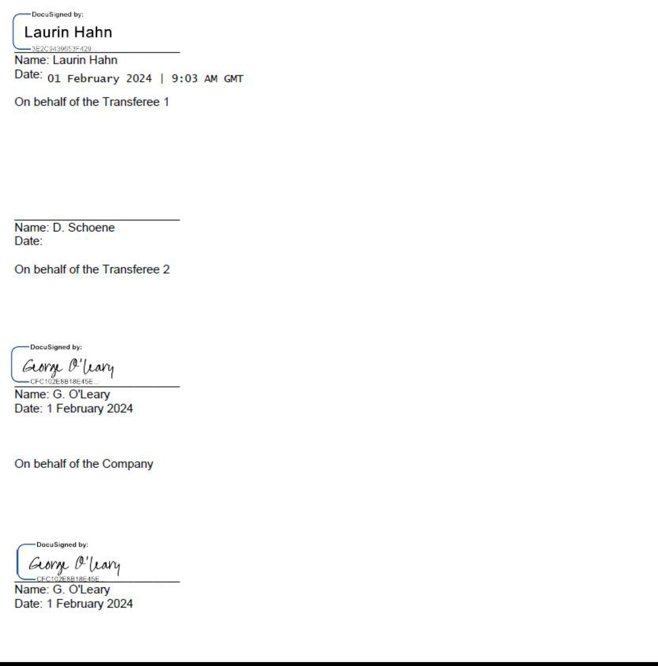

Signature page

On behalf of the Transferor
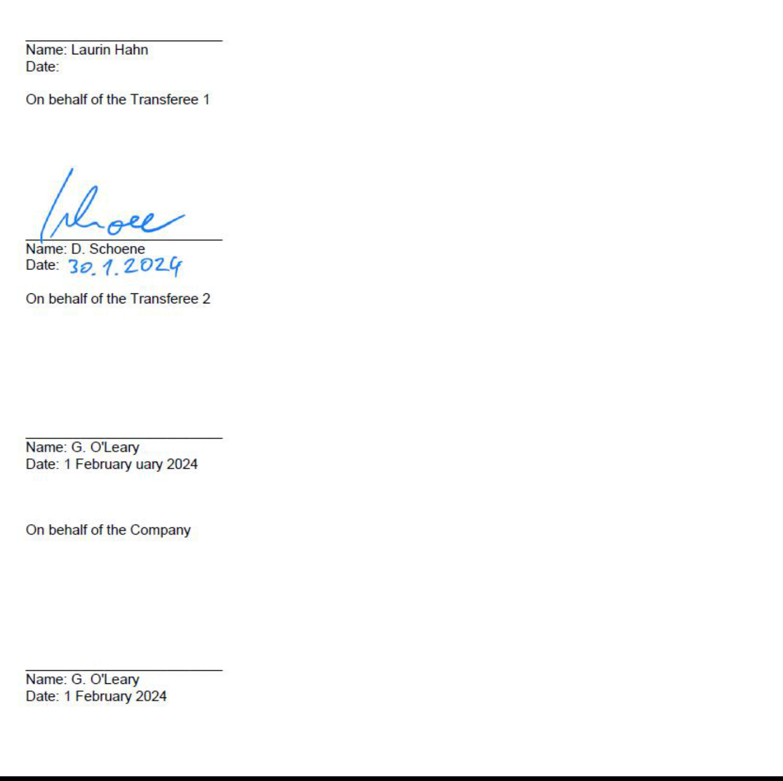

Annex 1

Approval management board of the Company

[Inserted separately]

MANAGEMENT BOARD RESOLUTIONS

BY UNANIMOUS CONSENT WITHOUT HOLDING A MEETING

THE UNDERSIGNED:

- Laurin Sinan Paul Hahn (Laurin);

- Jona Johannes Christians (Jona);

- Markus Ferdinand Volmer; and

- Torsten Kiedel,

forming all managing directors (the Managing Directors) and therefore the entire management board (the Management Board) of:

Sono Group N.V., a public company ('naamloze vennootschap'), with its statutory seat in Amsterdam (office address: 8093 5 Munich, Waldmeisterstrasse 76) and registered with the Trade Register held by the Chamber of Commerce for the Netherlands under number 80683568 (the Company),

WHEREAS:

- pursuant to article 20.8 of the articles of association of the Company, included in a notarial deed of amendment of the articles of association, executed before a substitute of Paul Cornelis Simon van der Bijl, civil law notary in Amsterdam, the Netherlands, on 17 November 2021 (the “Articles”), the Management Board is entitled to adopt resolutions in writing (instead of at a meeting), provided that all Managing Directors are familiar with the resolution to be passed and none of them objects to this decision- making process;

- the Company has agreed to enter into a restructuring, pursuant to which the Company will execute certain transactions (the “Restructuring”);

- Laurin inter alia holds the following shares in the capital of the Company:

  - 1,578,947 high-voting shares in the capital of the Company, each with a nominal value of EUR 1.50 (the "Laurin HV Shares"); and

  - 16,296,053 ordinary shares in the capital of the Company, each with a nominal value of EUR 0.06;

2

- Jona inter alia holds the following shares in the capital of the Company:

  - 1,421,053 high-voting shares in the capital of the Company, each with a nominal value of EUR 1.50 (the "Jona HV Shares"); and

  - 14,316,447 ordinary shares in the capital of the Company, each with a nominal value of EUR 0.06;

- as part of the Restructuring, Laurin and Jona will sell and transfer the said shares in the capital of the Company, as follows:

Laurin

- to Bambino 225. V V UG, c/o Dentons GmbH Wirtschaftsprüfungsgesellschaft Steuerberatungsgesellschaft, Markgrafenstraße 33, 10117 Berlin, Germany, as the transferee designated by Mr. Ivo-Meinert Willrodt (the "Transferee 1"): 7,187,500 ordinary shares in the capital of the Company, each with a nominal value of EUR 0.06; and

- to SVSE LLC, a limited liability company formed under the laws of the State of Delaware, United States of America, registered with the Department of State under number 3005183, as the transferee(s) designated by the Company (the “Transferee 2”:

  - the Laurin HV Shares; and

  - 9,108,553 ordinary shares in the capital of the Company, each with a nominal value of EUR 0.06,

Jona

- to the Transferee 1:

  - 6,118,749 ordinary shares in the capital of the Company, each with a nominal value of EUR 0.06; and

- to the Transferee 2:

  - the Jona HV Shares; and

  - 8,197,698 ordinary shares in the capital of the Company, each with a nominal value of EUR 0.06;

HEREBY RESOLVE:

3

- To approve the said transfers of the Laurin HV Shares and the Jona HV Shares to the Transferee 1 in accordance with article 16.1 of the Articles.

- To the extent required, to approve the establishment of a right of pledge on the Laurin HV Shares and the Jona HV Shares by the Tranferee 2 for the benefit of YA II PN Ltd. (the Pledgee);

- To approve the (conditional) transfer of the voting rights related to the Laurin HV Shares and the Jona HV Shares to the Pledgee;

(IV) That the Company will execute the applicable sale and transfer agreements and the deeds of pledge;

AND HEREBY:

- Confirm that to the best of their knowledge the Company is not a party to any proceeding before the Enterprise Chamber

(Ondernemingskamer), that the Enterprise Chamber has not given any order, directly or indirectly affecting the Company and the Management Board has not adopted any resolution in respect of the merger (fusie) or division (juridische splitsing) of the Company.

(VI)

Confirm that the approval of the Supervisory Board for the subject resolution has been granted in accordance with article 20.9 sub (f) of the Articles.

(VII)

Confirm that the Pledgee and Dentons Europe LLP may rely on these resolutions.

This Management Board Resolution may be entered into in any number of counterparts and by the signatories in separate counterparts, each of which, when executed, shall be an original, but all counterparts shall together constitute one and the same instrument. Each signatory may deliver a signed copy of this Management Board Resolution by fax or as PDF and any such copy shall be deemed to be an original for all purposes.

This Management Board Resolution may be signed electronically.

Signature page follows.

SIGNATURE PAGE TO THE BOARD RESOLUTION

Signed on the dates as mentioned below the signatures.

L.S.P. Hahn

Date: 30.01.2024

- Christians Date: 30.01.2024

M.F. Volmer |  | T. Kiedel
Date: 30.01.2024 |  | Date: 30.01.2024

Annex 2

Approval supervisory board of the Company

[Inserted separately]

1

Supervisory board resolutions by unanimous consent without holding a meeting

THE UNDERSIGNED:

- David Dodge; and

- Christopher Schreiber,

jointly the supervisory directors (Supervisory Directors) and forming the Supervisory Board (the Supervisory Board) of:

Sono Group N.V., a public company ('naamloze vennootschap'), with its statutory seat in Amsterdam (office address: 8093 5 Munich, Waldmeisterstrasse 76) and registered with the Trade Register held by the Chamber of Commerce for the Netherlands under number 80683568, (the Company),

WHEREAS:

- pursuant to article 26.8 of the articles of association of the Company, included in a notarial deed of amendment of the articles of association, executed before a substitute of Paul Cornelis Simon van der Bijl, civil law notary in Amsterdam, the Netherlands, on 17 November 2021 (the Articles), the Supervisory Board is entitled to adopt resolutions in writing (instead of at a meeting), provided that all Supervisory Directors are familiar with the resolution to be passed and none of them objects to this decision- making process;

- The Supervisory Board has considered the resolutions (a copy of which is attached hereto (Annex), adopted by the Management Board (the Management Board Resolutions);

- Capitalised terms used herein shall, unless otherwise defined herein, have the meaning given to such terms in the Management Board Resolutions (as defined below); and

- Each member of the Supervisory Board has considered the Management Board Resolutions.

HEREBY RESOLVE:

2

To approve the Management Board Resolutions.

AND HEREBY:

Confirm that Dentons Europe LLP and DLA Piper Netherlands N.V. may rely on these resolutions.

This Supervisory Board Resolution may be entered into in any number of counterparts and by the signatories in separate counterparts, each of which, when executed, shall be an original, but all counterparts shall together constitute one and the same instrument.

Each signatory may deliver a signed copy of this Supervisory Board Resolution by fax or as PDF and any such copy shall be deemed to be an original for all purposes.

This Supervisory Board Resolution may be signed electronically.

Signature page follows.

Signature page to the Supervisory Board resolutions by unanimous consent without holding a meeting of Sono Group N.V., signed on the dates mentioned below the signatures.

David Dodge |  | Chris Schreiber
Date: 1 February 2024 |  | Date: 1 February 2024

ANNEX – MANAGEMENT BOARD RESOLUTIONS

[Separate document]

