UNITED STATES

SECURITIES AND EXCHANGE COMMISSION
Washington, D.C. 20549

FORM 6-K

REPORT OF FOREIGN PRIVATE ISSUER

PURSUANT TO RULE 13a-16 OR 15d-16

UNDER THE SECURITIES EXCHANGE ACT OF 1934

For the month of December 2024

Commission File Number: 001-41066

Sono Group N.V.

(Registrant’s name)

Waldmeisterstrasse 93

80935 Munich

Germany

(Address of principal executive offices)

Indicate by check mark whether the registrant files or will file annual reports under cover of Form 20-F or Form 40-F.

Form 20-F ☒ Form 40-F ☐

Reverse Share Split

As previously disclosed, the shareholders of Sono Group N.V. approved a reverse share split (the “Reverse Share Split”) of the Company’s ordinary shares, nominal value of €0.06 (the “Ordinary Shares”), and the Company’s high voting shares, nominal value of €1.50 (the “High Voting Shares”). On December 23, 2024, Sono Group N.V. (the “Company”) amended its articles of association (the “Amended Articles”) to implement the Reverse Share Split at a ratio of 1-for-75 (the “Reverse Split Ratio”), resulting in every 75 Ordinary Shares issued and outstanding immediately prior to the Reverse Share Split being converted into one Ordinary Shares and every 75 High Voting Shares issued and outstanding immediately prior to the Reverse Share Split being converted into one High Voting Share. A copy of the Amended Articles is attached hereto as Exhibit 3.1 and incorporated herein by reference.

The Reverse Share Split became effective under Dutch corporate law as of the date of the Amended Articles; however, the Reverse Share Split will not be reflected in quotations on the OTCQB until processed by the Financial Industry Regulatory Authority (“FINRA”). The Company is continuing to engage with FINRA in order to process the Reverse Share Split as soon as possible. In addition, on the effective date of the Reverse Share Split the Ordinary Shares will trade under a new CUSIP number. No fractional shares will be issued in connection with the Reverse Share Split; all fractional shares will be rounded up. Shareholders with shares held in certificate form will be able to exchange share certificates by contacting the Company’s transfer agent, Equiniti Trust Company, LLC. Shareholders that hold shares in book-entry form or in brokerage accounts are not required to take any action and will see the impact of the Reverse Share Split reflected in their accounts.

Securities Purchase Agreement, Debenture and Call Option Agreement

On December 30, 2024, the Company entered into a securities purchase agreement (the “Securities Purchase Agreement”) with YA II PN, Ltd. (“Yorkville”), pursuant to which the Company agreed to sell and issue to Yorkville a new convertible debenture (the “Debenture”) in the aggregate principal amount of $5 million, which is convertible into Ordinary Shares as described below. The issuance and sale of the Debenture is subject to certain conditions and limitations, including the Company’s receipt of notice from Nasdaq that the Company has met all the applicable requirements for listing of the Ordinary Shares on the Nasdaq Capital Market.

The Debenture, when issued, will mature on the one-year anniversary of the issuance date of the Debenture. Further, interest will accrue on the outstanding principal balance of the Debenture at an annual rate of 12%, which will increase to an annual rate of 18% upon an Event of Default (as defined in the Debenture) for so long as such Event of Default remains uncured. Yorkville will have the right to convert the Debenture into Ordinary Shares at the lower of
- a price per Ordinary Share equal to $0.25 or (ii) 85% of the lowest daily volume weighted average price of the Ordinary Shares during the seven consecutive trading days immediately preceding the conversion date or other date of determination (the “Variable Conversion Date”); provided that the Variable Conversion Date may not be lower than the Floor Price (as defined in the Debenture) then in effect and the nominal value of one Ordinary Share.

In connection with the transactions contemplated by the Securities Purchase Agreement, Yorkville and SVSE LLC (“SVSE”), whose sole member is George O’Leary, will enter into a call option agreement (the “Call Option Agreement”) before the issuance of the Debenture. Pursuant to the Call Option Agreement, SVSE will agree to provide Yorkville with a call option (the “Call Option”) to purchase all of the Ordinary Shares and High Voting Shares held by SVSE at a price of $0.1125 per Ordinary Share and $1.875 per High Voting Share (post Reverse Share Split). The Call Option will expire at 5:00 p.m. Eastern time on the four-year anniversary of the date of the Call Option Agreement (the “Expiration Time”), and may be exercised prior to the Expiration Time on multiple occasions with respect to a portion of the Ordinary Shares and High Voting Shares held by SVSE. Under the terms of the Call Option Agreement, Yorkville may not exercise the Call Option if, after giving effect to such exercise, Yorkville and any of its affiliates would beneficially own more than 4.99% of (i) the number of High Voting Shares outstanding, (ii) the number of Ordinary Shares outstanding, or (iii) the voting power of the total capital of the Company (including due to the voting rights of the High Voting Shares). Such ownership limitations may be waived by Yorkville upon not less than 65 days prior notice to the Company.

The foregoing description of the Securities Purchase Agreement, form of Debenture and Call Option Agreement does not purport to be complete and is qualified in its entirety by the terms of the Securities Purchase Agreement, form of Debenture and Call Option Agreement, which are attached hereto as Exhibits 10.1, 4.1 and 4.2, respectively, and are incorporated herein by reference.

Exchange Agreement

On December 30, 2024, the Company entered into an exchange agreement (the “Exchange Agreement”) with Yorkville, pursuant to which the Company agreed, subject to the satisfactions of certain conditions precedent, to issue 1,242 shares of preferred stock of the Company, each with a nominal value of €300 (the “Preferred Shares”), to Yorkville solely in exchange for the surrender and cancellation of all of the debentures held by Yorkville, including the Debenture to be issued as described above.

Each Preferred Share is convertible into 30,000 Ordinary Shares. In connection with the conversion of each Preferred Share, the effective conversion price (the “Effective Conversion Price”) per share shall be equal to 85% of the lowest daily volume weighted average price of the Ordinary Shares during the 10 trading days immediately preceding the date of the notice of conversion, subject to a floor price equal to 20% of the closing price of the Ordinary Shares immediately prior to the date of the Exchange Agreement. Upon the conversion of each Preferred Share, Yorkville is required to surrender such Preferred Share and Yorkville will automatically sell and transfer to the Company for no consideration (the “Repurchase”) additional Preferred Shares such that the total number of Preferred Shares surrendered and subject to the Repurchase will be equal to (a) the total number of Ordinary Shares issuable upon such conversion, multiplied by (b) the Effective Conversion Price, divided by (c) 30,000. Under the terms of the Exchange Agreement, Yorkville may not convert Preferred Shares if, after giving effect to such conversion, Yorkville and any of its affiliates would beneficially own more than 4.99% of the number or voting power of the Ordinary Shares outstanding immediately after giving effect to such conversion. Such ownership limitations may be waived by Yorkville upon not less than 65 days prior notice to the Company.

The closing of the transactions contemplated by the Exchange Agreement are subject to certain conditions precedent, including the Company’s receipt of notice from Nasdaq that the Company has met all the applicable requirements for listing of the Ordinary Shares on the Nasdaq Capital Market.

The foregoing description of the Exchange Agreement does not purport to be complete and is qualified in its entirety by the terms of the Exchange Agreement, which is attached hereto as Exhibit 10.2, respectively, and is incorporated herein by reference.

Appointment of Chief Financial Officer

The Company’s management board and supervisory board have approved the appointment of Mr. Scott Calhoun, the Company’s current active Controller, to serve as the Company’s Chief Financial Officer. George O’Leary will continue to serve as the Company’s Managing Director and Chief Executive Officer.

Pro Forma Financial Statements

The Company has issued an unaudited pro forma condensed consolidated balance sheet and statement of income as of the nine-months ended September 30, 2024 (the “Pro Forma Financial Information”), which give effect to the transactions contemplated by the Securities Purchase Agreement and the Exchange Agreement. The Pro Forma Financial Information, which is attached hereto as Exhibit 99.1, is being furnished in connection with the Company’s planned uplisting to Nasdaq.

Incorporation By Reference

The information in this report on Form 6-K is hereby incorporated by reference into the Company’s registration statement on Form S-8 (File No. 333-261241), to be a part thereof from the date on which this report is submitted, to the extent not superseded by documents or reports subsequently filed or furnished.

Exhibit |  |  |  | Description of Exhibit
3.1 |  |  |  | Deed of partial amendment of the articles of association (Reverse Share Split and Capital Reduction)
4.1 |  |  |  | Form of Secured Convertible Debenture (included in Exhibit 10.1)
4.2 |  |  |  | Form of Call Option Agreement, by and between SVSE LLC and YA II PN, Ltd. (included in Exhibit 10.1)
10.1 |  |  |  | Securities Purchase Agreement, dated December 30, 2024, by and between Sono Group N.V. and YA II PN, Ltd.
10.2 |  |  |  | Exchange Agreement, dated December 30, 2024, by and between Sono Group N.V. and YA II PN, Ltd.
99.1 |  |  |  | Sono Group N.V. pro forma condensed consolidated balance sheet and statement of income as of and for the nine months ended September
 |  |  |  | 30, 2024

SIGNATURE

Pursuant to the requirements of the Securities Exchange Act of 1934, the registrant has duly caused this report to be signed on its behalf by the undersigned, thereunto duly authorized.

Sono Group N.V.

By /s/ George O’Leary

Name: George O’Leary
Title: Managing Director

Date: December 30, 2024

Exhibit 3.1
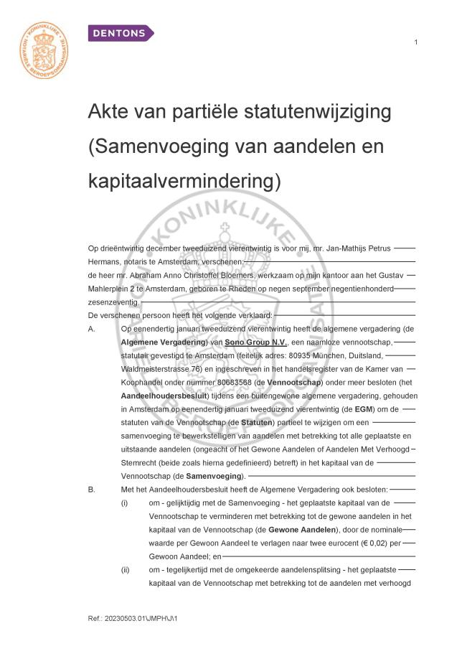

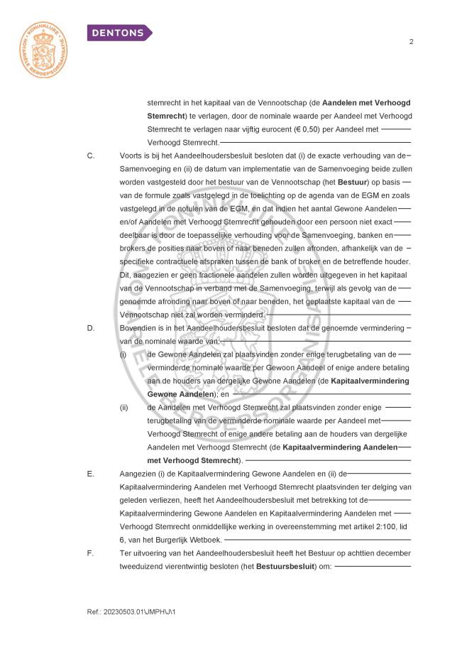

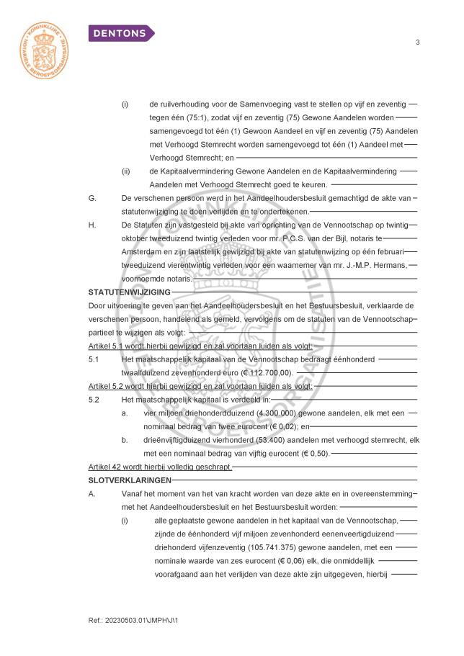

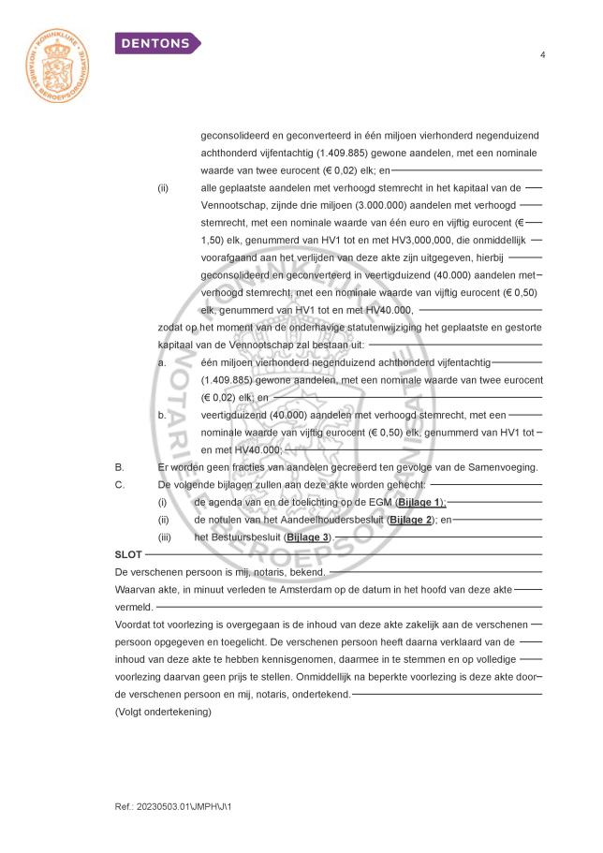

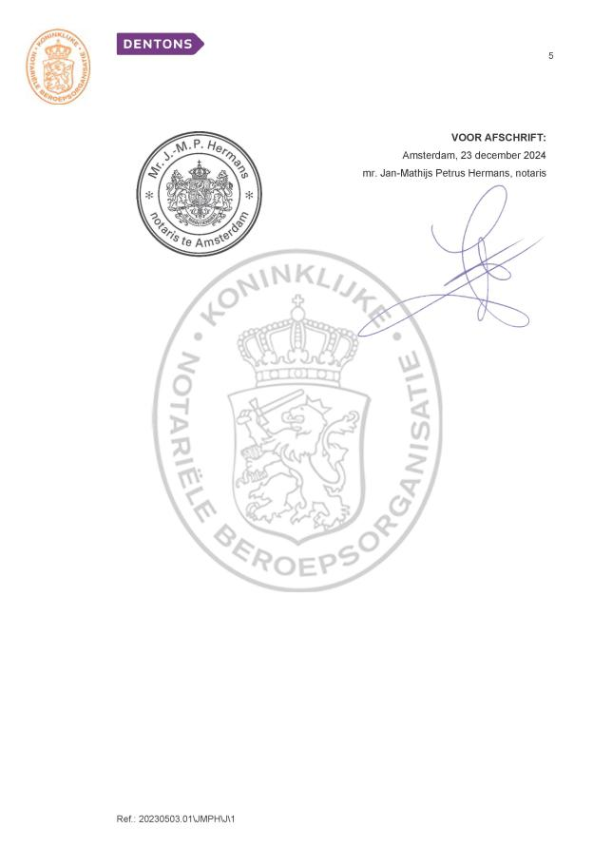

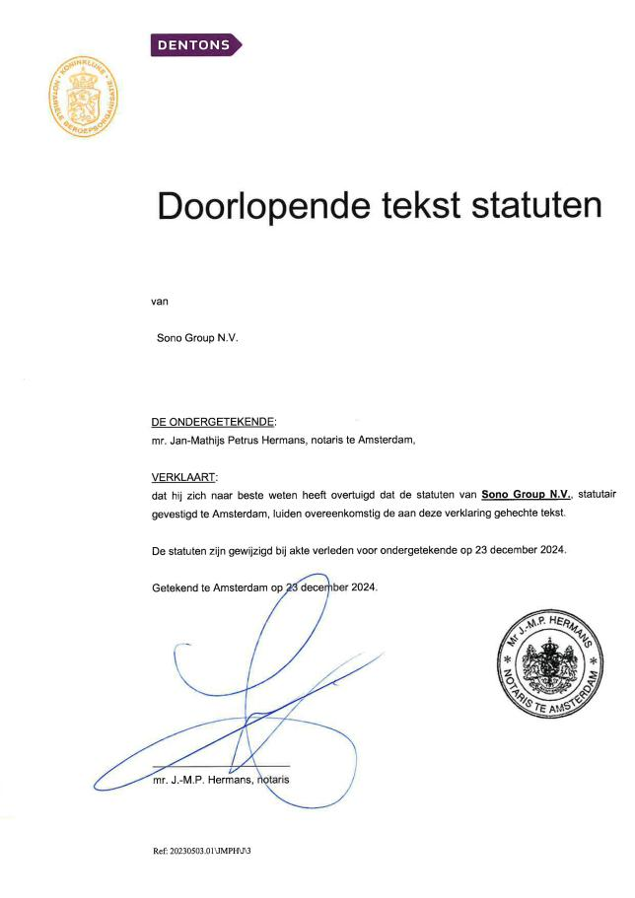



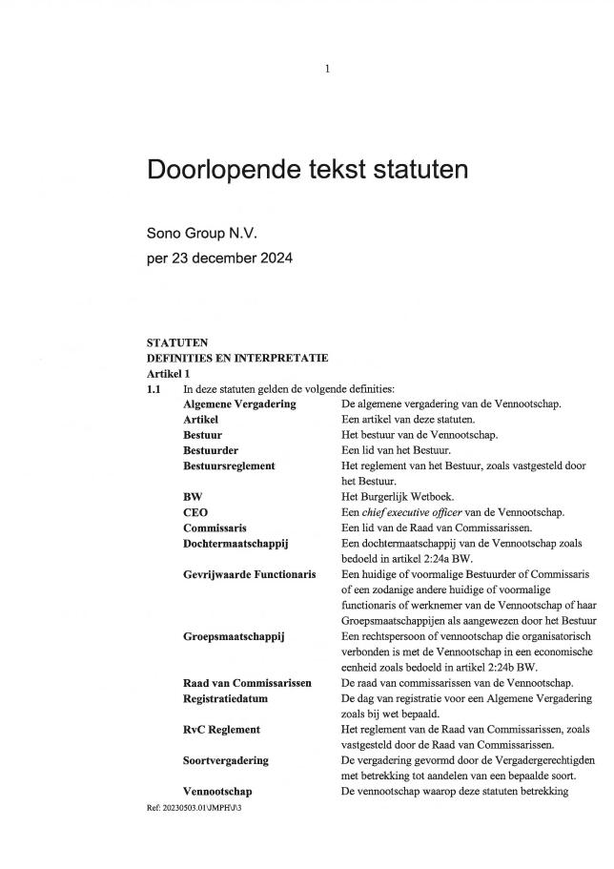

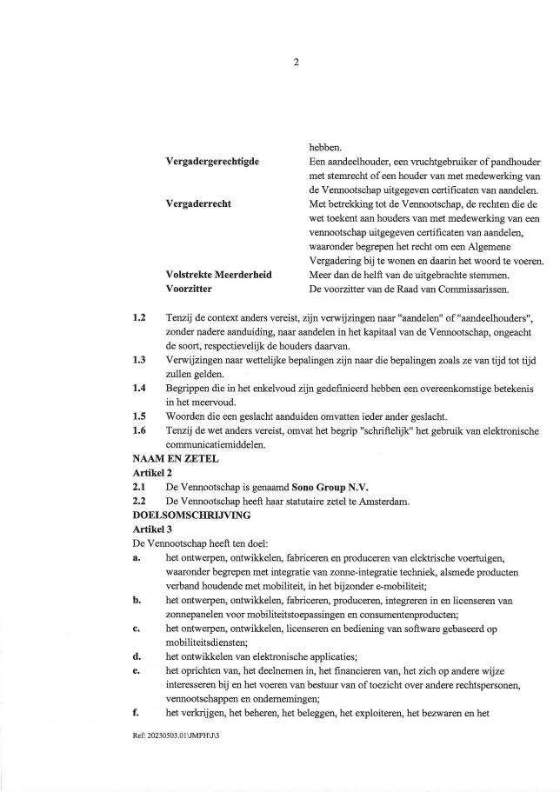

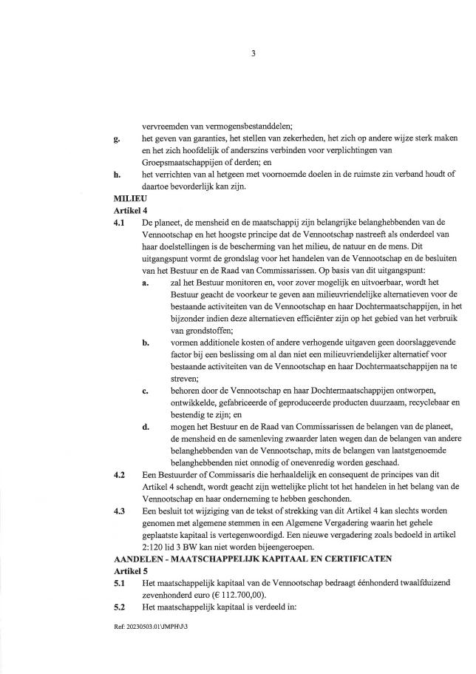

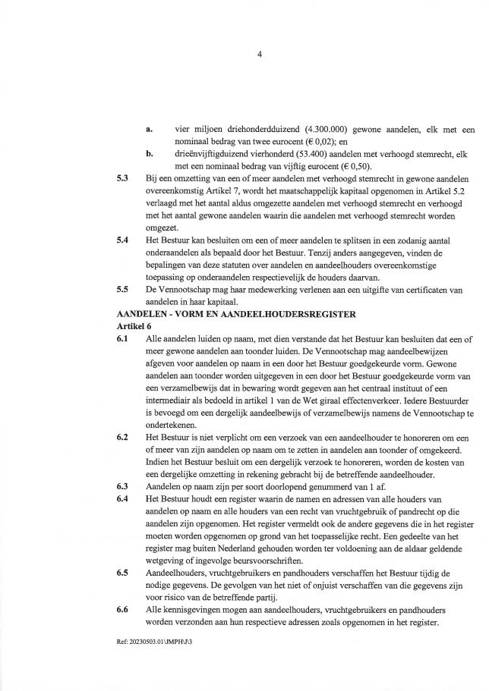

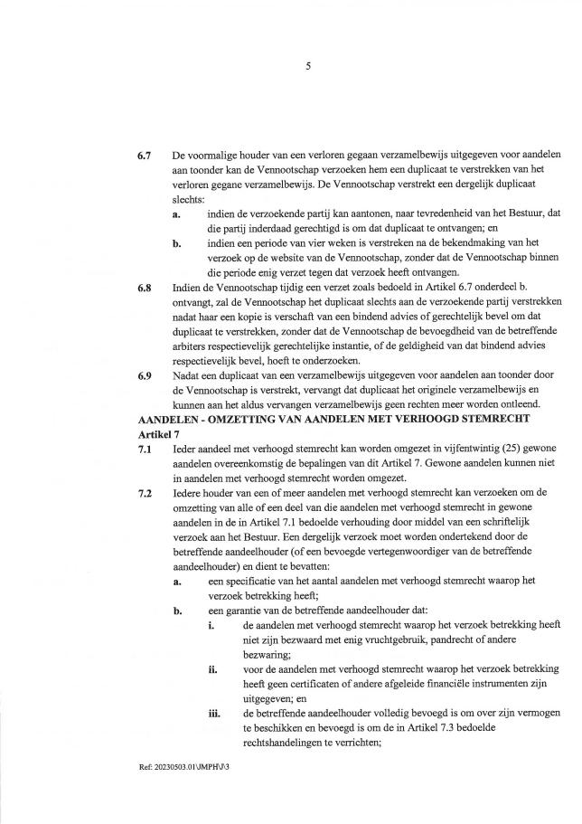

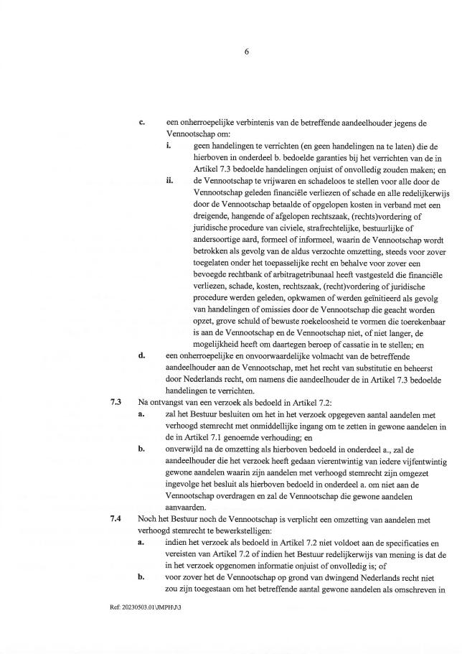

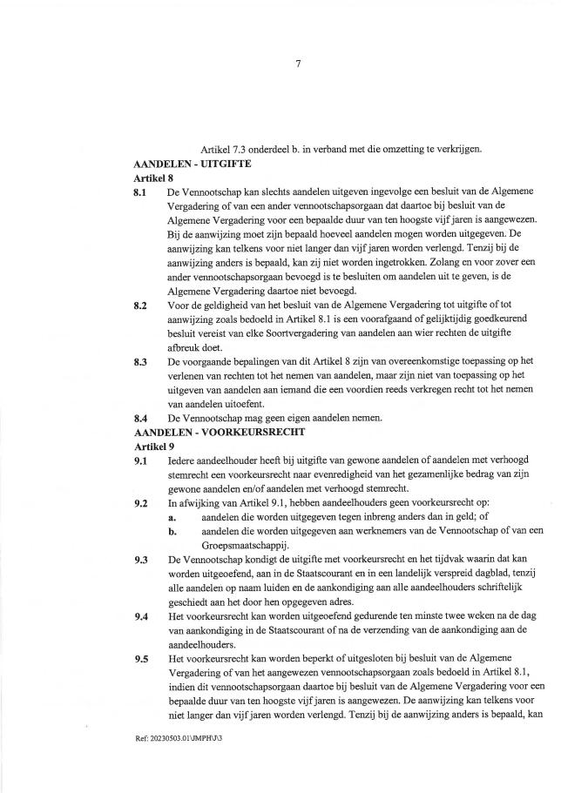

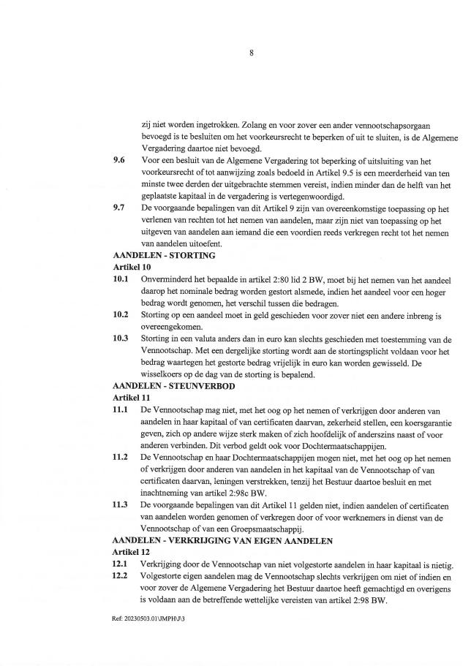

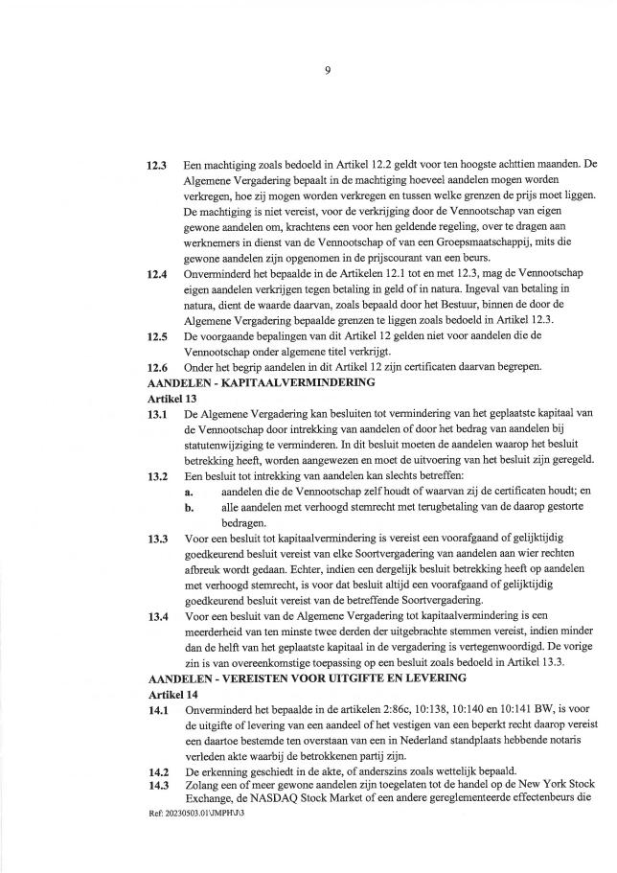

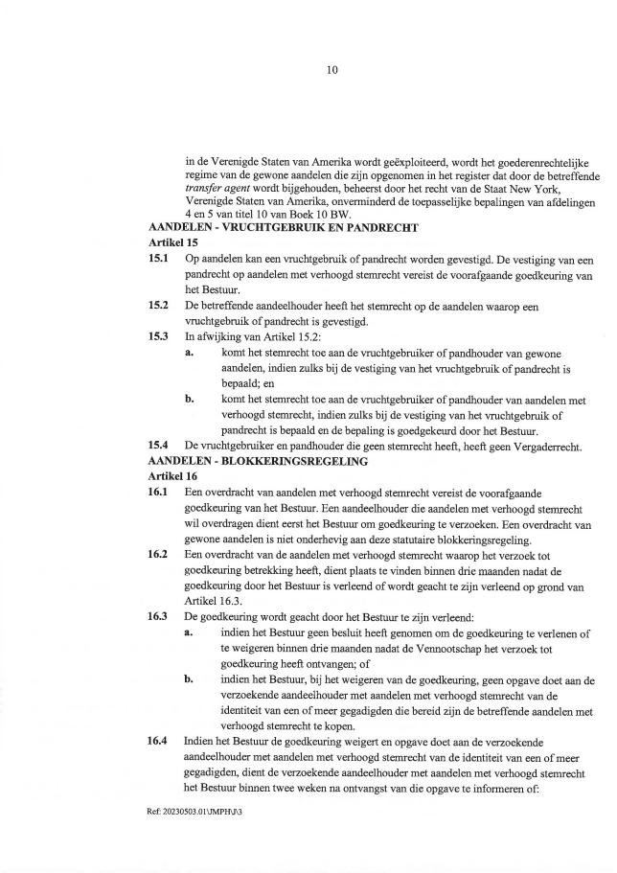

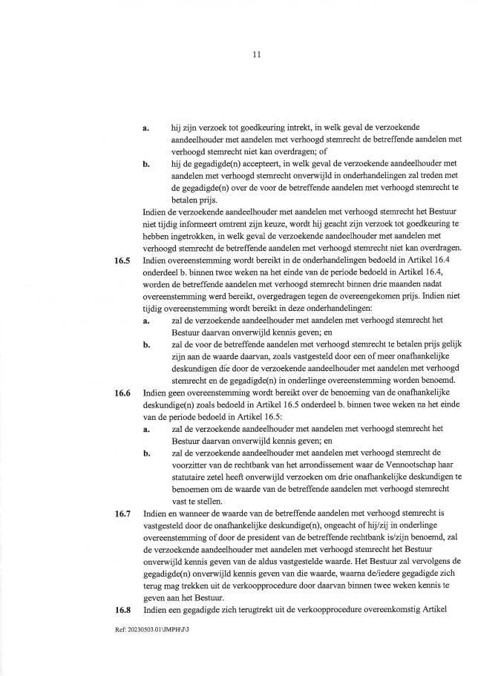

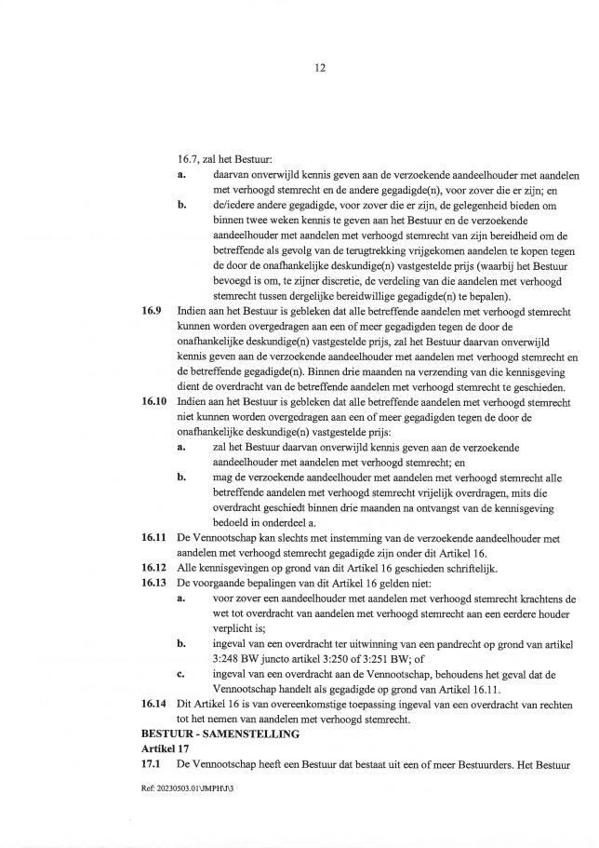

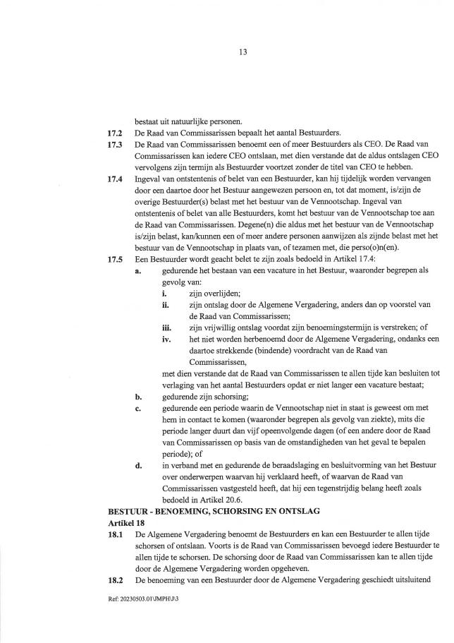

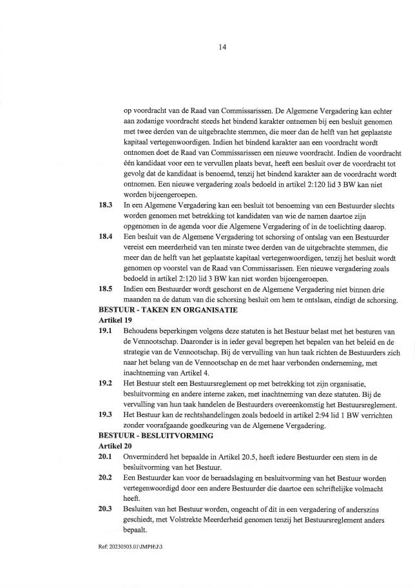

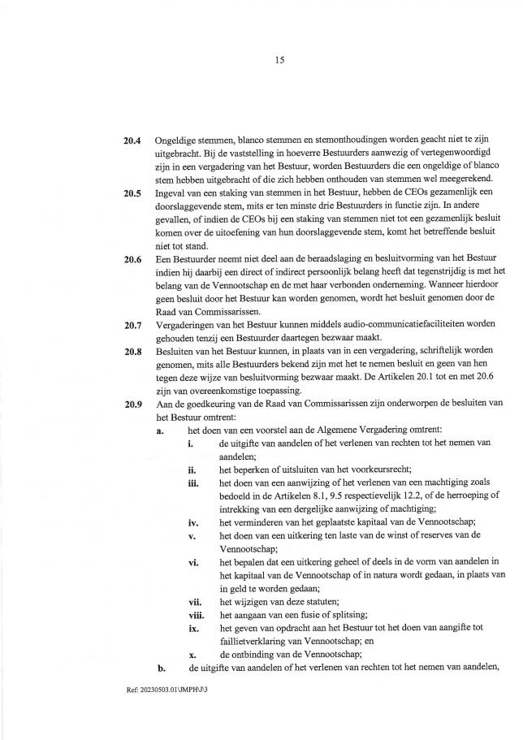

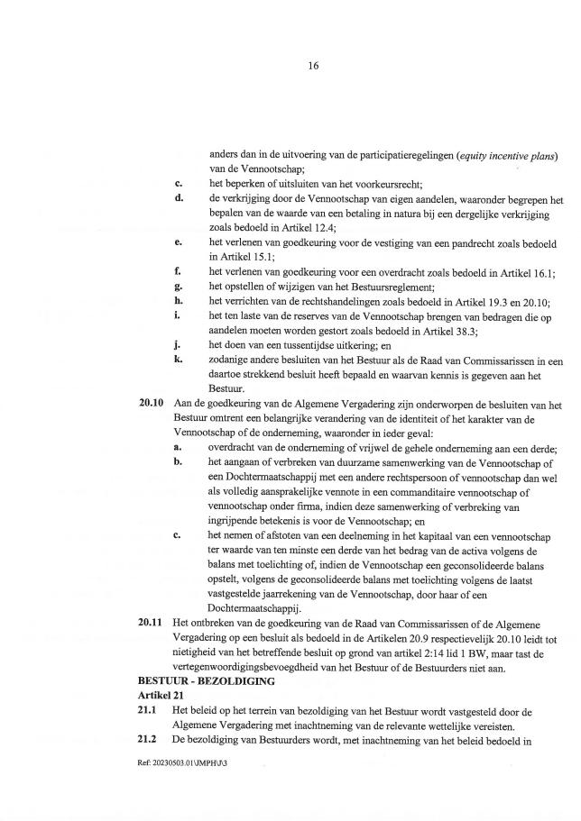

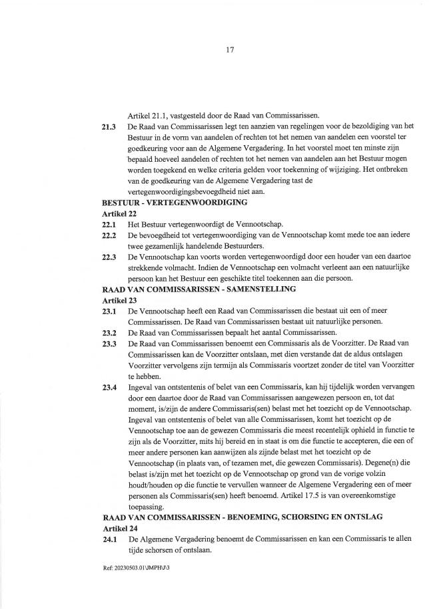

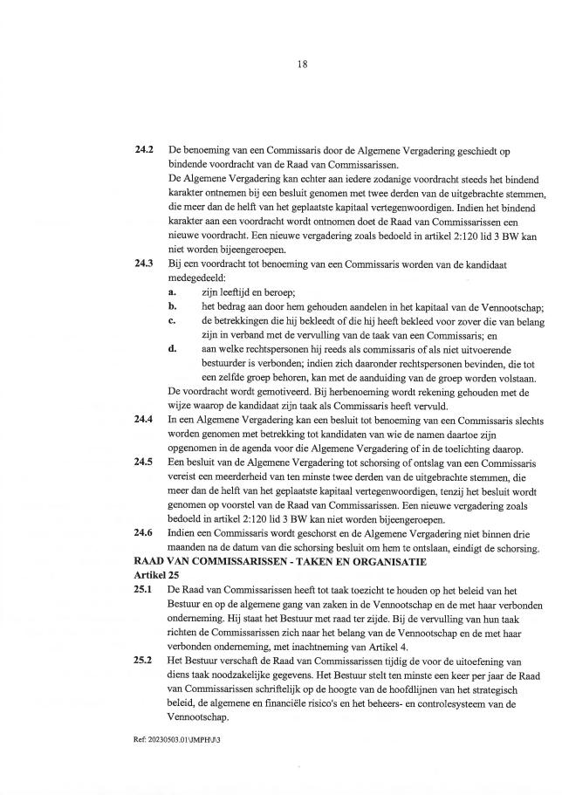

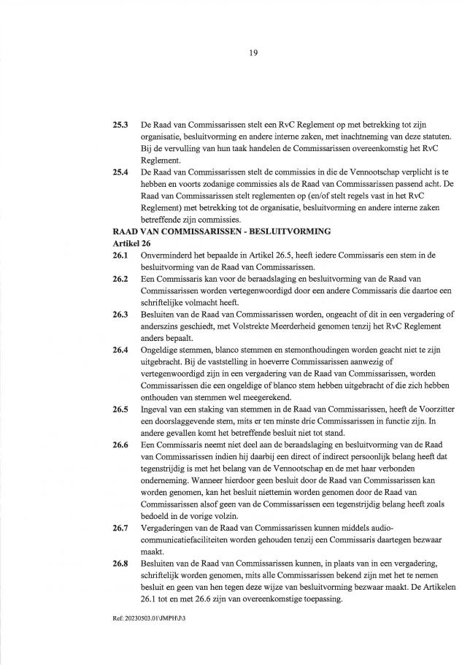

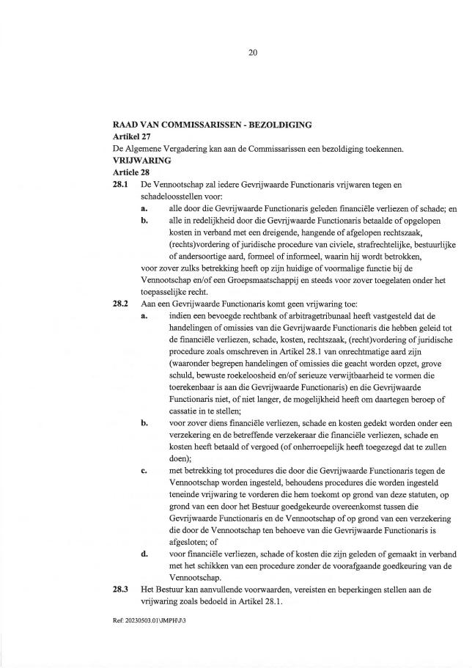

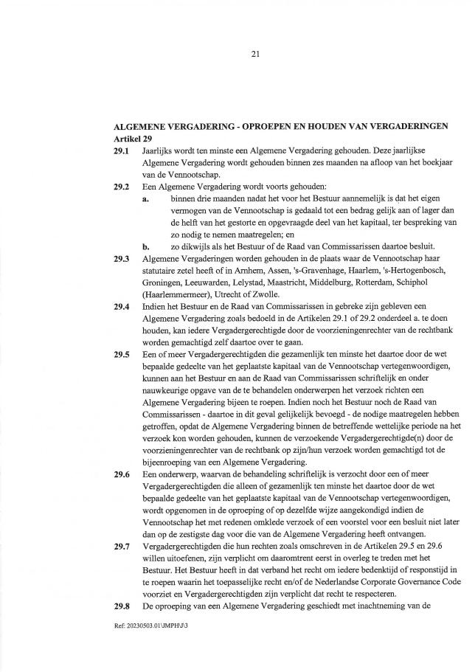

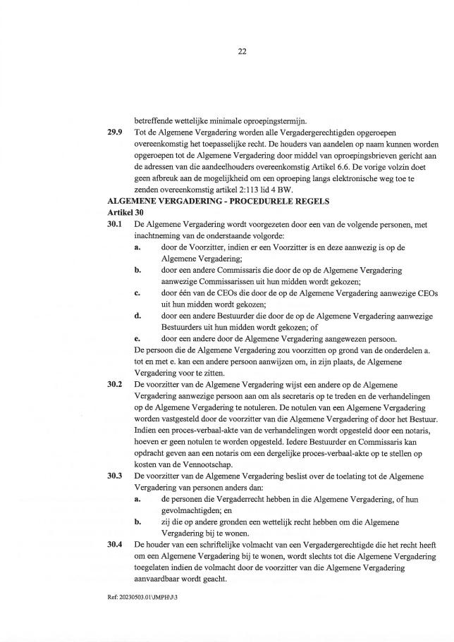

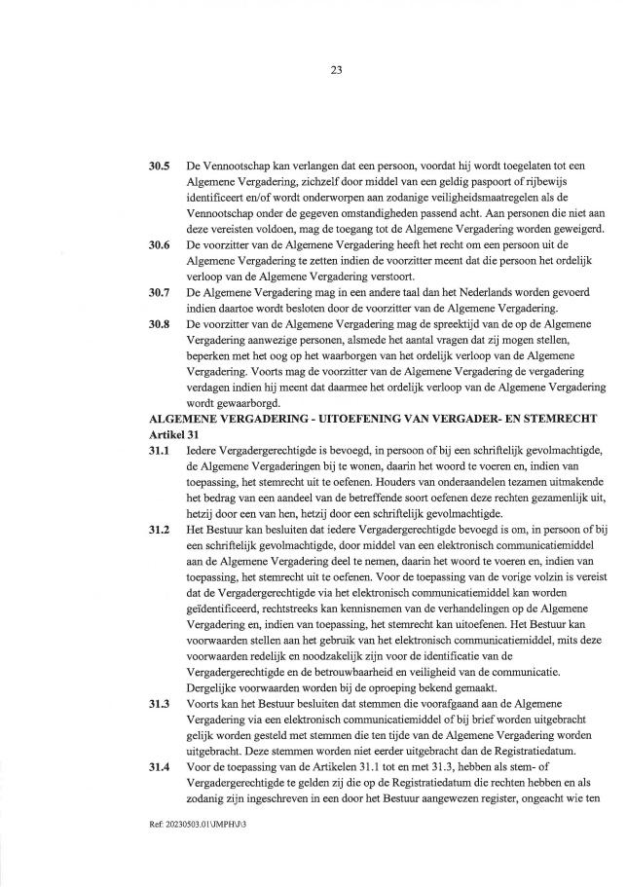

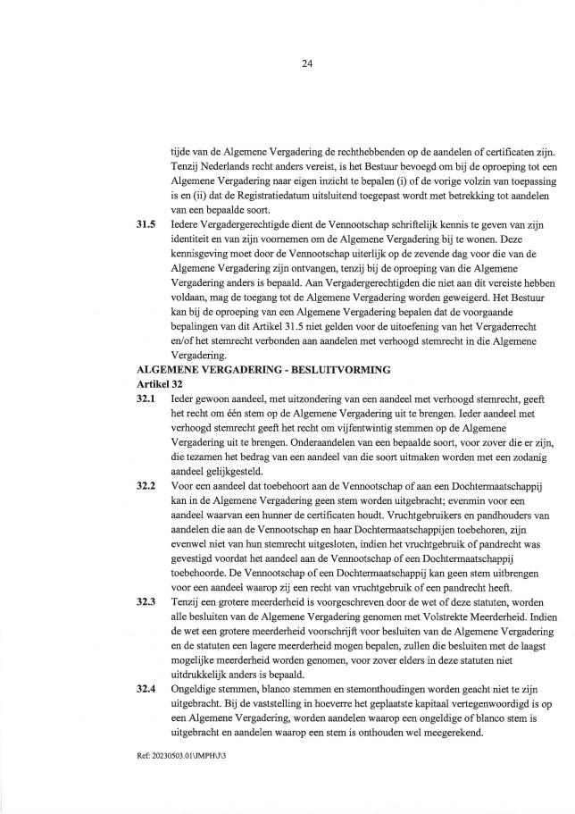

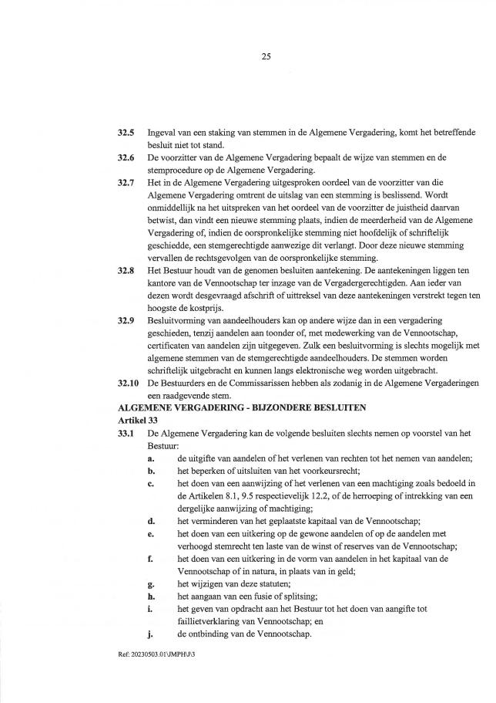

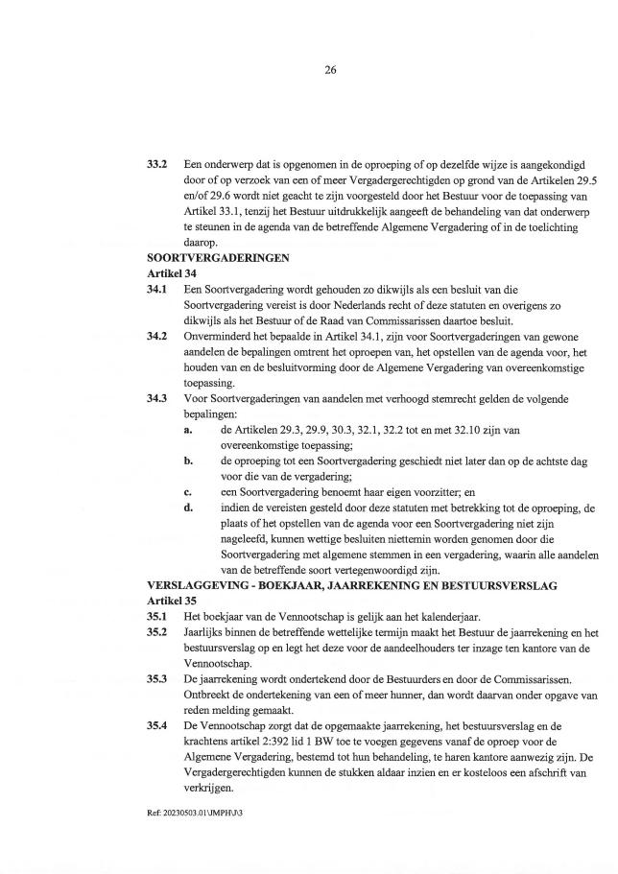

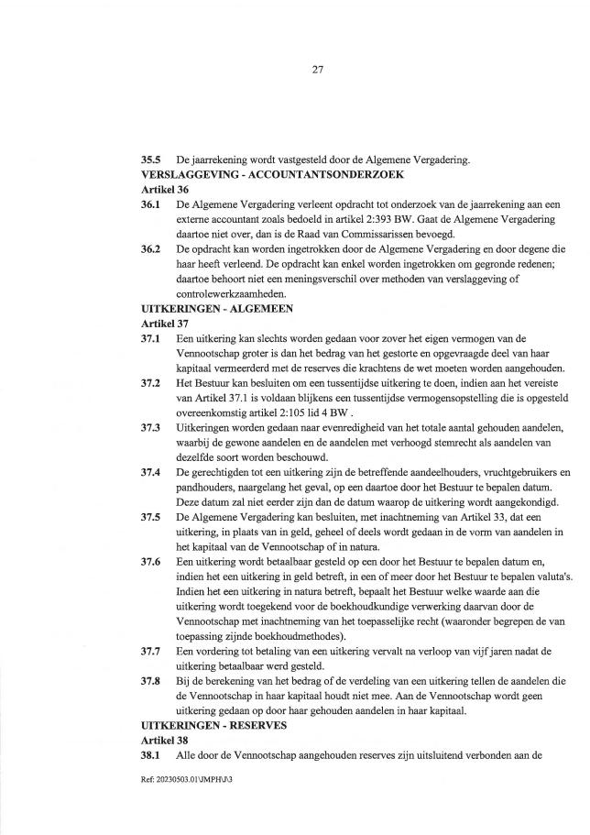

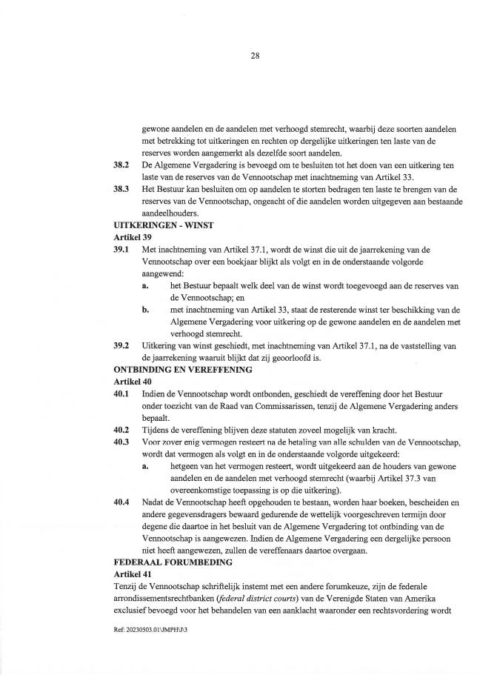

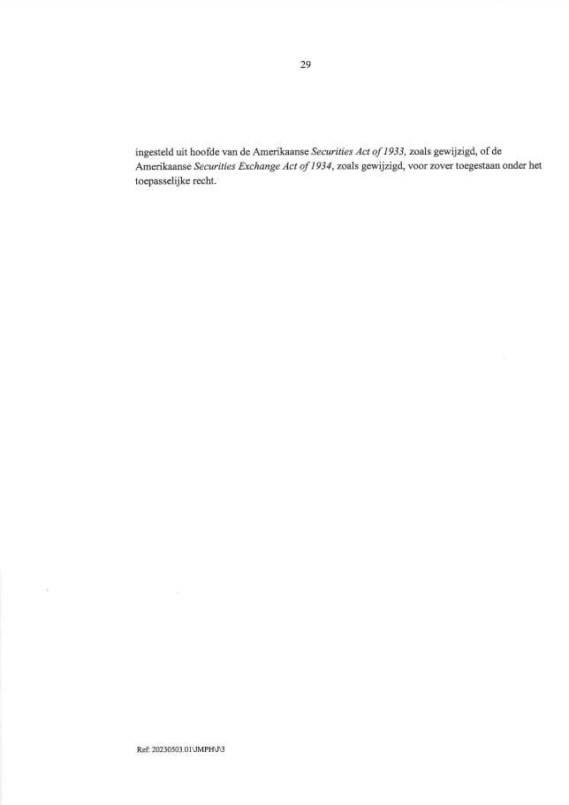



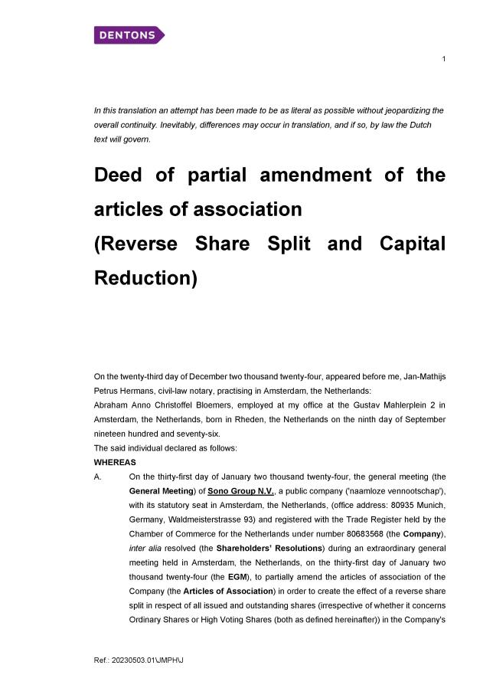

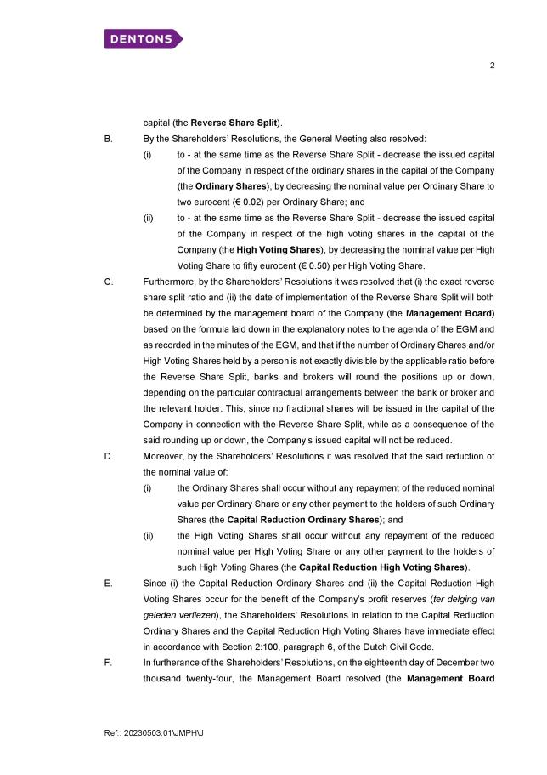

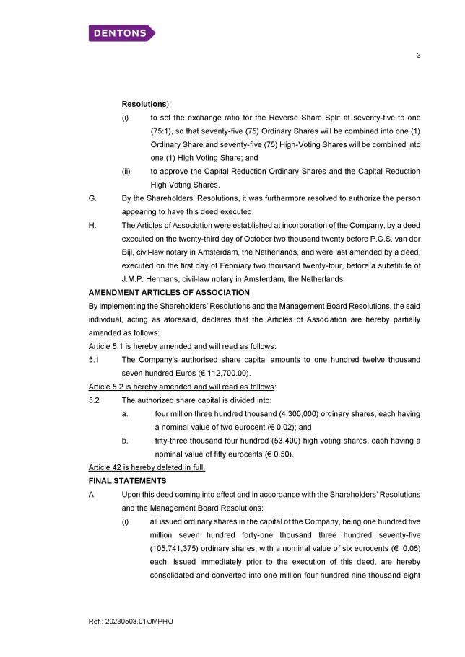

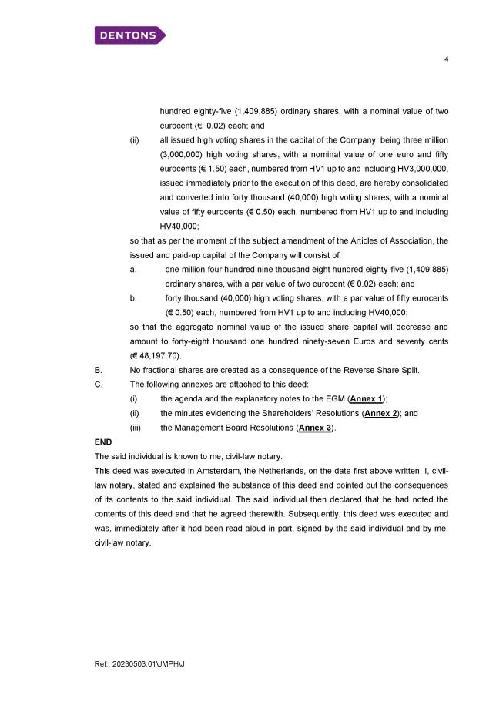

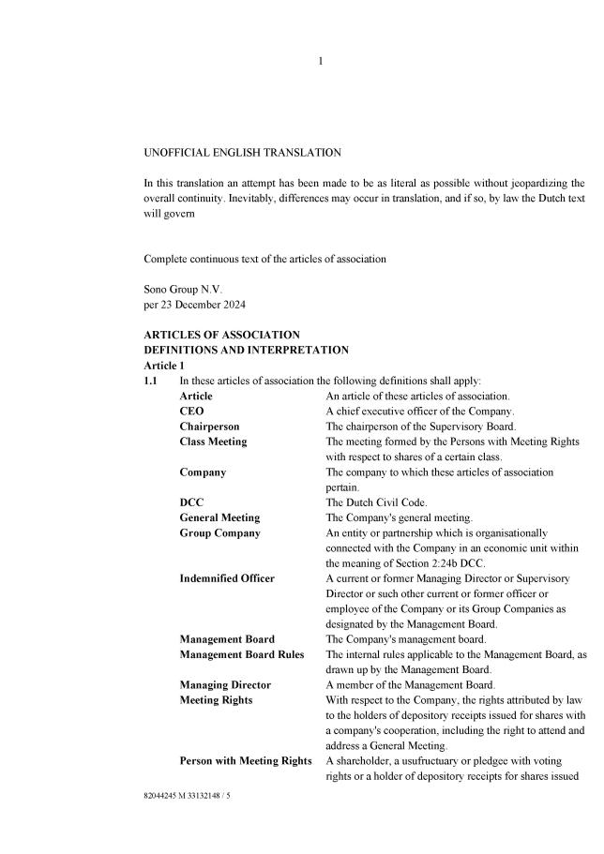

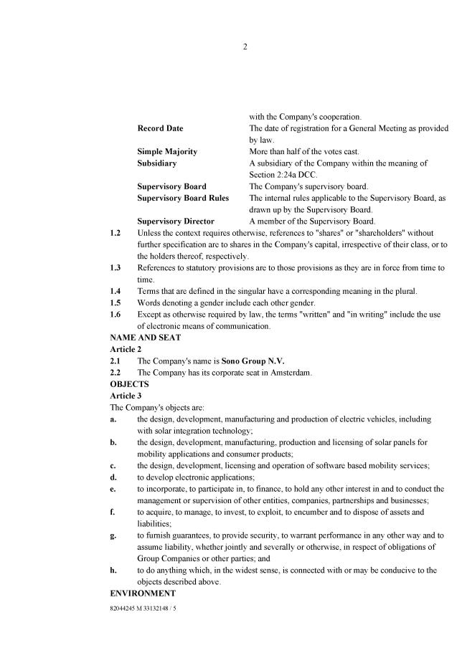

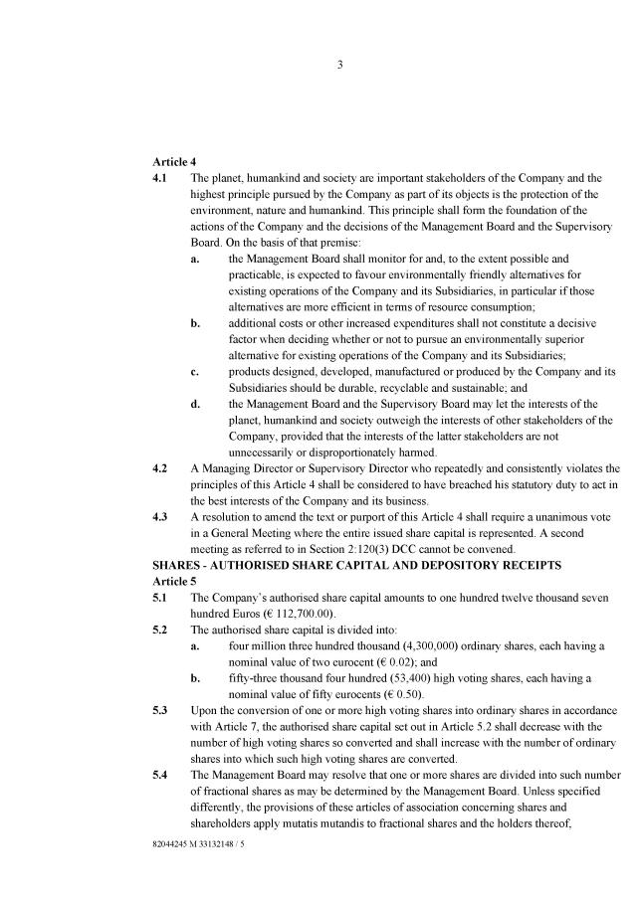

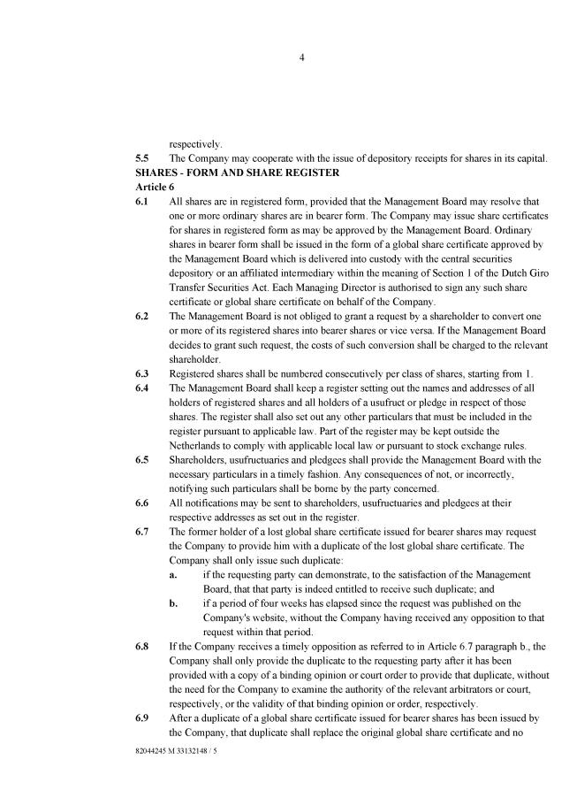

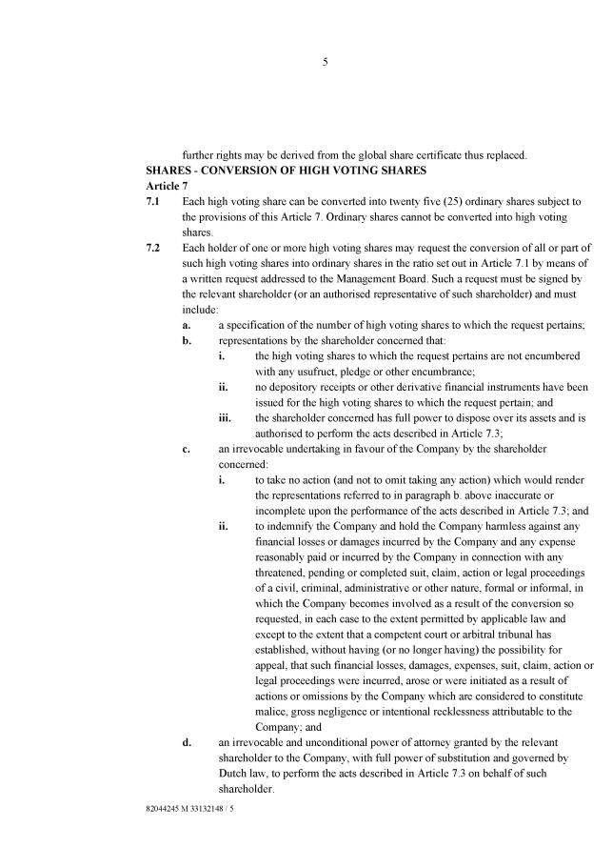

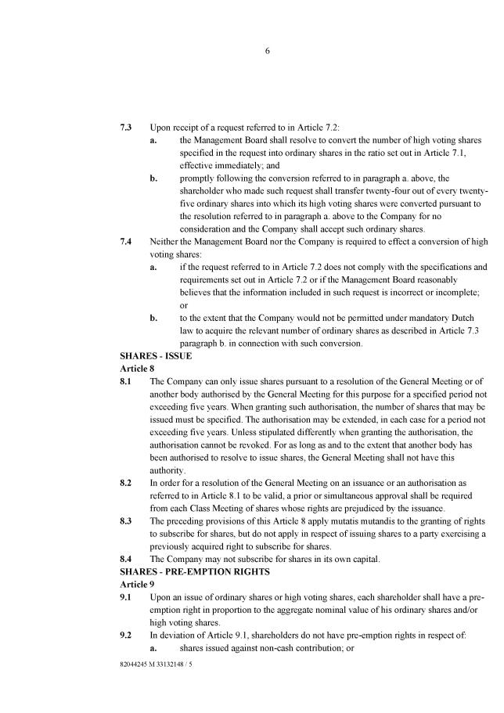

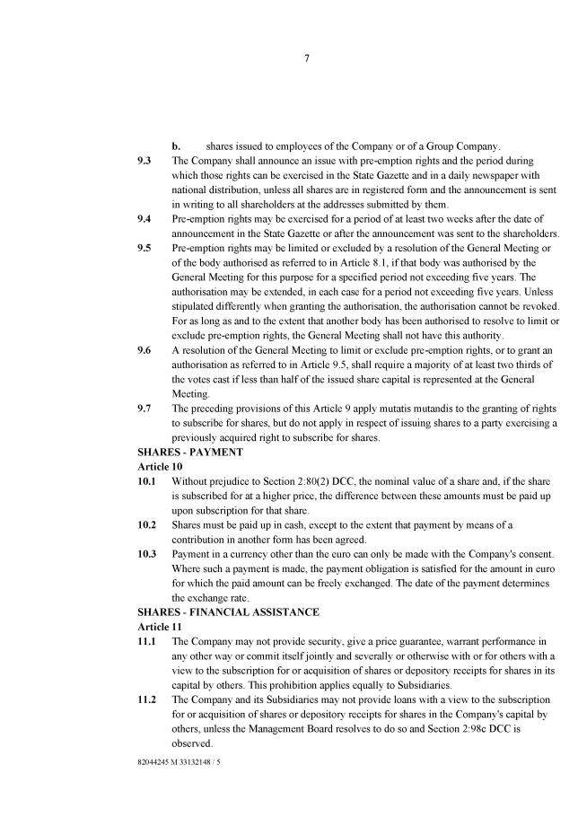

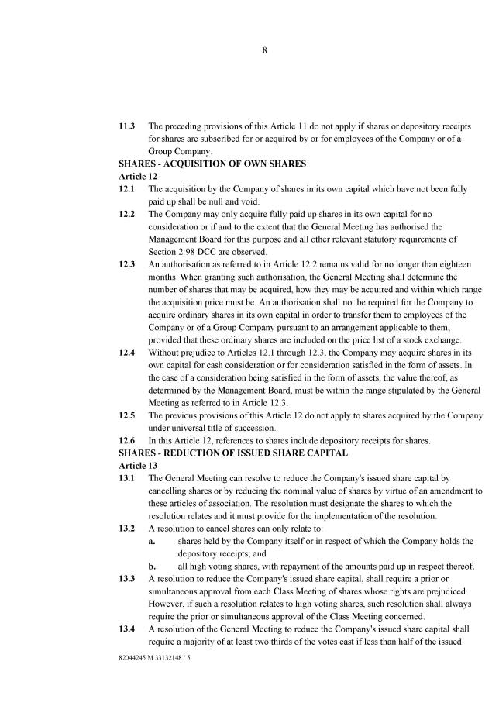

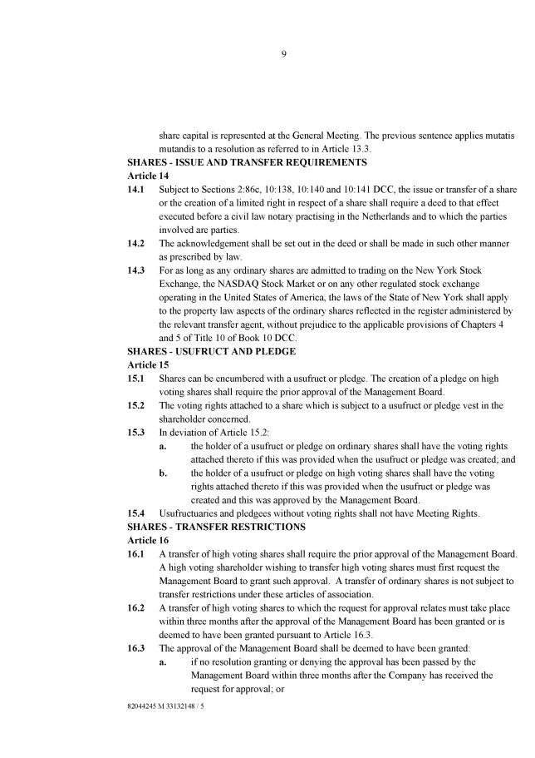

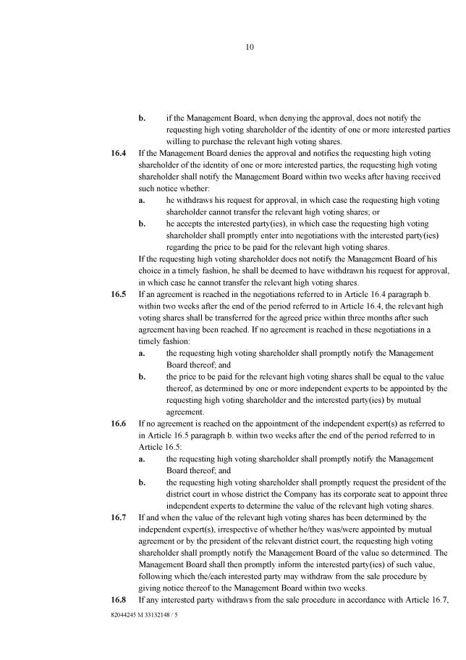

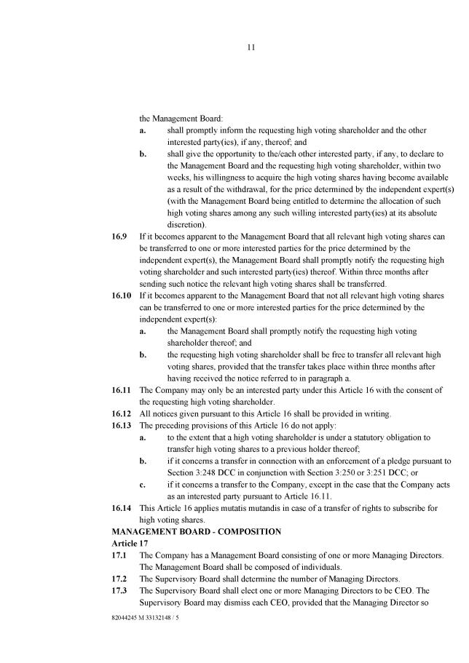

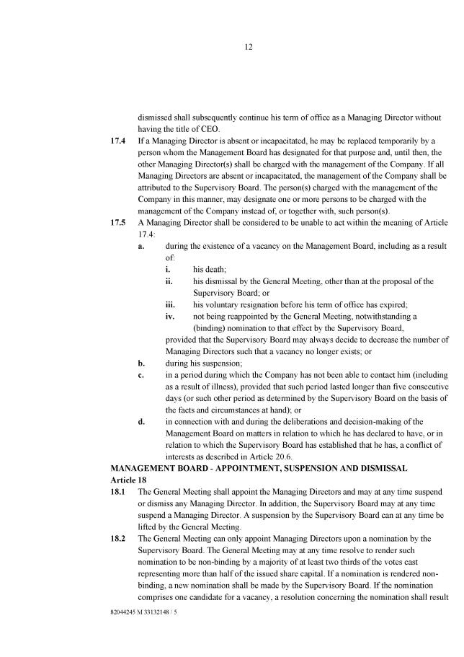

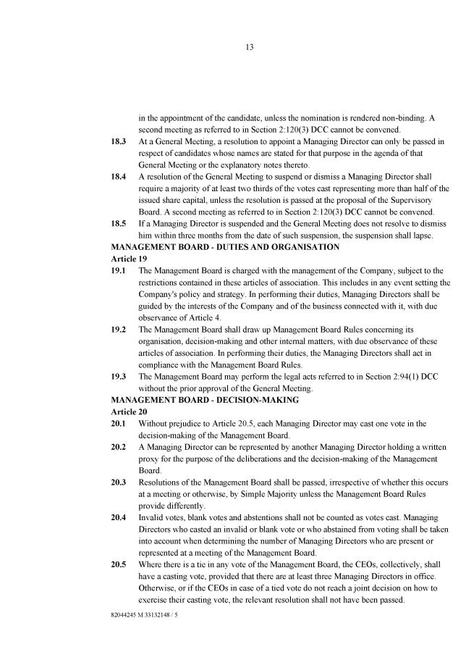

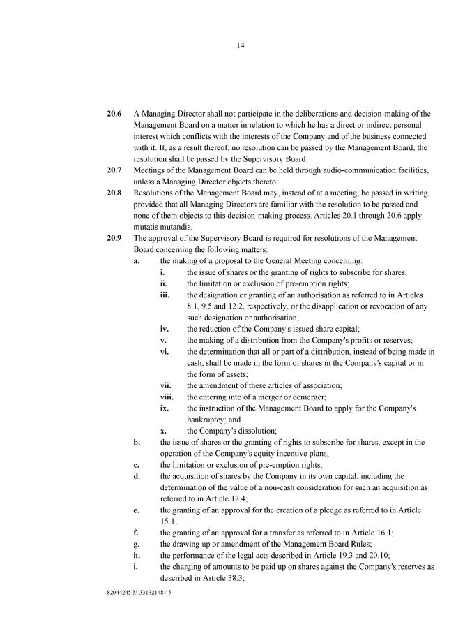

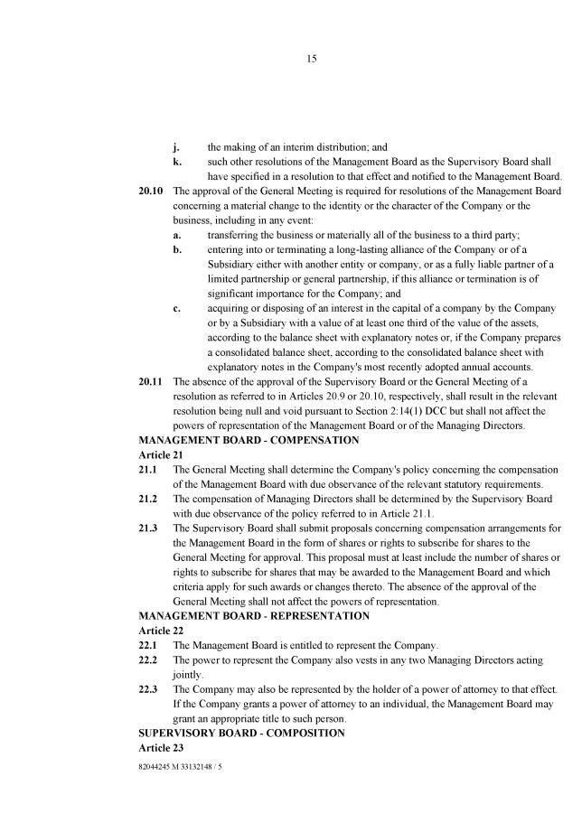

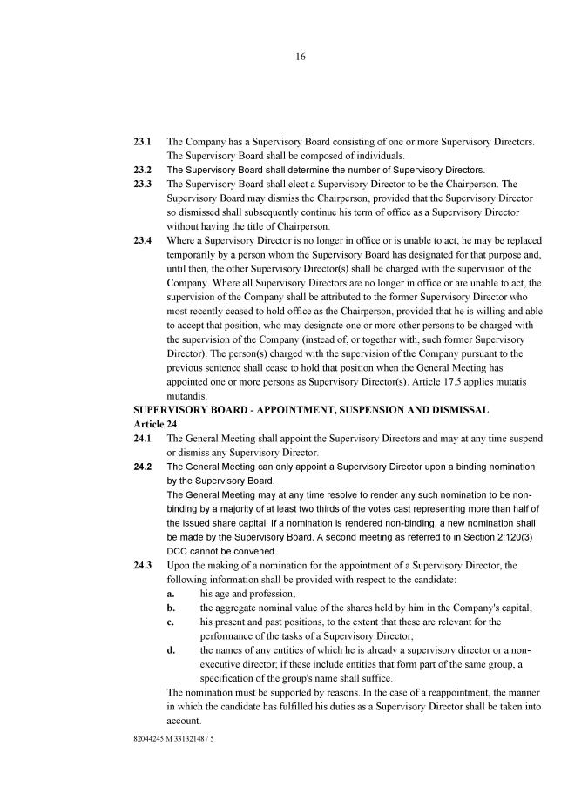

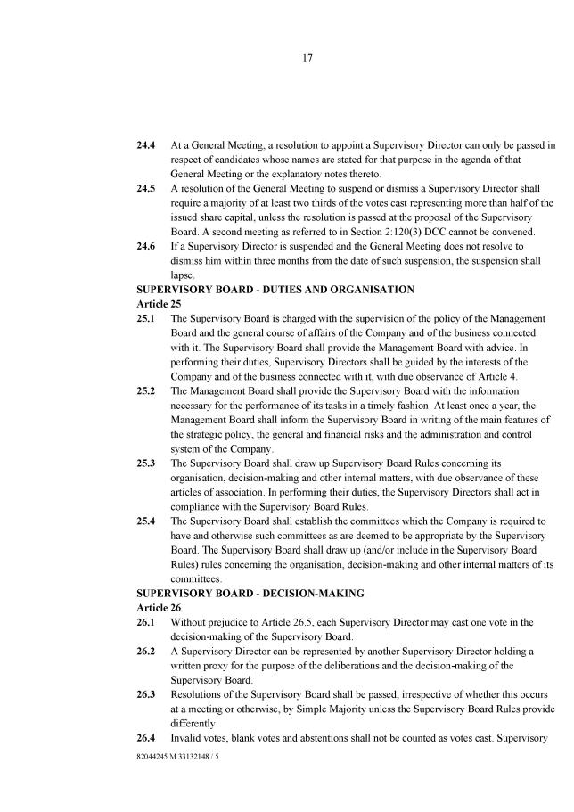

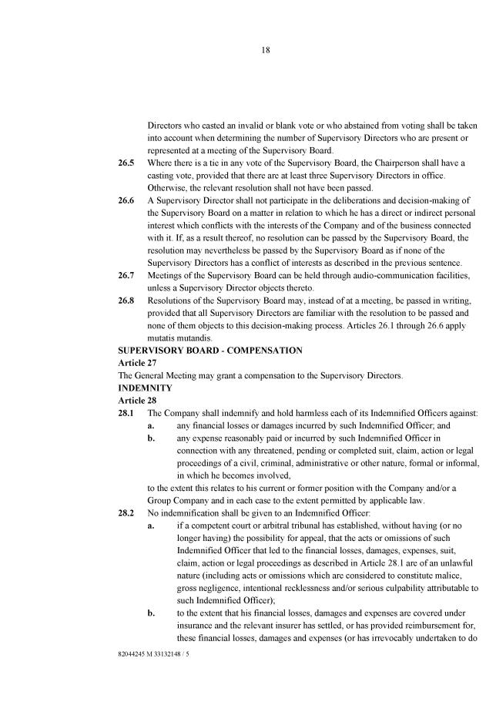

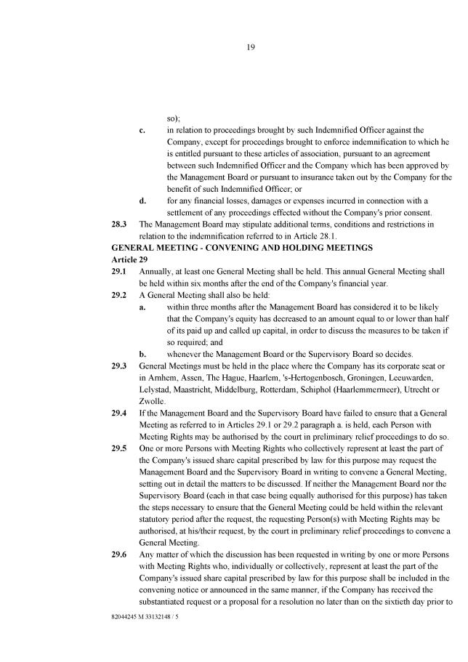

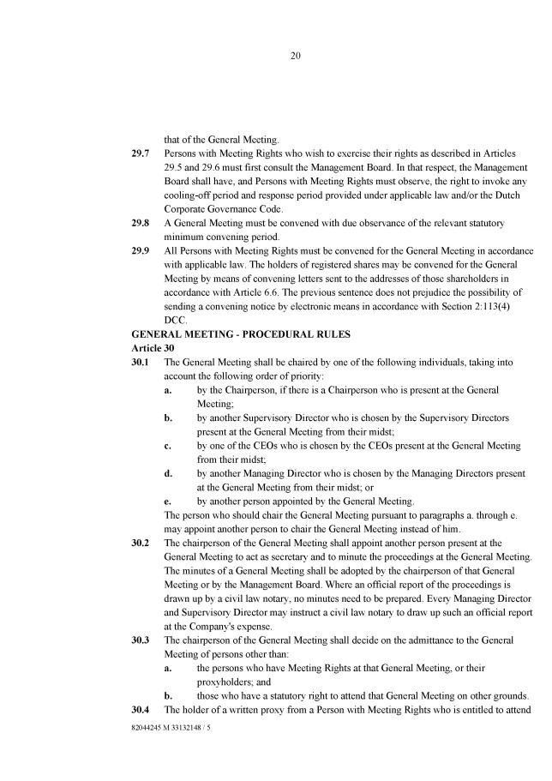

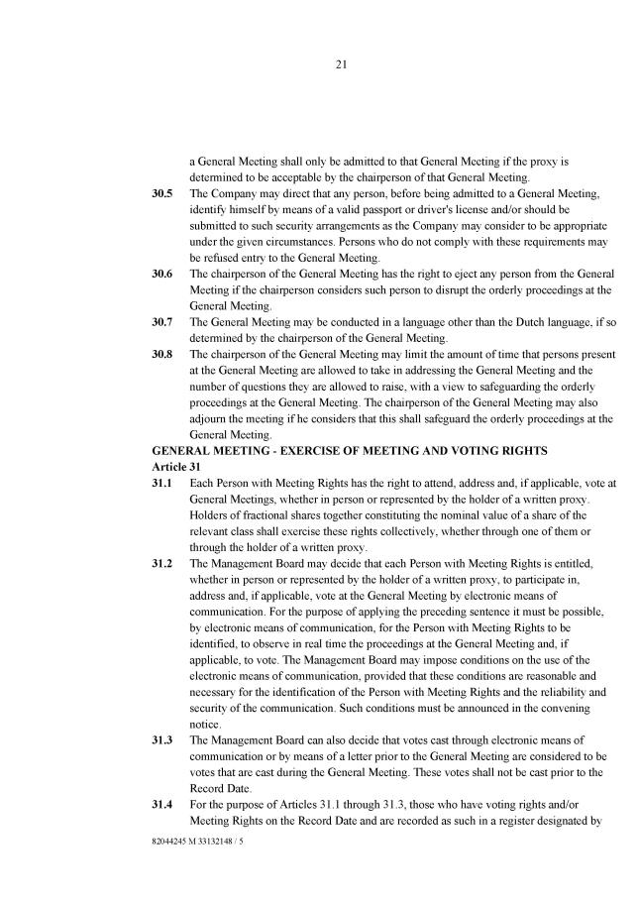

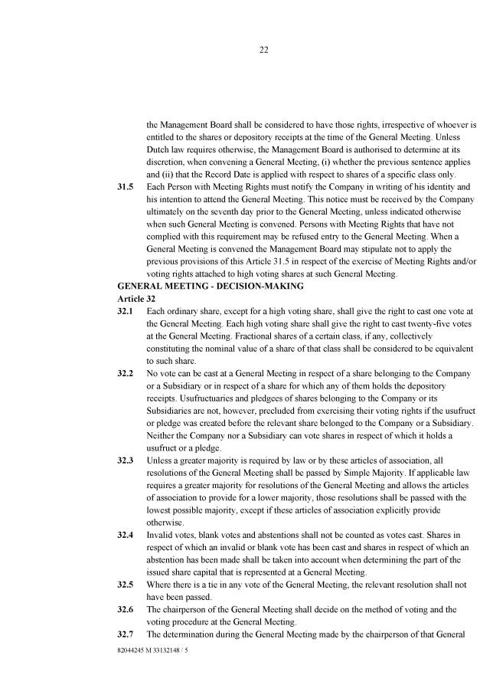

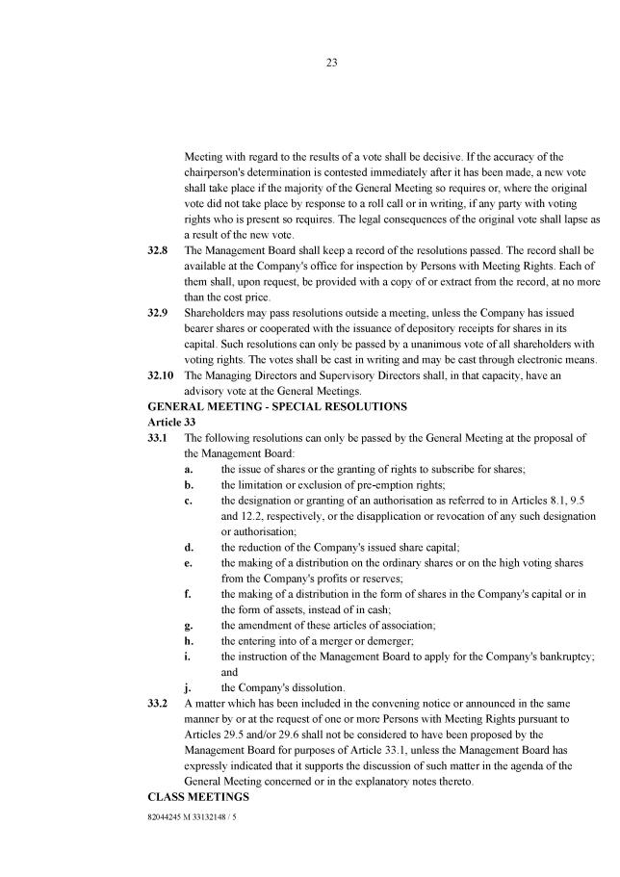

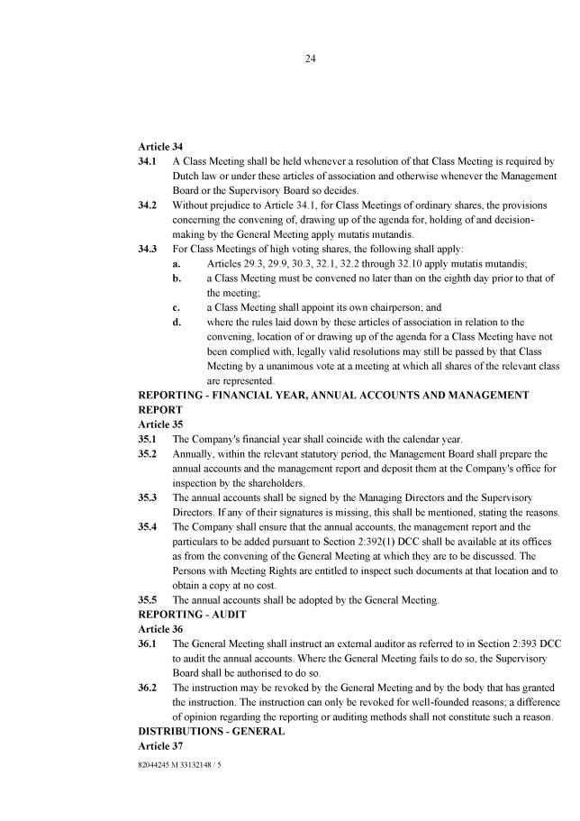

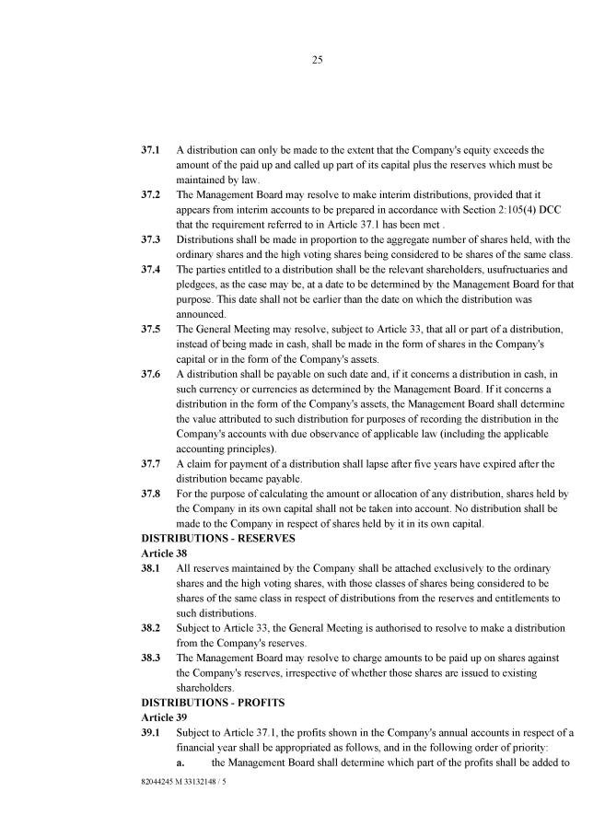

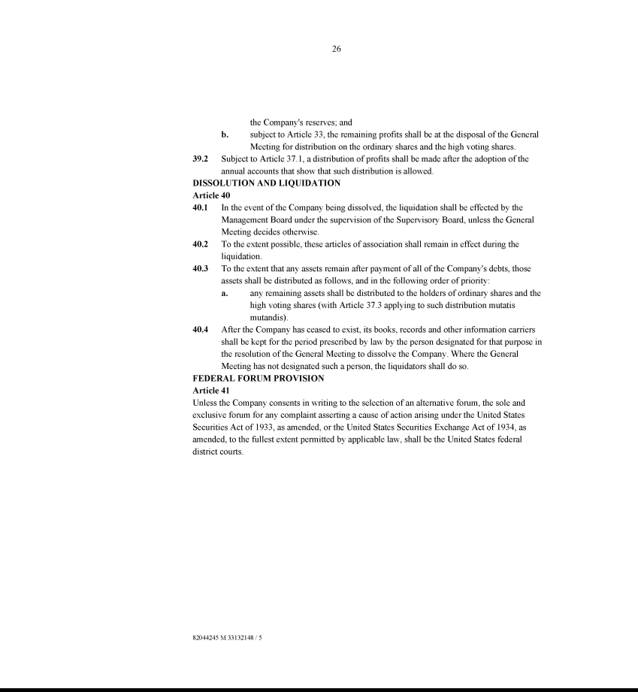

Exhibit 10.1

SECURITIES PURCHASE AGREEMENT

THIS SECURITIES PURCHASE AGREEMENT (this “Agreement”), dated as of December 30, 2024, is between SONO GROUP N.V., a Dutch public limited liability company (the “Company”), and YA II PN, LTD. (the “Buyer”).

WITNESSETH

WHEREAS, the Company and the Buyer desire to enter into this transaction for the Company to sell and the Buyer to purchase the Convertible Debenture (as defined below) pursuant to an exemption from registration pursuant to Section 4(a)(2) and/or Rule 506 of Regulation D (“Regulation D”) as promulgated by the U.S. Securities and Exchange Commission (the “SEC”) under the Securities Act of 1933, as amended (the “Securities Act”);

WHEREAS, the parties desire that, upon the terms and subject to the conditions contained herein, the Company shall issue and sell to the Buyer, as provided herein, and the Buyer shall purchase a convertible debenture in the form attached hereto as “Exhibit A” (the “Convertible Debenture”) in the aggregate principal amount of $5,000,000, which shall be convertible into ordinary shares of the Company, nominal value of €0.06 per share (the “Ordinary Shares”) (as converted, the “Conversion Shares”). The Convertible Debenture shall be purchased at the closing as set forth below (the “Closing”), at a purchase price equal to 100% of the principal amount of the Convertible Debenture (the “Purchase Price”);

WHEREAS, immediately following the execution and delivery of this Agreement, the parties hereto will be executing and delivering an Exchange Agreement (the “Exchange Agreement”) pursuant to which the Convertible Debenture, along with the other convertible debentures held by the Buyer, will be exchanged for preferred stock of the Company (the “Preferred Shares”) which are convertible into Ordinary Shares; and

WHEREAS, the Convertible Debenture and the Conversion Shares are collectively referred to herein as the “Securities.”

AGREEMENT

NOW, THEREFORE, in consideration of the premises and the mutual covenants contained herein and for other good and valuable consideration, the receipt and sufficiency of which are hereby acknowledged, the Company and the Buyer hereby agree as follows:

- PURCHASE AND SALE OF CONVERTIBLE DEBENTURE.

(a) Purchase of Convertible Debenture. Subject to the satisfaction (or waiver) of the conditions set forth in Sections 6 and 7 below, the Company shall issue and sell to the Buyer, and the Buyer agrees to purchase from the Company at the Closing the Convertible Debenture with a principal amount corresponding to the Purchase Price.

- Closing Date. The Closing shall occur on the first Business Day on which the conditions to the Closing set forth in Sections 6 and 7 below are satisfied or waived (or such other date as is mutually agreed to by the Company and the Buyer) (the “Closing Date”). As used herein “Business Day” means any day other than a Saturday, Sunday or other day on which commercial banks in New York, New York are authorized or required by law to remain closed.

(c) Form of Payment; Deliveries. Subject to the satisfaction of the terms and conditions of this Agreement, on the Closing Date, (i) the Buyer shall deliver to the Company the Purchase Price for the Convertible Debenture to be issued and sold to Buyer at the Closing and (ii) the Company shall deliver to the Buyer the Convertible Debenture, duly executed on behalf of the Company, with an aggregate principal amount corresponding to the Purchase Price.

- Registration Rights. The Company confirms that the Conversion Shares shall be subject to any registration rights the Buyer may have with the Company, including those provided by the Registration Rights Agreement, dated December 7, 2022, by and between the Company and the Buyer (the “Registration Rights Agreement”); provided that the Company and Buyer shall work together in good faith to give effect to those rights as necessary given the Company is not currently listed on a national securities exchange.

- BUYER’S REPRESENTATIONS AND WARRANTIES.

The Buyer hereby represents and warrants to the Company that, as of the date hereof and as of the Closing Date:

  - Investment Purpose. The Buyer is acquiring the Securities for its own account for investment purposes and not with a view towards, or for resale in connection with, the public sale or distribution thereof, except pursuant to sales registered under or exempt from the registration requirements of the Securities Act; provided, however, that by making the representations herein, the Buyer does not agree, or make any representation or warranty, to hold any of the Securities for any minimum or other specific term and reserves the right to dispose of the Securities at any time in accordance with, or pursuant to, a registration statement covering such Securities or an available exemption under the Securities Act. The Buyer does not presently have any agreement or understanding, directly or indirectly, with any Person to distribute any of the Securities. “Person” means an individual, corporation, limited liability company, association, partnership, limited partnership, syndicate, person (including, without limitation, a “person” as defined in Section 13(d)(3) of the Exchange Act), trust, association, or other entity and any Governmental Entity (as defined below).

  - Accredited Investor Status. The Buyer is an institutional “Accredited Investor” as that term is defined in Rule 501(a)(3) of Regulation

D.

  - Reliance on Exemptions. The Buyer understands that the Securities are being offered and sold to it in reliance on specific exemptions from the registration requirements of United States federal and state securities laws and that the Company is relying in part upon the truth and accuracy of, and the Buyer’s compliance with, the representations, warranties, agreements, acknowledgments and understandings of the Buyer set forth herein in order to determine the availability of such exemptions and the eligibility of the Buyer to acquire the Securities pursuant to applicable United States securities laws.

  - Information. The Buyer and its advisors (and its counsel), if any, have been furnished with all materials relating to the business, finances and operations of the Company and information the Buyer deemed material to making an informed investment decision regarding its purchase of the Securities, which have been requested by the Buyer. The Buyer and its advisors, if any, have been afforded the opportunity to ask questions of the Company and its management. Neither such inquiries nor any other due diligence investigations conducted by the Buyer or its advisors, if any, or its representatives shall modify, amend or affect the Buyer’s right to rely on the Company’s representations and warranties contained in Section 3 below. The Buyer understands that its investment in the Securities involves a high degree of risk. The Buyer has sought such accounting, legal and tax advice, as it has considered necessary to make an informed investment decision with respect to its acquisition of the Securities.

  - Transfer or Resale. The Buyer understands that: (i) the Securities have not been registered under the Securities Act or any state securities laws, and may not be offered for sale, sold, assigned or transferred unless (A) subsequently registered thereunder, (B) the Buyer shall have delivered to the Company an opinion of counsel, in a generally acceptable form, to the effect that such Securities to be sold, assigned or transferred may be sold, assigned or transferred pursuant to an exemption from such registration requirements, or (C) the Buyer provides the Company with reasonable assurances (in the form of seller and broker representation letters) and a legal opinion under Section 2(e)(i)(B) that such Securities can be sold, assigned or transferred pursuant to Rule

- promulgated under the Securities Act, as amended (or a successor rule thereto) (collectively, “Rule 144”), in each case following the applicable holding period set forth therein; and (ii) any sale of the Securities made in reliance on Rule 144 may be made only in accordance with the terms of Rule 144 and further, if Rule 144 is not applicable, any resale of the Securities under circumstances in which the seller (or the person through whom the sale is made) may be deemed to be an underwriter (as that term is defined in the Securities Act) may require compliance with some other exemption under the Securities Act or the rules and regulations of the SEC thereunder.

(f) Legends. The Buyer agrees to the imprinting, so long as it is required by this Section 2(f), of a restrictive legend on the Securities in

substantially the following form:

THE SECURITIES FOR WHICH THIS CERTIFICATE HAS BEEN ISSUED AND THOSE SECURITIES INTO WHICH THEY ARE

CONVERTIBLE HAVE NOT BEEN REGISTERED UNDER THE SECURITIES ACT OF 1933, AS AMENDED, OR APPLICABLE STATE

SECURITIES LAWS. THE SECURITIES AND THOSE SECURITIES INTO WHICH THEY ARE CONVERTIBLE HAVE BEEN ACQUIRED

SOLELY FOR INVESTMENT PURPOSES AND NOT WITH A VIEW TOWARD RESALE AND MAY NOT BE OFFERED FOR SALE, SOLD,

TRANSFERRED OR ASSIGNED IN THE ABSENCE OF AN EFFECTIVE REGISTRATION STATEMENT FOR THE SECURITIES UNDER

THE SECURITIES ACT OF 1933, AS AMENDED, OR APPLICABLE STATE SECURITIES LAWS, OR AN OPINION OF COUNSEL, IN A

GENERALLY ACCEPTABLE FORM, THAT REGISTRATION IS NOT REQUIRED UNDER SAID ACT OR APPLICABLE STATE

SECURITIES LAWS

Certificates for the Conversion Shares shall not contain any legend (including the legend set forth above), (i) while a registration statement covering the resale of such Conversion Shares is effective under the Securities Act, (ii) following any sale of such Conversion Shares pursuant to Rule 144, (iii) if such Conversion Shares are eligible for sale under Rule 144, or (iv) if such legend is not required under applicable requirements of the Securities Act (including judicial interpretations and pronouncements issued by the staff of the SEC). The Buyer agrees that the removal of the restrictive legend from certificates for Securities as set forth in this Section 2(f) is predicated upon the Company’s reliance that the Buyer will sell any Securities pursuant to either the registration requirements of the Securities Act, including any applicable prospectus delivery requirements, or an exemption therefrom, and that if Securities are sold pursuant to a registration statement, they will be sold in compliance with the plan of distribution set forth therein.

- Organization; Authority. The Buyer is an entity duly organized, validly existing and in good standing under the laws of the jurisdiction of its organization with the requisite power and authority to enter into and to consummate the transactions contemplated by the Transaction Documents (as defined below) to which it is a party and otherwise to carry out its obligations hereunder and thereunder.

- Authorization, Enforcement. This Agreement has been duly and validly authorized, executed and delivered on behalf of the Buyer and shall constitute the legal, valid and binding obligations of the Buyer enforceable against the Buyer in accordance with its terms, except as such enforceability may be limited by general principles of equity or to applicable bankruptcy, insolvency, reorganization, moratorium, liquidation and other similar laws relating to, or affecting generally, the enforcement of applicable creditors' rights and remedies.

(i) No Conflicts. The execution, delivery and performance by the Buyer of this Agreement and the consummation by the Buyer of the transactions contemplated hereby will not (i) result in a violation of the organizational documents of the Buyer, (ii) conflict with, or constitute a default (or an event which with notice or lapse of time or both would become a default) under, or give to others any rights of termination, amendment, acceleration or cancellation of, any agreement, indenture or instrument to which the Buyer is a party or (iii) result in a violation of any law, rule, regulation, order, judgment or decree (including federal and state securities laws) applicable to the Buyer, except, in the case of clauses (ii) and (iii) above, for such conflicts, defaults, rights or violations which could not, individually or in the aggregate, reasonably be expected to have a material adverse effect on the ability of the Buyer to perform its obligations hereunder.

(j) Certain Trading Activities. The Buyer has not directly or indirectly, nor has any Person acting on behalf of or pursuant to any understanding with the Buyer, engaged in any transactions in the securities of the Company (including, without limitation, any Short Sales (as defined below) involving the Company's securities) during the period commencing as of the time that the Buyer first contacted the Company or the Company's agents regarding the specific investment in the Company contemplated by this Agreement and ending immediately prior to the execution of this Agreement by the Buyer.

- REPRESENTATIONS AND WARRANTIES OF THE COMPANY.

The Company hereby makes the representations and warranties set forth below to the Buyer:

(a) Organization and Qualification. The Company and each of its Subsidiaries are entities duly formed, validly existing and, except as disclosed in the SEC Documents (as defined herein), in good standing (to the extent good standing is a known concept in the applicable jurisdiction) under the laws of the jurisdiction in which they are formed, and have the requisite power and authority to own their properties and to carry on their business as now being conducted and as presently proposed to be conducted. The Company and each of its Subsidiaries is duly qualified as a foreign entity to do business and is in good standing (to the extent good standing is a known concept in the applicable jurisdiction) in every jurisdiction in which its ownership of property or the nature of the business conducted by it makes such qualification necessary, except to the extent that the failure to be so qualified or be in good standing would not reasonably be expected to have a Material Adverse Effect (as defined below). As used in this Agreement, “Material Adverse Effect” means any material adverse effect on (i) the business, properties, assets, liabilities, operations (including results thereof) or condition (financial or otherwise) of the Company and its Subsidiaries, taken as a whole, (ii) the transactions contemplated hereby or in any of the other Transaction Documents or any other agreements or instruments to be entered into by the Company in connection herewith or therewith or (iii) the authority or ability of the Company to perform any of its obligations under any of the Transaction Documents (as defined below). “Subsidiaries” means any Person in which the Company, directly or indirectly, owns a majority of the outstanding capital stock having voting power or holds a majority of the equity or similar interest of such Person, and each of the foregoing, is individually referred to herein as a “Subsidiary.”

(b) Authorization; Enforcement; Validity. The Company has the requisite power and authority to enter into and perform its obligations under this Agreement and any other Transaction Documents and to issue the Securities in accordance with the terms hereof and thereof. The execution and delivery of this Agreement and any other Transaction Documents by the Company and the consummation by the Company of the transactions contemplated hereby and thereby (including, without limitation, the issuance of the Convertible Debenture and the reservation for issuance and issuance of the Conversion Shares issuable upon conversion of the Convertible Debenture), have been duly authorized by the Company's management board and supervisory board and no further filing, consent or authorization is required by the Company, its management board or its supervisory board or its general meeting of shareholders or any Governmental Entity (as defined below). This Agreement has been, and any other Transaction Documents to which the Company is a party will be prior to the Closing, duly executed and delivered by the Company, and each constitutes the legal, valid and binding obligations of the Company, enforceable against the Company in accordance with its respective terms, except as such enforceability may be limited by general principles of equity or applicable bankruptcy, insolvency, reorganization, moratorium, liquidation or similar laws relating to, or affecting generally, the enforcement of applicable creditors' rights and remedies and except as rights to indemnification and to contribution may be limited by federal or state securities law. “Transaction Documents” means, collectively, this Agreement, the Registration Rights Agreement, the Convertible Debenture, and each of the other agreements and instruments entered into by the Company and the Buyer or delivered by the Company in connection with the transactions contemplated hereby and thereby, as may be amended from time to time.

- Issuance of Securities. The issuance of the Securities has been duly authorized and, upon issuance and payment in accordance with the terms of the Transaction Documents the Securities shall be validly issued, fully paid and non-assessable (meaning that the holders of the Securities will not by reason of merely being such a holder, be subject to assessment or calls by the Company or its creditors for further payment on such Securities) and free from all preemptive or similar rights, mortgages, defects, claims, liens, pledges, charges, taxes, rights of first refusal, encumbrances, security interests and other encumbrances (collectively “Liens”) with respect to the issuance thereof. As of the Closing Date, the number of Ordinary Shares comprised in the Company's authorized share capital but unissued and not otherwise reserved for issuance (including (i) in relation to equity or debt securities convertible into or exchangeable or exercisable for or that can be settled in Ordinary Shares (other than the Convertible Debenture) and (ii) Ordinary Shares remaining available for issuance under the Company's equity incentive plans) shall be not less than the maximum number of Ordinary Shares issuable upon conversion of the Convertible Debenture then outstanding (assuming for purposes hereof that (x) the Convertible Debenture is convertible at the Floor Price (as defined in the Convertible Debenture) as of the date of determination, and (y) any such conversion shall not take into account any limitations on the conversion of the Convertible Debenture set forth therein) (the “Required Reserve Amount”). Upon issuance in accordance with conversion of the Convertible in accordance with its terms, the Conversion Shares, when issued, will be validly issued, fully paid and nonassessable (meaning that the holders of the Conversion Shares will not by reason of merely being such a holder, be subject to assessment or calls by the Company or its creditors for further payment on such Conversion Shares) and free from all preemptive or similar rights or Liens with respect to the issue thereof, with the holders being entitled to all rights accorded to a holder of Ordinary Shares.

- No Conflicts. The execution, delivery and performance of the Transaction Documents by the Company and the consummation by the Company of the transactions contemplated hereby and thereby (including, without limitation, the issuance of the Convertible Debenture, the Conversion Shares, and the reservation for issuance of the Conversion Shares from the Company’s authorized share capital) will not (i) result in a violation of the Company’s articles of association, or other organizational documents of the Company, or any capital stock or other securities of the Company, (ii) conflict with, or constitute a default under, or give to others any rights of termination, amendment, acceleration or cancellation of, any agreement, indenture or instrument to which the Company or any of its Subsidiaries is a party, or (iii) result in a violation of any law, rule, regulation, order, judgment or decree (including, without limitation, U.S. federal and state securities laws and regulations, the securities laws of the jurisdictions of the Company's incorporation or in which it or its Subsidiaries operate and the rules and regulations of the OTCQB and including all applicable laws, rules and regulations of the country of incorporation of the Company) applicable to the Company or any of its Subsidiaries or by which any property or asset of the Company or any of its Subsidiaries is bound or affected, except in the case of (ii) and (iii) for any conflict, default, right or violation that would not reasonably be expected to result in a Material Adverse Effect.

- Consents. The Company is not required to obtain any material consent from, authorization or order of, or make any filing or registration with (other than any filings as may be required by any federal or state securities agencies and any filings as may be required by the OTCQB), any Governmental Entity (as defined below) or any regulatory or self-regulatory agency or any other Person in order for it to execute, deliver or perform any of its obligations under or contemplated by the Transaction Documents, in each case, in accordance with the terms hereof or thereof. All consents, authorizations, orders, filings and registrations which the Company or any Subsidiary is required to obtain pursuant to the preceding sentence have been or will be obtained or effected on or prior to the Closing Date, and neither the Company nor any of its Subsidiaries are aware of any facts or circumstances which might prevent the Company or any of its Subsidiaries from obtaining or effecting any of the registration, application or filings contemplated by the Transaction Documents. The Company is not in violation of the requirements of the OTCQB and has no knowledge of any facts or circumstances which could reasonably lead to delisting or suspension of the Ordinary Shares in the foreseeable future. The issuance of all of the Securities hereunder does not require obtaining the approval of the OTCQB, stockholders of the Company or any other Person or Governmental Entity. “Governmental Entity” means any nation, state, county, city, town, village, district, or other political jurisdiction of any nature, federal, state, local, municipal, foreign, or other government, governmental or quasi-governmental authority of any nature (including any governmental agency, branch, department, official, or entity and any court or other tribunal), multi-national organization or body; or body exercising, or entitled to exercise, any administrative, executive, judicial, legislative, police, regulatory, or taxing authority or power of any nature or instrumentality of any of the foregoing, including any entity or enterprise owned or controlled by a government or a public international organization or any of the foregoing.

- Acknowledgment Regarding Buyer's Purchase of Securities. The Company acknowledges and agrees that the Buyer is acting solely in the capacity of an arm's length purchaser with respect to the Transaction Documents and the transactions contemplated hereby and thereby and that the Buyer is not (i) an officer or director of the Company or any of its Subsidiaries, (ii) to its knowledge, an "affiliate" (as defined in Rule 144) of the Company or any of its Subsidiaries or (iii) to its knowledge, a “beneficial owner” of more than 10% of the shares of Ordinary Shares (as defined for purposes of Rule 13d-3 of the 1934 Act). The Company further acknowledges that neither the Buyer (nor any affiliate of the Buyer) is acting as a financial advisor or fiduciary of the Company or any of its Subsidiaries (or in any similar capacity) with respect to the Transaction Documents and the transactions contemplated hereby and thereby, and any advice given by the Buyer or any of its representatives or agents in connection with the Transaction Documents and the transactions contemplated hereby and thereby is merely incidental to the Buyer's purchase of the Securities. The Company further represents to the Buyer that the Company's decision to enter into the Transaction Documents to which it is a party has been based solely on the independent evaluation by the Company and its representatives.

(g) No Integrated Offering. None of the Company, its Subsidiaries or any of their affiliates, nor any Person acting on their behalf has, directly or indirectly, made any offers or sales of any security or solicited any offers to buy any security, under circumstances that would cause this offering of the Securities to require approval of stockholders of the Company under any applicable stockholder approval provisions, including, without limitation, under the rules and regulations of any exchange or automated quotation system on which any of the securities of the Company are listed or designated for quotation. None of the Company, its Subsidiaries, their affiliates nor any Person acting on their behalf will take any action or steps that would cause the offering of any of the Securities to be integrated with other offerings of securities of the Company.

(h) Dilutive Effect. The Company understands and acknowledges that the number of Conversion Shares will increase in certain circumstances. The Company further acknowledges its obligation to issue the Conversion Shares upon conversion of the Convertible Debenture in accordance with the terms thereof is absolute and unconditional, regardless of the dilutive effect that such issuance may have on the ownership interests of other stockholders of the Company.

- SEC Documents; Financial Statements. Since December 31, 2023, the Company has filed all reports and other documents required to be filed by it with the SEC pursuant to the reporting requirements of the Exchange Act (all of the foregoing filed prior to the date hereof and all exhibits and appendices included therein and financial statements, notes and schedules thereto and documents incorporated by reference therein being hereinafter referred to as the “SEC Documents”). The Company has delivered or has made available to the Buyer or their respective representatives true, correct and complete copies of each of the SEC Documents not available on the EDGAR system. To the best of the Company’s knowledge, as of their respective dates, the SEC Documents complied in all material respects with the requirements of the Exchange Act and the rules and regulations of the SEC promulgated thereunder applicable to the SEC Documents, and none of the SEC Documents, at the time they were filed with the SEC, contained any untrue statement of a material fact or omitted to state a material fact required to be stated therein or necessary in order to make the statements therein, in the light of the circumstances under which they were made, not misleading. To the best of the Company’s knowledge, as of their respective dates, the financial statements of the Company included in the SEC Documents complied in all material respects with applicable accounting requirements and the published rules and regulations of the SEC with respect thereto as in effect as of the time of filing. Such financial statements have been prepared in accordance with International Financial Reporting Standards (“IFRS”) as issued by the International Accounting Standards Board, consistently applied, during the periods involved (except, if applicable, (i) as may be otherwise indicated in such financial statements or the notes thereto, or (ii) in the case of unaudited interim statements, to the extent they may exclude footnotes or may be condensed or summary statements) and, to the best of the Company’s knowledge, fairly present in all material respects the financial position of the Company as of the dates thereof and the results of its operations and cash flows for the periods then ended (subject, in the case of unaudited statements, to normal year-end audit adjustments which will not be material, either individually or in the aggregate). The reserves, if any, established by the Company or the lack of reserves, if applicable, are reasonable based upon facts and circumstances known by the Company on the date hereof and there are no loss contingencies that are required to be accrued by the Statement of Financial Accounting Standard No. 5 of the Financial Accounting Standards Board which are not provided for by the Company in its financial statements or otherwise. No other information provided by or on behalf of the Company to the Buyer which is not included in the SEC Documents contains any untrue statement of a material fact or omits to state any material fact necessary in order to make the statements therein not misleading, in the light of the circumstance under which they are or were made. The Company is not currently contemplating to amend or restate any of the financial statements (including, without limitation, any notes or any letter of the independent accountants of the Company with respect thereto) included in the SEC Documents (the “Financial Statements”), nor is the Company currently aware of facts or circumstances which would require the Company to amend or restate any of the Financial Statements, in each case, in order for any of the Financials Statements to be in compliance with IFRS and the rules and regulations of the SEC. The Company has not been informed by its independent accountants that they recommend that the Company amend or restate any of the Financial Statements or that there is any need for the Company to amend or restate any of the Financial Statements.

- Absence of Certain Changes. Since the date of the Company's most recent audited financial statements contained in its Form 20-F, and except as disclosed in the SEC Documents that have been filed after the date of such Form 20-F, there has been no Material Adverse Effect, nor any event or occurrence specifically affecting the Company or its Subsidiaries that would be reasonably expected to result in a Material Adverse Effect. Since the date of the Company's most recent audited financial statements contained in its Form 20-F, neither the Company nor any of its Subsidiaries has (i) declared or paid any dividends, (ii) sold any material assets, individually or in the aggregate, outside of the ordinary course of business or (iii) made any material capital expenditures, individually or in the aggregate, outside of the ordinary course of business. Neither the Company nor any of its Subsidiaries has taken any steps to seek protection pursuant to any law or statute relating to bankruptcy, insolvency, reorganization, receivership, liquidation or winding up, nor does the Company or any Subsidiary have any knowledge or reason to believe that any of their respective creditors intend to initiate involuntary bankruptcy proceedings or any actual knowledge of any fact which would reasonably lead a creditor to do so.

- No Undisclosed Events, Liabilities, Developments or Circumstances. No event, liability, development or circumstance has occurred or exists, or is reasonably expected to exist or occur specific to the Company, any of its Subsidiaries or any of their respective businesses, properties, liabilities, prospects, operations (including results thereof) or condition (financial or otherwise), that has not been publicly disclosed or disclosed with the Buyer at an earlier moment in time and would reasonably be expected to have a Material Adverse Effect.

- Conduct of Business; Regulatory Permits. Except as disclosed in the SEC Documents, neither the Company nor any of its Subsidiaries is in violation of any term under its Articles of Association, any certificate of designation, preferences or rights of any other outstanding series of preferred stock of the Company or any of its Subsidiaries or their organizational charter, certificate of formation, memorandum of association, Articles of Association or certificate of incorporation or, respectively, which would reasonably be expected to have a Material Adverse Effect. Except as disclosed in the SEC Documents, neither the Company nor any of its Subsidiaries is in violation of any judgment, decree or order or any statute, ordinance, rule or regulation applicable to the Company or any of its Subsidiaries, and neither the Company nor any of its Subsidiaries will conduct its business in violation of any of the foregoing, except in all cases for violations which would not reasonably be expected to have a Material Adverse Effect. The Company and each of its Subsidiaries possess all certificates, authorizations and permits issued by the appropriate regulatory authorities necessary to conduct their respective businesses, except where the failure to possess such certificates, authorizations or permits would not reasonably be expected to have, individually or in the aggregate, a Material Adverse Effect, and neither the Company nor any of its Subsidiaries has received any notice of proceedings relating to the revocation or modification of any such certificate, authorization or permit. There is no agreement, commitment, judgment, injunction, order or decree binding upon the Company or any of its Subsidiaries or to which the Company or any of its Subsidiaries is a party which has or would reasonably be expected to have the effect of prohibiting or materially impairing any business practice of the Company or any of its Subsidiaries, any acquisition of property by the Company or any of its Subsidiaries or the conduct of business by the Company or any of its Subsidiaries as currently conducted other than such effects, individually or in the aggregate, which have not had and would not reasonably be expected to have a Material Adverse Effect on the Company or any of its Subsidiaries.

- Foreign Corrupt Practices. Neither the Company nor any of its Subsidiaries nor, to the knowledge of the Company, any director, officer, agent, employee, nor any other person acting for or on behalf of the Company or any of its Subsidiaries (individually and collectively, a “Company Affiliate”) have violated the U.S. Foreign Corrupt Practices Act or any other applicable anti-bribery or anti-corruption laws, nor has any Company Affiliate offered, paid, promised to pay, or authorized the payment of any money, or offered, given, promised to give, or authorized the giving of anything of value, to any officer, employee or any other person acting in an official capacity for any Governmental Entity to any political party or official thereof or to any candidate for political office (individually and collectively, a “Government Official”) or to any person under circumstances where such Company Affiliate knew or was aware of a high probability that all or a portion of such money or thing of value would be offered, given or promised, directly or indirectly, to any Government Official, for the purpose, in violation of applicable law, of: (i) (A) influencing any act or decision of such Government Official in his/her official capacity, (B) inducing such Government Official to do or omit to do any act in violation of his/her lawful duty, (C) securing any improper advantage, or (D) inducing such Government Official to influence or affect any act or decision of any Governmental Entity, or (ii) assisting the Company or its Subsidiaries in obtaining or retaining business for or with, or directing business to, the Company or its Subsidiaries.

- Equity Capitalization.

- Definitions:

- “High Voting Shares” means (i) as of the date hereof, the Company's high voting shares, nominal value of one euro and fifty eurocents (EUR 1.50) per share that form part of the Company’s authorized and/or issued share capital from time to time, as applicable and (ii) after giving effect to a 1-for-75 reverse share split (the “Proposed Reverse Share Split”), the Company’s high voting shares, nominal value 25 eurocent (EUR 0.25) per share that form part of the Company’s authorized and/or issued share capital from time to time, as applicable.

- Authorized Share Capital. As of the date hereof, the authorized share capital of the Company consists of (A) 320,000,000 Ordinary Shares, of which, 105,740,729 are issued and outstanding, (B) 4,000,000 High Voting Shares, of which 3,000,000 are issued and outstanding, and (C) zero Preferred Shares.

- Valid Issuance; Available Shares. All of such outstanding shares in the Company's capital are duly authorized and have been validly issued and are fully paid and non-assessable (meaning that the holders of those shares will not by reason of merely being such a holder, be subject to assessment or calls by the Company or its creditors for further payment on such shares).

- Authorized Share Capital. After giving effect to the Proposed Reverse Share Split and the consummation of the transactions contemplated by the Exchange Agreement, the authorized share capital of the Company will consist of (A) 120,000,000 Ordinary Shares, (B) 50,000 High Voting Shares, and (C) 1,250 Preferred Shares.

- Existing Securities; Obligations. Except as disclosed in the SEC Documents: (A) none of the Company's or any Subsidiary's shares, interests or capital stock is subject to preemptive rights or any other similar rights or Liens suffered or permitted by the Company or any Subsidiary; (B) there are no outstanding options (other than pursuant to the Company’s Employee Stock Option Program 2024), warrants, scrip, rights to subscribe to, calls or commitments of any character whatsoever relating to, or securities or rights convertible into, or exercisable or exchangeable for, any shares, interests or capital stock of the Company or any of its Subsidiaries, or contracts, commitments, understandings or arrangements by which the Company or any of its Subsidiaries is or may become bound to issue additional shares, interests or capital stock of the Company or any of its Subsidiaries or options (other than pursuant to the Company’s Employee Stock Option Program 2024), warrants, scrip, rights to subscribe to, calls or commitments of any character whatsoever relating to, or securities or rights convertible into, or exercisable or exchangeable for, any shares, interests or capital stock of the Company or any of its Subsidiaries; (C) there are no agreements or arrangements under which the Company or any of its Subsidiaries is obligated to register the sale of any of their securities under the Securities Act (except pursuant to this Agreement); (D) there are no outstanding securities or instruments of the Company or any of its Subsidiaries which contain any redemption or similar provisions, and there are no contracts, commitments, understandings or arrangements by which the Company or any of its Subsidiaries is or may become bound to redeem a security of the Company or any of its Subsidiaries; (E) there are no securities or instruments containing anti-dilution or similar provisions that will be triggered by the issuance of the Securities; and (G) neither the Company nor any Subsidiary has any stock appreciation rights or "phantom stock" plans or agreements or any similar plan or agreement.

- Organizational Documents. The Company has furnished to the Buyer or filed on EDGAR true, correct and complete copies of the Company's Articles of Association, as amended and as in effect on the date hereof (the “Articles of Association”).

- Litigation. Except as disclosed in the SEC Documents, there is no action, suit, arbitration, proceeding, inquiry or investigation before or by the OTCQB, any court, public board, other Governmental Entity, self-regulatory organization or body pending or, to the knowledge of the Company, threatened against or affecting the Company or any of its Subsidiaries, the Ordinary Shares or any of the Company's or its Subsidiaries' officers or directors, whether of a civil or criminal nature or otherwise, in their capacities as such, which would reasonably be expected to result in a Material Adverse Effect. The Company is not aware of any event which might result in or form the basis for any such action, suit, arbitration, investigation, inquiry or other proceeding. Without limitation of the foregoing, there has not been, and to the knowledge of the Company, there is not pending or contemplated, any investigation by the SEC involving the Company, any of its Subsidiaries or any current or former director or officer of the Company or any of its Subsidiaries. Neither the Company nor any of its Subsidiaries is the subject of any order, writ, judgment, injunction, decree, determination or award of any Governmental Entity that would reasonably be expected to result in a Material Adverse Effect.

- Manipulation of Price. Neither the Company nor any of its Subsidiaries has, and, to the knowledge of the Company, no Person acting on their behalf has, directly or indirectly, (i) taken any action designed to cause or to result in the stabilization or manipulation of the price of any security of the Company or any of its Subsidiaries to facilitate the sale or resale of any of the Securities, (ii) sold, bid for, purchased, or paid any compensation for soliciting purchases of, any of the Securities, or (iii) paid or agreed to pay to any Person any compensation for soliciting another to purchase any other securities of the Company or any of its Subsidiaries.

- Registration Eligibility. The Company is eligible to register the resale of the Conversion Shares by the Buyer using either Form F-1 or Form F-3 (or Form S-1 or Form S-3 if the Company is not a foreign private issuer) promulgated under the Securities Act.

- Shell Company Status. The Company is not, and has never been, an issuer identified in, or subject to, Rule 144(i).

(s) Sanctions Matters. Neither the Company nor any of its Subsidiaries or, to the knowledge of the Company, any director, officer or controlled affiliate of the Company or any director or officer of any Subsidiary, is a Person that is, or is owned or controlled by a Person that is (i) the subject of any sanctions administered or enforced by the U.S. Department of Treasury’s Office of Foreign Asset Control (“OFAC”), the United Nations Security Council, the European Union, Her Majesty’s Treasury, or other relevant sanctions authorities, including, without limitation, designation on OFAC’s Specially Designated Nationals and Blocked Persons List or OFAC’s Foreign Sanctions Evaders List or other relevant sanctions authority (collectively, “Sanctions”), or (ii) located, organized or resident in a country or territory that is the subject of Sanctions that broadly prohibit dealings with that country or territory (including, without limitation, the Crimea, Zaporizhzhia and Kherson regions of Ukraine, the Donetsk People’s Republic and Luhansk People’s Republic in Ukraine, Cuba, Iran, North Korea, Russia, Sudan and Syria (the “Sanctioned Countries”)). Neither the Company nor any of its Subsidiaries nor any director, officer or controlled affiliate of the Company or any of its Subsidiaries, has ever had funds blocked by a United States bank or financial institution, temporarily or otherwise, as a result of OFAC concerns.

- No General Solicitation. Neither the Company, nor any of its affiliates, nor any Person acting on its or their behalf, has engaged in any form of general solicitation or general advertising (within the meaning of Regulation D under the Securities Act) in connection with the offer or sale of the Securities.

- Private Placement. Assuming the accuracy of the Buyer’s representations and warranties set forth in Section 2, no registration under the Securities Act is required for the offer and sale of the Securities by the Company to the Buyer as contemplated hereby. The issuance and sale of the Securities

hereunder does not contravene the rules and regulations of the Primary Market.

- COVENANTS.

  - Reporting Status. For the period beginning on the date hereof, and ending on the date on which the Convertible Debenture is no longer outstanding (the “Reporting Period”), the Company shall use its best efforts file on a timely basis all reports required to be filed with the SEC pursuant to the Exchange Act, and the Company shall not terminate its status as an issuer required to file reports under the Exchange Act even if the Exchange Act or the rules and regulations thereunder would no longer require or otherwise permit such termination.

(b) Use of Proceeds. Neither the Company nor any of its Subsidiaries will, directly or indirectly, use the proceeds of the transactions contemplated herein to repay any loans to any executives or employees of the Company or to make any payments in respect of any related party debt. Neither the Company nor any of its Subsidiaries will, directly or indirectly, use the proceeds from the transactions contemplated herein, or lend, contribute or otherwise make available such proceeds to any subsidiary, joint venture partner or other Person (a) for the purpose of funding or facilitating any activities or business of or with any Person or in any country or territory that, at the time of such funding or facilitation, is the subject of Sanctions or is a Sanctioned Country, or (b) in any other manner that will result in a violation of Sanctions by any Person (including any Person participating in the transactions contemplated by this Agreement, whether as underwriter, advisor, investor or otherwise). For the past five years, neither the Company nor any of its Subsidiaries has engaged in, and is not now engaged in, any dealings or transactions with any Person, or in any country or territory, that at the time of the dealing or transaction is or was the subject of Sanctions or was a Sanctioned Country.

(c) Listing. To the extent applicable, the Company shall secure the listing or designation for quotation (as the case may be) of all of the Underlying Securities (as defined below) upon each national securities exchange and/or automated quotation system, if any, upon which the Ordinary Shares are then listed or designated for quotation (as the case may be, each an “Eligible Market”), subject to official notice of issuance, and shall use reasonable efforts to maintain such listing or designation for quotation (as the case may be) of all Underlying Securities from time to time issuable under the terms of the Transaction Documents on such Eligible Market for the Reporting Period. Neither the Company nor any of its Subsidiaries shall take any action which could be reasonably expected to result in the delisting or suspension of the Ordinary Shares on an Eligible Market during the Reporting Period. The Company shall pay all fees and expenses in connection with satisfying its obligations under this Section 4(c). “Underlying Securities” means the (i) the Conversion Shares, and (ii) any Ordinary Shares of the Company issued or issuable with respect to the Conversion Shares, including, without limitation, (1) as a result of any stock split, stock dividend, recapitalization, exchange or similar event or otherwise and (2) shares of capital stock of the Company into which the Ordinary Shares are converted or exchanged without regard to any limitations on conversion of the Convertible Debenture.

(d) Pledge of Securities. Notwithstanding anything to the contrary contained in this Agreement, the Company acknowledges and agrees that, subject to compliance with applicable federal and state securities laws, the Securities may be pledged by the Buyer in connection with a bona fide margin agreement or other loan or financing arrangement that is secured by the Securities. The Company hereby agrees to execute and deliver such documentation as a pledgee of the Securities may reasonably request in connection with a pledge of the Securities to such pledgee by the Buyer.

  - Disclosure of Transactions and Other Material Information. On or before 9:30 a.m., New York time, on the first Business Day after the date of this Agreement, the Company shall file a current report on Form 6-K describing all the material terms of the transactions contemplated by the Transaction Documents in the form required by the Exchange Act and attaching all the material Transaction Documents (including, without limitation, this Agreement (and all schedules to this Agreement) (including all attachments, the “Current Report”). From and after the filing of the Current Report, the Company shall have disclosed all material, non-public information (if any) provided to the Buyer by the Company or any of its Subsidiaries or any of their respective officers, directors, employees or agents in connection with the transactions contemplated by the Transaction Documents. In addition, effective upon the filing of the Current Report the Company acknowledges and agrees that any and all confidentiality or similar obligations with respect to the transactions contemplated by the Transaction Documents, whether written or oral, between the Company, any of its Subsidiaries or any of their respective officers, directors, affiliates, employees or agents, on the one hand, and the Buyer or any of its affiliates, on the other hand, shall terminate. The Company shall not, and the Company shall cause each of its Subsidiaries and each of its and their respective officers, directors, employees and agents not to, provide the Buyer with any material, non-public information regarding the Company or any of its Subsidiaries from and after the date hereof without first obtaining the express prior written consent of the Buyer (which may be granted or withheld in the Buyer's sole discretion).

  - Reservation of Shares. So long as the Convertible Debenture remains outstanding, the Company shall take all action necessary to at all times have a number of Ordinary Shares comprised in the Company's authorized share capital but unissued and not otherwise reserved for issuance (including

- in relation to equity or debt securities convertible into or exchangeable or exercisable for or that can be settled in Ordinary Shares (other than the Convertible Debenture) and (ii) Ordinary Shares remaining available for issuance under the Company's equity incentive plans) that is no less than the Required Reserve Amount; provided that at no time shall the number of Ordinary Shares reserved pursuant to this Section 4(f) be reduced other than proportionally with respect to all Ordinary Shares in connection with any conversion (other than pursuant to the conversion of the Convertible Debenture in accordance with its terms) and/or cancellation, or reverse stock split. If at any time the number of Ordinary Shares reserved pursuant to this Section 4(f) becomes less than the Required Reserve Amount, the Company will promptly take all corporate action necessary to propose to its general meeting of shareholders an increase of its authorized share capital necessary to meet the Company's obligations pursuant to the Transaction Documents, recommending that shareholders vote in favor of such increase.

  - Conduct of Business. During the Reporting Period, the business of the Company and its Subsidiaries shall not be conducted in violation of any law, ordinance or regulation of any Governmental Entity, except where such violations would not reasonably be expected to result, either individually or in the aggregate, in a Material Adverse Effect.

(h) Short Selling. The Buyer hereby agrees that it shall not directly or indirectly, engage in any Short Sales involving the Company’s securities during the period commencing on the date hereof and ending when the Convertible Debenture is no longer outstanding. "Short Sales" means all "short sales" as defined in Rule 200 promulgated under Regulation SHO under the Exchange Act.

(i) Trading Information. Upon the Company’s request, the Buyer agrees to provide the Company with trading reports setting forth the

number and average sales prices of Ordinary Shares sold by the Buyer in the prior trading week along with the total aggregate number of Ordinary Shares traded on each Trading Day. “Trading Day” means a day on which the Ordinary Shares are quoted or traded on an Eligible Market on which the Ordinary Shares are then quoted or listed; provided, that in the event that the Ordinary Shares are not listed or quoted, then Trading Day shall mean a Business Day.

  - Certain Issuances and Charter Amendments. From the date hereof until the Convertible Debenture has been repaid or converted, unless the Buyer shall have given prior written consent, the Company shall not, and shall not permit any of its subsidiaries (whether or not a subsidiary on the date hereof) to, directly or indirectly (i) amend its charter documents, including, without limitation, its Articles of Association, in any manner that materially and adversely affects any rights of the holders of the Convertible Debenture, (ii) make any payments in respect of any related party debt, or (iii) enter into, agree to enter into, or effect, any Variable Rate Transaction other than with the Buyer. “Variable Rate Transaction” shall mean a transaction in which the Company (i) issues or sells any equity or debt securities that are convertible into, exchangeable or exercisable for, or include the right to receive additional shares of Ordinary Shares either (A) at a conversion price, exercise price, exchange rate or other price that is based upon and/or varies with the trading prices of or quotations for the Ordinary Shares at any time after the initial issuance of such equity or debt securities, or (B) with a conversion, exercise or exchange price that is subject to being reset at some future date after the initial issuance of such equity or debt security or upon the occurrence of specified or contingent events directly or indirectly related to the business of the Company or the market for the Ordinary Shares (including, without limitation, any “full ratchet” or “weighted average” anti-dilution provisions, but not including any standard anti-dilution protection for any reorganization, recapitalization, non-cash dividend, stock split or other similar transaction), or (ii) enters into any agreement, including but not limited to an “equity line of credit,” or other continuous offering or similar offering of Ordinary Shares.

- REGISTER; LEGEND.

  - Register. The Company shall maintain at its principal executive offices or with the transfer agent and registrar of the Company (or at such other office or agency of the Company as it may designate by notice to the Buyer), a register for the Convertible Debenture in which the Company shall record the name and address of the Person in whose name the Convertible Debenture has been issued (including the name and address of each transferee), and the amount of the Convertible Debenture held by such Person. The Company shall keep the register open and available at all times during business hours for inspection of the Buyer or its legal representatives.

  - Transfer Restrictions. The Securities may only be disposed of in compliance with state and federal securities laws. In connection with any transfer of Securities other than pursuant to an effective registration statement or Rule 144, to the Company or to an Affiliate of the Buyer or in connection with a pledge as contemplated herein, the Company may require the transferor thereof to provide to the Company an opinion of counsel selected by the transferor and reasonably acceptable to the Company, the form and substance of which opinion shall be reasonably satisfactory to the Company, to the effect that such transfer does not require registration of such transferred Securities under the Securities Act. As a condition of transfer, any such transferee shall agree in writing to be bound by the terms of this Agreement and shall have the rights and obligations of the Buyer under this Agreement.

- CONDITIONS TO THE COMPANY’S OBLIGATION TO SELL.

The obligation of the Company hereunder to issue and sell the Convertible Debenture to the Buyer at the Closing is subject to the satisfaction, at or before the Closing Date, of each of the following conditions, provided that these conditions are for the Company’s sole benefit and may be waived by the Company at any time in its sole discretion by providing the Buyer with prior written notice thereof:

(a)

Company.

The Buyer shall have executed each of the relevant Transaction Documents to which it is a party and delivered the same to the

  - The Buyer shall have delivered to the Company the relevant Purchase Price for the Convertible Debenture being purchased by the Buyer at the Closing by wire transfer of immediately available funds in accordance with the wire transfer instructions of Company.

  - The representations and warranties of the Buyer shall be true and correct in all material respects as of the date when made and as of the Closing Date as though originally made at that time (except for representations and warranties that speak as of a specific date, which shall be true and correct as of such specific date), and the Buyer shall have performed, satisfied and complied in all material respects with the covenants, agreements and conditions required by this Agreement to be performed, satisfied or complied with by the Buyer at or prior to such Closing Date.

- CONDITIONS TO THE BUYER'S OBLIGATION TO PURCHASE.

The obligation of the Buyer hereunder to purchase the Convertible Debenture at the Closing is subject to the satisfaction, at or before the Closing Date, of

each of the following conditions, provided that these conditions are for the Buyer's sole benefit and may be waived by the Buyer at any time in its sole

discretion by providing the Company with prior written notice thereof:

- The Company shall have duly executed and delivered to the Buyer each of the relevant Transaction Documents to which it is a party and the Company shall have duly executed and delivered to the Buyer (by a member of the Company’s management board serving at the time of adoption of the authorization of the execution and delivery of this Agreement and the other Transaction Documents) the Convertible Debenture with the principal amount corresponding to the Purchase Price.

- Each and every representation and warranty of the Company shall be true and correct in all material respects (other than representations and warranties qualified by materiality, which shall be true and correct in all respects) as of the date when made and as of the Closing Date as though originally made at that time (except for representations and warranties that speak as of a specific date, which shall be true and correct as of such specific date) and the Company shall have performed, satisfied and complied in all respects with the covenants, agreements and conditions required to be performed, satisfied or complied with by the Company at or prior to the Closing Date as set forth in each Transaction Document.

(c) The Ordinary Shares (A) shall be designated for quotation or listed (as applicable) on the OTCQB and (B) shall not have been suspended, as of the Closing Date, by the SEC or the OTCQB from trading on the OTCQB nor shall suspension by the SEC or the OTCQB have been threatened, as of the Closing Date, either (I) in writing by the SEC or the OTCQB or (II) by falling below the minimum maintenance requirements of the OTCQB.

- After giving effect to the pro forma effect of the transactions contemplated herein and by the Exchange Agreement, the Company shall have received notice from Nasdaq that the Company has met all the applicable requirements for the listing of its Ordinary Shares on the Nasdaq Capital Market.

- The Company shall have obtained all governmental, regulatory or third-party consents and approvals, if any, necessary for the sale of the Securities, including without limitation, those required by the OTCQB, if any.

- No statute, rule, regulation, executive order, decree, ruling or injunction shall have been enacted, entered, promulgated or endorsed by any court or Governmental Entity of competent jurisdiction that prohibits the consummation of any of the transactions contemplated by the Transaction Documents.

- From the date hereof to the Closing Date, no event or series of events shall have occurred that has resulted in or would reasonably be expected to result in a Material Adverse Effect

- The Buyer shall have received the wire transfer instructions of the Company.

- SVSE LLC, a Delaware limited liability company (“SVSE”), shall have executed and delivered to the Buyer a call option agreement in the form set forth on Exhibit B attached hereto, granting to the Buyer an option to purchase Ordinary Shares and High Voting Shares held by SVSE.

- TERMINATION.

In the event that the Closing shall not have occurred by January 15, 2025, then the Buyer shall have the right to terminate its obligations under this Agreement at any time on or after the close of business on such date without liability of the Buyer to any other party; provided, however, the right to terminate this Agreement under this Section 8 shall not be available to the Buyer if the failure of the transactions contemplated by this Agreement to have been consummated by such date is the result of the Buyer's breach of this Agreement. Nothing contained in this Section 8 shall be deemed to release any party from any liability for any breach by such party of the terms and provisions of this Agreement or any other Transaction Documents or to impair the right of any party to compel specific performance by any other party of its obligations under this Agreement or any other Transaction Documents.

- MISCELLANEOUS.

  - Recitals. The recitals to this Agreement are a material and substantive part of this Agreement. The recitals are incorporated herein and made part of this Agreement.

(b) Governing Law; Jurisdiction; Jury Trial. All questions concerning the construction, validity, enforcement and interpretation of this Agreement shall be governed by the internal laws of the State of New York, without giving effect to any choice of law or conflict of law provision or rule (whether of the State of New York or any other jurisdictions) that would cause the application of the laws of any jurisdictions other than the State of New York. The Company hereby irrevocably submits to the exclusive jurisdiction of the state and federal courts sitting in The City of New York, Borough of Manhattan, for the adjudication of any dispute hereunder or in connection herewith or under any of the other Transaction Documents or with any transaction contemplated hereby or thereby, and hereby irrevocably waives, and agrees not to assert in any suit, action or proceeding, any claim that it is not personally subject to the jurisdiction of any such court, that such suit, action or proceeding is brought in an inconvenient forum or that the venue of such suit, action or proceeding is improper. Each party hereby irrevocably waives personal service of process and consents to process being served in any such suit, action or proceeding by mailing a copy thereof to such party at the address for such notices to it under this Agreement and agrees that such service shall constitute good and sufficient service of process and notice thereof. Nothing contained herein shall be deemed to limit in any way any right to serve process in any manner permitted by law. Nothing contained herein shall be deemed or operate to preclude any Buyer from bringing suit or taking other legal action against the Company in any other jurisdiction to collect on the Company's obligations to such Buyer or to enforce a judgment or other court ruling in favor of such Buyer.

EACH PARTY HEREBY IRREVOCABLY WAIVES ANY RIGHT IT MAY HAVE TO, AND AGREES NOT TO REQUEST, A JURY TRIAL FOR THE ADJUDICATION OF ANY DISPUTE HEREUNDER OR UNDER ANY OTHER TRANSACTION DOCUMENT OR IN CONNECTION WITH OR ARISING OUT OF THIS AGREEMENT, ANY OTHER TRANSACTION DOCUMENT OR ANY TRANSACTION CONTEMPLATED HEREBY OR THEREBY.

- Counterparts. This Agreement may be executed in two or more identical counterparts, all of which shall be considered one and the same agreement and shall become effective when counterparts have been signed by each party and delivered to the other party. In the event that any signature is delivered by facsimile transmission or by an e-mail which contains a portable document format (.pdf) file of an executed signature page, such signature page shall create a valid and binding obligation of the party executing (or on whose behalf such signature is executed) with the same force and effect as if such signature page were an original thereof.

- Electronic Signatures. The words “execution,” “signed,” “signature,” and words of like import in this Agreement shall be deemed to include electronic signatures or electronic records, each of which shall be of the same legal effect, validity or enforceability as a manually executed signature or the use of a paper-based recordkeeping system, as the case may be, to the extent and as provided for in any applicable law, including the Federal Electronic Signatures in Global and National Commerce Act, the New York State Electronic Signatures and Records Act, or any other similar state laws based on the Uniform Electronic Transactions Act.

(e) Headings; Gender. The headings of this Agreement are for convenience of reference and shall not form part of, or affect the interpretation of, this Agreement. Unless the context clearly indicates otherwise, each pronoun herein shall be deemed to include the masculine, feminine, neuter, singular and plural forms thereof. The terms "including," "includes," "include" and words of like import shall be construed broadly as if followed by the words "without limitation." The terms "herein," "hereunder," "hereof" and words of like import refer to this entire Agreement instead of just the provision in which they are found.

- Entire Agreement, Amendments, Budget. This Agreement supersedes all other prior oral or written agreements between the Buyer, the Company, their affiliates and persons acting on their behalf with respect to the matters discussed herein (including, without limitation, any term sheets) and which shall terminate in accordance with the terms set forth in the Term Sheet , and this Agreement and the instruments referenced herein contain the entire understanding of the parties with respect to the matters covered herein and therein and, except as specifically set forth herein or therein, neither the Company nor the Buyer makes any representation, warranty, covenant or undertaking with respect to such matters. No provision of this Agreement may be waived or amended other than by an instrument in writing signed by the party to be charged with enforcement. The parties hereby acknowledge and agree that upon the completion of the Closing all obligations of the Buyer to provide or commit to any further funding to the Company in accordance with the funding commitment letter entered into on November 17, 2023, as has been amended and supplemented (the “Funding Commitment”) shall be terminated. The Company agrees to use the Euro equivalent of $2 million of the proceeds of the transactions contemplated herein in accordance with the Budget (as defined in the Funding Commitment) and the Company shall maintain a cash balance (until otherwise agreed by the Buyer) in an amount equal to the remaining proceeds.

- Notices. Any notices, consents, waivers or other communications required or permitted to be given under the terms of this Agreement must be in writing by letter and email and will be deemed to have been delivered: upon the later of (A) either (i) receipt, when delivered personally or (ii) one

- Business Day after deposit with an overnight courier service with next day delivery specified, in each case, properly addressed to the party to receive the same and (B) receipt, when sent by electronic mail. The addresses and e-mail addresses for such communications shall be:

If to the Company, to: SONO GROUP N.V.

Waldmeisterstraße 93

80935 Munich

Germany

Telephone: +49 (89) 4520 5818

Attention: Legal Department

E-Mail: legal@sonomotors.com

With a copy to: DLA Piper Nederland N.V.

Strawinskyhuis Prinses

Amaliaplein 3 1077 XS Amsterdam

Netherlands

+31 (0)20 541 98 88

Attention: Pabe Suurd

E-Mail: Pabe.Suurd@dlapiper.com

If to the Buyer, to:

Legal Department

c/o Yorkville Advisors Global, LP

1012 Springfield Avenue

Mountainside, NJ 07092

Email: legal@yorkvilleadvisors.com

or to such other address, e-mail address and/or to the attention of such other Person as the recipient party has specified by written notice given to each other

party five (5) days prior to the effectiveness of such change. Written confirmation of receipt (A) given by the recipient of such notice, consent, waiver or other

communication, (B) electronically generated by the sender's e-mail service provider containing the time, date, recipient e-mail address or (C) provided by an

overnight courier service shall be rebuttable evidence of personal service, receipt by facsimile or receipt from an overnight courier service in accordance with

clause (i), (ii) or (iii) above, respectively.

- Successors and Assigns. This Agreement shall be binding upon and inure to the benefit of the parties and their respective successors and assigns, including any purchasers of the Convertible Debenture (but excluding any purchasers of Underlying Securities, unless pursuant to a written assignment by the Buyer). The Company shall not assign this Agreement or any rights or obligations hereunder without the prior written consent of the Buyer. In connection with any transfer of any or all of its Securities, the Buyer may assign all, or a portion, of its rights and obligations hereunder in connection with such Securities without the consent of the Company, in which event such assignee shall be deemed to be the Buyer hereunder with respect to such transferred Securities.

- Indemnification.

  - In consideration of the Buyer's execution and delivery of the Transaction Documents and acquiring the Securities thereunder and in addition to all of the Company's other obligations under the Transaction Documents, the Company shall defend, protect, indemnify and hold harmless the Buyer its stockholders, partners, members, officers, directors, employees and agents (collectively, the “Indemnitees”) from and against any and all actions, causes of action, suits, claims, losses, costs, penalties, fees, liabilities and damages, and expenses in connection therewith, and including reasonable attorneys' fees and disbursements (the “Indemnified Liabilities”), incurred by any Indemnitee as a result of, or arising out of, or relating to (i) any misrepresentation or breach of any representation or warranty made by the Company in any of the Transaction Documents, (ii) any breach of any covenant, agreement or obligation of the Company or any Subsidiary contained in any of the Transaction Documents or (iii) any cause of action, suit, proceeding or claim brought or made against such Indemnitee by a third party (including for these purposes a derivative action brought on behalf of the Company or any Subsidiary) or which otherwise involves such Indemnitee that arises out of or results from (A) the execution, delivery, performance or enforcement of any of the Transaction Documents, (B) , or (C) the status of the Buyer or holder of the Securities either as an investor in the Company pursuant to the transactions contemplated by the Transaction Documents or as a party to this Agreement (including, without limitation, as a party in interest or otherwise in any action or proceeding for injunctive or other equitable relief). The Company will not be liable to any Indemnitee under the foregoing indemnification provisions, for any settlement by an Indemnitee effected without the Company’s prior written consent (except as set forth below), or (b) to the extent that any Indemnified Liability of such Indemnitee is finally determined by a court or arbitral tribunal to have resulted from the willful misconduct or gross negligence of the Buyer or any other Indemnitee, and any expenses incurred in connection therewith that were previously reimbursed to the Buyer or any other Indemnitee by the Company will be repaid to the Company by the Buyer and such other Indemnitee. To the extent that the foregoing undertaking by the Company may be unenforceable for any reason, the Company shall make the maximum contribution to the payment and satisfaction of each of the Indemnified Liabilities which is permissible under applicable law.

  - Promptly after receipt by an Indemnitee under this Section 9(i) of notice of the commencement of any action or proceeding (including any governmental action or proceeding) involving an Indemnified Liability, such Indemnitee shall, if a claim in respect thereof is to be made against the Company under this Section 9(i), deliver to the Company a written notice of the commencement thereof, and the Company shall have the right to participate in, and, to the extent the Company so desires, to assume control of the defense thereof with counsel mutually reasonably satisfactory to the Company and the Indemnitee; provided, however, that an Indemnitee shall have the right to retain its own counsel with the fees and expenses of such counsel to be paid by the Company if: (A) the Company has agreed in writing to pay such fees and expenses; (B) the Company shall have failed promptly to assume the defense of such Indemnified Liability and to employ counsel reasonably satisfactory to such Indemnitee in any such Indemnified Liability; or (C) the named parties to any such Indemnified Liability (including any impleaded parties) include both such Indemnitee and the Company, and such Indemnitee shall have been advised by counsel that a conflict of interest is likely to exist if the same counsel were to represent such Indemnitee and the Company (in which case, if such Indemnitee notifies the Company in writing that it elects to employ separate counsel at the expense of the Company, then the Company shall not have the right to assume the defense thereof and such counsel shall be at the expense of the Company), provided further, that in the case of clause (C) above the Company shall not be responsible for the reasonable fees and expenses of more than one (1) separate legal counsel for the Indemnitees. The Indemnitee shall reasonably cooperate with the Company in connection with any negotiation or defense of any such action or Indemnified Liability by the Company and shall furnish to the Company all information reasonably available to the Indemnitee which relates to such action or Indemnified Liability. The Company shall keep the Indemnitee reasonably apprised at all times as to the status of the defense or any settlement negotiations with respect thereto. The Company shall not be liable for any settlement of any action, claim or proceeding effected without its prior written consent, provided, however, that the Company shall not unreasonably withhold, delay or condition its consent. The Company shall not, without the prior written consent of the Indemnitee, consent to entry of any judgment or enter into any settlement or other compromise which does not include as an unconditional term thereof the giving by the claimant or plaintiff to such Indemnitee of a release from all liability in respect to such Indemnified Liability or litigation, and such settlement shall not include any admission as to fault on the part of the Indemnitee. Following indemnification as provided for hereunder, the Company shall be subrogated to all rights of the Indemnitee with respect to all third parties, firms or corporations relating to the matter for which indemnification has been made. The failure to deliver written notice to the Company within a reasonable time of the commencement of any such action shall not relieve the Company of any liability to the Indemnitee under this Section 9(i), except to the extent that the Company is materially and adversely prejudiced in its ability to defend such action.

- The indemnification required by this Section 9(i) shall be made by periodic payments of the amount thereof during the course of the investigation or defense, within ten (10) days after bills supporting the Indemnified Liabilities are received by the Company.

- The indemnity agreement contained herein shall be in addition to (A) any cause of action or similar right of the

Indemnitee against the Company or others, and (B) any liabilities the Company may be subject to pursuant to the law.

(j) No Strict Construction. The language used in this Agreement will be deemed to be the language chosen by the parties to express their mutual intent, and no rules of strict construction will be applied against any party.

[REMAINDER PAGE INTENTIONALLY LEFT BLANK]

IN WITNESS WHEREOF, the Buyer and the Company have caused their respective signature page to this Securities Purchase Agreement to be duly executed as of the date first written above.

COMPANY:

SONO GROUP N.V.

By:/s/ George O’Leary

Name: George O’Leary

Title: Chief Executive Officer and Managing Director

IN WITNESS WHEREOF, the Buyer and the Company have caused their respective signature page to this Securities Purchase Agreement to be duly executed as of the date first written above.

BUYER:

YA II PN, LTD.

By: Yorkville Advisors Global, LP

Its: Investment Manager

By: Yorkville Advisors Global II, LLC

Its: General Partner

By: /s/ Michael Rosselli

Name: Michael Rosselli

Title: Partner

EXHIBIT A

FORM OF CONVERTIBLE DEBENTURE

NEITHER THIS SECURED DEBENTURE NOR THE SECURITIES INTO WHICH THIS DEBENTURE IS CONVERTIBLE HAVE BEEN REGISTERED WITH THE SECURITIES AND EXCHANGE COMMISSION OR THE SECURITIES COMMISSION OF ANY STATE. THESE SECURITIES HAVE BEEN SOLD IN RELIANCE UPON AN EXEMPTION FROM REGISTRATION UNDER THE SECURITIES ACT OF 1933, AS AMENDED (THE “SECURITIES ACT”), AND, ACCORDINGLY, MAY NOT BE OFFERED OR SOLD EXCEPT PURSUANT TO AN EFFECTIVE REGISTRATION STATEMENT UNDER THE SECURITIES ACT OR PURSUANT TO AN AVAILABLE EXEMPTION FROM, OR IN A TRANSACTION NOT SUBJECT TO, THE REGISTRATION REQUIREMENTS OF THE SECURITIES ACT AND IN ACCORDANCE WITH APPLICABLE STATE SECURITIES LAWS.

sono group n.v.

Secured Convertible Debenture

Principal Amount: $5,000,000

Debenture Issuance Date: January [•], 2025

Debenture Number: SEV-6

FOR VALUE RECEIVED, SONO GROUP N.V., a Dutch public limited liability company (the “Company”), hereby promises to pay to the order of YA II PN, Ltd., or its registered assigns (the “Holder”), the amount set out above as the principal amount (as reduced or increased pursuant to the terms hereof pursuant to redemption, conversion or otherwise, the “Principal”) when due, whether upon the Maturity Date (as defined below), acceleration, redemption or otherwise (in each case in accordance with the terms hereof) and to pay interest (“Interest”) on any outstanding Principal at the applicable Interest Rate from the date set out above as the Debenture Issuance Date (the “Issuance Date”) until the same becomes due and payable, whether upon the Maturity Date or acceleration, conversion, redemption or otherwise (in each case in accordance with the terms hereof). This Secured Convertible Debenture (including all debentures issued in exchange, transfer or replacement hereof, this “Debenture”) was originally issued pursuant to the Securities Purchase Agreement dated as of December 30, 2024, as it may be amended from time to time (the “Securities Purchase Agreement”) between the Company and the Holder. All Obligations owed by the Company to the Holder under this Debenture and each other Transaction Document are guaranteed by the Guarantors pursuant to the Guaranty and secured by the Company and the Guarantors pursuant to the Security Documents. Certain capitalized terms used herein are defined in Section 14.

(1) GENERAL TERMS

(a) Maturity Date. On the Maturity Date, the Company shall pay to the Holder an amount in cash representing all outstanding Principal, accrued and unpaid Interest, and any other amounts outstanding pursuant to the terms of this Debenture. The “Maturity Date” shall be January [•], 2026, as may be extended at the option of the Holder. Other than as specifically permitted by this Debenture, the Company may not prepay or redeem any portion of the outstanding Principal and accrued and unpaid Interest

(b) Interest Rate and Payment of Interest. Interest shall accrue on the outstanding Principal balance hereof at an annual rate equal to 12% (“Interest Rate”), which Interest Rate shall increase to an annual rate of 18% upon an Event of Default for so long as it remains uncured. Interest shall be calculated based on a 365-day year and the actual number of days elapsed, to the extent permitted by applicable law.

(2) PAYMENTS

(a) RESERVED

(b) Early Redemption. The Company at its option shall have the right, but not the obligation, to redeem (“Optional Redemption”) early a portion or all amounts outstanding under this Debenture as described in this Section; provided that (i) the trading price of the Ordinary Shares is less than the Fixed Conversion Price and (ii) the Company provides the Holder with at least five (5) Business Days’ prior written notice (each, a “Redemption Notice”) of its desire to exercise an Optional Redemption. Each Redemption Notice shall be irrevocable and shall specify the outstanding balance of the Secured Convertible Debenture to be redeemed and the applicable Redemption Premium. The “Redemption Amount” shall be equal to the outstanding Principal balance being redeemed by the Company, plus the applicable Redemption Premium, plus all accrued and unpaid interest. After receipt of the Redemption Notice, the Holder shall have five (5) Business Days to elect to convert all or any portion of the Debenture. On the 6th Business Day after the Redemption Notice, the Company shall deliver to the Holder the Redemption Amount with respect to the Principal amount redeemed after giving effect to conversions effected during the five (5) Business Day period.

(3) EVENTS OF DEFAULT.

(a) An “Event of Default”, wherever used herein, means any one of the following events (whatever the reason and whether it shall be voluntary or involuntary or effected by operation of law or pursuant to any judgment, decree or order of any court, or any order, rule or regulation of any administrative or governmental body):

(i) the Company’s or any Guarantor’s failure to pay to the Holder any amount of Principal, Redemption Premium, Interest, or other amounts when and as due under this Debenture or any other Transaction Document;

(ii) The Company, any Subsidiary of the Company, or any Guarantor shall commence, or there shall be commenced against the Company, any Subsidiary of the Company, or any Guarantor under any applicable bankruptcy or insolvency laws as now or hereafter in effect or any successor thereto, or the Company, any Subsidiary of the Company, or any Guarantor commences any other proceeding under any reorganization, arrangement, adjustment of debt, relief of debtors, dissolution, insolvency or liquidation or similar law of any jurisdiction whether now or hereafter in effect relating to the Company, any Subsidiary of the Company, or any Guarantor and any such bankruptcy, insolvency or other proceeding which remains undismissed for a period of sixty one (61) days; or the Company, any Subsidiary of the Company, or any Guarantor is adjudicated insolvent or bankrupt; or any order of relief or other order approving any such case or proceeding is entered; or the Company, any Subsidiary of the Company, or any Guarantor suffers any appointment of any custodian, private or court appointed receiver or the like for it or all or substantially all of its property which continues undischarged or unstayed for a period of sixty one (61) days; or the Company, any Subsidiary of the Company, or any Guarantor makes a general assignment of all or substantially all of its assets for the benefit of creditors; or the Company, any Subsidiary of the Company, or any Guarantor shall fail to pay, or shall state that it is unable to pay, or shall be unable to pay, its debts generally as they become due; or the Company, any Subsidiary of the Company, or any Guarantor shall call a meeting of its creditors with a view to arranging a composition, adjustment or restructuring of its debts; or the Company, any Subsidiary of the Company, or any Guarantor shall by any act or failure to act expressly indicate its consent to, approval of or acquiescence in any of the foregoing; or any corporate or other action is taken by the Company, any Subsidiary of the Company, or any Guarantor for the purpose of effecting any of the foregoing;

(iii) The Company, any Subsidiary of the Company, or any Guarantor shall default in any of its obligations under any obligation or any promissory note, mortgage, credit agreement or other facility, indenture agreement, factoring agreement or other instrument under which there may be issued, or by which there may be secured or evidenced any indebtedness for borrowed money or money due under any long term leasing or factoring arrangement of the Company, any Subsidiary of the Company, or any Guarantor in an amount exceeding EUR 200,000, whether such indebtedness now exists or shall hereafter be created and such default shall result in such indebtedness becoming or being declared due and payable and such default is not thereafter cured within five (5) Business Days;

(iv) The Company, any Subsidiary of the Company or any Guarantor shall be a party to any Change of Control Transaction (as defined in Section 14) unless in connection with such Change of Control Transaction this Debenture is retired;

(v) The Company’s (A) failure to issue and deliver the required number of Ordinary Shares to the Holder within four

- Business Days after the applicable Share Delivery Date or (B) notice, written or oral, to any holder of the Debenture, including by way of public announcement, at any time, of its intention not to comply with a request for conversion of the Debenture into Ordinary Shares that is tendered in accordance with the provisions of the Debenture, other than pursuant to Section 4(c);

(vi) The Company shall fail for any reason to deliver the payment in cash pursuant to a Buy-In (as defined in Section 4(b)(ii) herein) within five Business Days after such payment is due;

(vii) The Company’s failure to timely file with the Commission any Periodic Report on or before the due date of such filing as established by the Commission, it being understood, for the avoidance of doubt, that due date includes any permitted filing deadline extension under Rule 12b-25 under the Exchange Act . For purposes hereof, “Periodic Reports” means the Company’s (i) Annual Report on Form 10-K for the fiscal year ending December 31, 2024, (ii) any current report to be filed on Form 8-K, and (iii) all other reports required to be filed by the Company with the Commission under applicable laws and regulations (including, without limitation, Regulation S-K) for so long as any amounts are outstanding under this Debenture; provided that all such Periodic Reports shall include, when filed, all information, financial statements, audit reports (when applicable) and other information required to be included in such Periodic Reports in compliance with all applicable laws and regulations;

(viii) Any representation or warranty made or deemed made by the Company, any Subsidiary of the Company or any Guarantor in any Transaction Document shall prove to have been incorrect in any material respect (or, in the case of any such representation or warranty already qualified by materiality, such representation or warranty shall prove to have been incorrect) when made or deemed made;

(ix) Any material provision of any Transaction Document, at any time after its execution and delivery and for any reason other than as expressly permitted hereunder or thereunder or satisfaction in full of all Obligations, ceases to be in full force and effect; or the Company or any other Person contests in writing the validity or enforceability of any provision of any Transaction Document; or the Company or any Guarantor denies in writing that it has any or further liability or obligation under any Transaction Document, or purports in writing to revoke, terminate (other than in line with the relevant termination provisions) or rescind any Transaction Document;

(x) The Company or any Guarantor shall fail to observe or perform any material covenant, agreement or warranty contained in, or otherwise commit any material breach or default of any provision of this Debenture (except as may be covered by Section (3)(a)(i) through (3) (a)(ix) hereof) or any other Transaction Document (as defined in Section 14) which is not cured or remedied within the time prescribed (if any);

- Any Event of Default (as defined in the Other Debentures or in any Transaction Document other than this Debenture) occurs respect to any Other Debentures held by the Holder or any breach of any material term of any other debenture, note, or instrument held by the Holder in the Company or any agreement between or among the Company and the Holder; or

- any Security Document (including this Debenture) covering a material portion of the Collateral shall cease to create a valid and perfected lien, with the priority required by the Security Documents (including this Debenture) on and security interest in any material

portion of the Collateral covered thereby.

(b) During the time that any portion of this Debenture is outstanding, if any Event of Default has occurred and has not been

cured within the applicable cure period, if any, (other than an event with respect to the Company described in Section 3(a)(ii)) the full unpaid Principal amount

of this Debenture, together with interest and other amounts owing in respect thereof and other Obligations accrued hereunder and under any other Transaction

Document, to the date of acceleration shall become at the Holder's election given by notice pursuant to Section 7, immediately due and payable in cash;

provided that, in case of any event with respect to the Company described in Section 3(a)(ii), the full unpaid Principal amount of this Debenture, together with

interest and other amounts owing in respect thereof and other Obligations accrued hereunder and under any other Transaction Document, to the date of

acceleration, shall automatically become due and payable, in each case without presentment, demand, protest or other notice of any kind, all of which are

hereby waived by the Company. Furthermore, in addition to any other remedies, the Holder shall have the right (but not the obligation) to convert, at the

Conversion Rate, on one or more occasions all or part of the Conversion Amount in accordance with Section 4 hereof (subject to the beneficial ownership

limitations set out in Section (4)(c)) at any time after (x) an Event of Default (provided that such Event of Default is continuing) or (y) the Maturity Date. The

Holder need not provide, and the Company hereby waives, any presentment, demand, protest or other notice of any kind (other than required notice of

conversion) and the Holder may immediately enforce any and all of its rights and remedies hereunder and all other remedies available to it under applicable

law. Such declaration may be rescinded and annulled by the Holder in writing at any time prior to payment hereunder. No such rescission or annulment shall

affect any subsequent Event of Default or impair any right consequent thereon.

(4) CONVERSION OF DEBENTURE. This Debenture shall be convertible into Ordinary Shares, on the terms and conditions set forth in

this Section 4.

(a) Conversion Right. Subject to the limitations of Section (4)(c), at any time or times on or after the Issuance Date, the Holder shall be entitled to convert any portion of the outstanding and unpaid Conversion Amount (as defined below) into fully paid and non-assessable (meaning that the holders of the Ordinary Shares will not by reason of merely being such a holder, be subject to assessment or calls by the Company or its creditors for further payment on such Ordinary Shares) Ordinary Shares in accordance with Section (4)(b), at the Conversion Rate (as defined below). The number of Ordinary Shares issuable upon conversion of any Conversion Amount pursuant to this Section (4)(a) shall be determined by dividing (x) such Conversion Amount by (y) the Conversion Price (the “Conversion Rate”). The Company shall not issue any fraction of an Ordinary Share upon any conversion. If the issuance would result in the issuance of a fraction of an Ordinary Share, the Company shall round such fraction of an Ordinary Share up to the nearest whole share. The Company shall pay any and all issuance tax, stamp duties and similar documentary taxes that may be payable with respect to the issuance and delivery of Ordinary Shares upon conversion of any Conversion Amount.

(i) “Conversion Amount” means the portion of the Principal and/or accrued Interest to be converted, redeemed or otherwise with respect to which this determination is being made, and translated into USD on the applicable Conversion Date.

(ii) “Conversion Price” means, as of any Conversion Date (as defined below) or other date of determination the lower of (i) a price per Ordinary Share equal to USD 0.25 (the “Fixed Conversion Price”), or (ii) 85% of the lowest daily VWAP of the Ordinary Shares during the seven (7) consecutive Trading Days immediately preceding the Conversion Date or other date of determination (the “Variable Conversion Price”), provided that the Variable Conversion Price shall not be lower than the Floor Price then in effect; provided, further, that under no circumstances, will the Conversion Price per Ordinary Share be less than the nominal value of one Ordinary Share (translated into USD on the applicable Share Delivery Date (as defined below)). The Conversion Price shall be adjusted from time to time pursuant to the other terms and conditions of this Debenture.

(b) Mechanics of Conversion.

(i) Optional Conversion. To convert any Conversion Amount into Ordinary Shares on any date (a “Conversion Date”), the Holder shall (A) transmit by email (or otherwise deliver), for receipt on or prior to 11:59 p.m., New York Time, on such date, a copy of an executed notice of conversion in the form attached hereto as Exhibit I (the “Conversion Notice”) to the Company and (B) if required by Section (4)(b)(iii), surrender this Debenture to a nationally recognized overnight delivery service for delivery to the Company (or an indemnification undertaking reasonably satisfactory to the Company with respect to this Debenture in the case of its loss, theft or destruction). On or before the third (3rd) Trading Day following the date of receipt of a Conversion Notice (the “Share Delivery Date”), the Company shall (X) if legends are not required to be placed on certificates of Ordinary Shares and provided that the Transfer Agent is participating in the Depository Trust Company's (“DTC”) Fast Automated Securities Transfer Program, credit such aggregate number of Ordinary Shares to which the Holder shall be entitled to the Holder's or its designee's balance account with DTC through its Deposit Withdrawal Agent Commission system or (Y) if the Transfer Agent is not participating in the DTC Fast Automated Securities Transfer Program, issue and deliver to the address as specified in the Conversion Notice, a certificate, registered Ordinary Shares in the name of the Holder or its designee, for the number of Ordinary Shares to which the Holder shall be entitled which certificates shall not bear any restrictive legends unless required pursuant to rules and regulations of the Commission. If this Debenture is physically surrendered for conversion and the outstanding Principal of this Debenture is greater than the Principal portion of the Conversion Amount being converted, then the Company shall as soon as practicable and in no event later than three (3) Business Days after receipt of this Debenture and at its own expense, issue and deliver to the holder a new Debenture representing the outstanding Principal not converted. The Person or Persons entitled to receive the Ordinary Shares issuable upon a conversion of this Debenture shall be treated for all purposes as the record holder or holders of such Ordinary Shares upon the transmission of a Conversion Notice. In connection with any conversion of a Conversion Amount into Ordinary Shares on a Conversion Date, the Company shall, on the relevant Share Delivery Date, set off (verrekenen) its debt under the relevant Debenture(s) to pay such Conversion Amount against its receivable from the Holder to pay up in full, and satisfy the issue price, for the relevant Ordinary Shares issuable upon such conversion (and, for that purpose, such issue price shall be the same amount as the Conversion Amount).

(ii) Company's Failure to Timely Convert. If within three (3) Trading Days after the Company's receipt of an email copy of a Conversion Notice the Company shall fail to issue and deliver a certificate to the Holder or credit the Holder's balance account with DTC for the number of Ordinary Shares to which the Holder is entitled upon its conversion of any Conversion Amount, and if on or after such Trading Day the Holder purchases (in an open market transaction or otherwise) Ordinary Shares to deliver in satisfaction of a sale by the Holder of Ordinary Shares issuable upon such conversion that the Holder anticipated receiving from the Company (a “Buy-In”), then the Company shall, within three (3) Business Days after the Holder's request and in the Holder's discretion, either (i) pay cash to the Holder in an amount equal to the Holder's total purchase price (including brokerage commissions and other out of pocket expenses, if any) for the Ordinary Shares so purchased (the “Buy-In Price”), at which point the Company's obligation to deliver such certificate (and to issue such Ordinary Shares) shall terminate, or (ii) promptly honor its obligation to deliver to the Holder a certificate or certificates representing such Ordinary Shares and pay cash to the Holder in an amount equal to the excess (if any) of the Buy-In Price over the product of (A) such number of Ordinary Shares, times (B) the Closing Price on the Conversion Date.

(iii) Book-Entry. Notwithstanding anything to the contrary set forth herein, upon conversion of any portion of this Debenture in accordance with the terms hereof, the Holder shall not be required to physically surrender this Debenture to the Company unless (A) the full Conversion Amount represented by this Debenture is being converted or (B) the Holder has provided the Company with prior written notice (which notice may be included in a Conversion Notice) requesting reissuance of this Debenture upon physical surrender of this Debenture. The Holder and the Company shall maintain records showing the Principal and Interest converted and the dates of such conversions or shall use such other method, reasonably satisfactory to the Holder and the Company, so as not to require physical surrender of this Debenture upon conversion.

(c) Limitations on Conversions.

(i) Beneficial Ownership. The Holder shall not have the right to convert any portion of this Debenture or receive Ordinary Shares hereunder to the extent that after giving effect to such conversion or receipt of such Ordinary Shares, the Holder, together with any affiliate thereof, would beneficially own (as determined in accordance with Section 13(d) of the Exchange Act and the rules promulgated thereunder) in excess of 4.99% of the number of Ordinary Shares outstanding immediately after giving effect to such conversion or receipt of shares as payment of interest. Since the Holder will not be obligated to report to the Company the number of Ordinary Shares it may hold at the time of a conversion hereunder, unless the conversion at issue would result in the issuance of Ordinary Shares in excess of 4.99% of the then outstanding Ordinary Shares without regard to any other shares which may be beneficially owned by the Holder or an affiliate thereof, the Holder shall have the authority and obligation to determine whether the restriction contained in this Section will limit any particular conversion hereunder and to the extent that the Holder determines that the limitation contained in this Section applies, the determination of which portion of the Principal amount of this Debenture is convertible shall be the responsibility and obligation of the Holder. If the Holder has delivered a Conversion Notice for a Principal amount of this Debenture that, without regard to any other shares that the Holder or its affiliates may beneficially own, would result in the issuance in excess of the permitted amount hereunder, the Company shall notify the Holder of this fact and shall honor the conversion for the maximum Principal amount permitted to be converted on such Conversion Date in accordance with Section (4)(a) and, any Principal amount tendered for conversion in excess of the permitted amount hereunder shall remain outstanding under this Debenture. The provisions of this Section may be waived by the Holder upon not less than 65 days prior notice to the Company.

(d) Other Provisions.

(i) All calculations under this Section (4) shall be rounded to the nearest $0.0001 or whole share.

(ii) The Company covenants that the number of Ordinary Shares comprised in the Company's authorized share capital but unissued and not otherwise reserved for issuance (including (i) in relation to equity or debt securities convertible into or exchangeable or exercisable for or that can be settled in Ordinary Shares (other than the Debenture and the Other Debentures) and (ii) Ordinary Shares remaining available for issuance under the Company's equity incentive plans) shall be not less than the maximum number of Ordinary Shares issuable upon conversion of this Debenture and the Other Debentures (assuming for purposes hereof that (x) each debenture is convertible at the Floor Price stated therein as of the date of determination, (y) any such conversion shall not take into account any limitations on the conversion of each debenture set forth herein, including the Floor Price (the “Required Reserve Amount”), provided that at no time shall the number of Ordinary Shares reserved pursuant to this section 4(d)(ii) be reduced other than proportionally with respect to all Ordinary Shares in connection with any conversion (other than pursuant to the conversion of this Debenture and the Other Debentures in accordance with their terms) and/or cancellation, or reverse stock split. If at any time the number of Ordinary Shares reserved pursuant to this section 4(d)(ii) becomes less than the Required Reserve Amount, the Company will promptly take all corporate action necessary to propose to its general meeting of shareholders an increase of its authorized share capital necessary to meet the Company's obligations pursuant to this Debenture, recommending that shareholders vote in favor of such an increase. The Company covenants that, upon issuance in accordance with conversion of this Debenture in accordance with its terms, the Ordinary Shares, when issued, will be validly issued, fully paid and non-assessable (meaning that the holders of the Ordinary Shares will not by reason of merely being such a holder, be subject to assessment or calls by the Company or its creditors for further payment on such Ordinary Shares).

(iii) Nothing herein shall limit the Holder's right to pursue actual damages or declare an Event of Default pursuant to Section (3) herein for the Company’s failure to deliver certificates representing Ordinary Shares upon conversion within the period specified herein and the Holder shall have the right to pursue all remedies available to it at law or in equity including, without limitation, a decree of specific performance and/or injunctive relief, in each case without the need to post a bond or provide other security. The exercise of any such rights shall not prohibit the Holder from seeking to enforce damages pursuant to any other Section hereof or under applicable law.

(iv) Legal Opinions. The Company is obligated to cause its legal counsel to deliver legal opinions to the Company’s

transfer agent or registrar, as may be required in connection with any legend removal upon the expiration of any holding period or other requirement for which

the Underlying Shares may bear legends restricting the transfer thereof.

(e) Adjustment of Conversion Price upon Subdivision or Combination of Ordinary Shares. If the Company, at any time while this Debenture is outstanding, shall (a) pay a stock dividend or otherwise make a distribution or distributions on its Ordinary Shares or any other equity or equity equivalent securities payable in Ordinary Shares, (b) subdivide outstanding Ordinary Shares into a larger number of shares, (c) combine (including by way of reverse stock split) outstanding Ordinary Shares into a smaller number of shares, or (d) issue by reclassification of shares of the Ordinary Shares any shares of capital stock of the Company, then each of the Fixed Conversion Price and the Floor Price shall be multiplied by a fraction of which the numerator shall be the number of Ordinary Shares (excluding treasury shares, if any) outstanding before such event and of which the denominator shall be the number of Ordinary Shares outstanding after such event. Any adjustment made pursuant to this Section shall become effective immediately after the record date for the determination of stockholders entitled to receive such dividend or distribution and shall become effective immediately after the effective date in the case of a subdivision, combination or re-classification.

(f) Other Corporate Events. In addition to and not in substitution for any other rights hereunder, prior to the consummation of any Fundamental Transaction pursuant to which holders of Ordinary Shares are entitled to receive securities or other assets with respect to or in exchange for Ordinary Shares (a “Corporate Event”), the Company shall make appropriate provision to ensure that the Holder will thereafter have the right to receive upon a conversion of this Debenture, at the Holder's option, (i) in addition to the Ordinary Shares receivable upon such conversion, such securities or other assets to which the Holder would have been entitled with respect to such Ordinary Shares had such Ordinary Shares been held by the Holder upon the consummation of such Corporate Event (without taking into account any limitations or restrictions on the convertibility of this Debenture) or (ii) in lieu of the Ordinary Shares otherwise receivable upon such conversion, such securities or other assets received by the holders of Ordinary Shares in connection with the consummation of such Corporate Event in such amounts as the Holder would have been entitled to receive had this Debenture initially been issued with conversion rights for the form of such consideration (as opposed to Ordinary Shares) at a conversion rate for such consideration commensurate with the Conversion Rate. Provision made pursuant to the preceding sentence shall be in a form and substance satisfactory to the Holder. The provisions of this Section shall apply similarly and equally to successive Corporate Events and shall be applied without regard to any limitations on the conversion or redemption of this Debenture. Notwithstanding the foregoing, the Company shall have the right to pay in cash the Principal amount of this Debenture, together with interest and other amounts owing in respect thereof, immediately prior to the consummation of the Fundamental Transaction in accordance with the early redemption provisions set forth in Section 2(b).

(g) Whenever the Conversion Price is adjusted pursuant to Section 4 hereof, the Company shall promptly provide the Holder with a written notice setting forth the Conversion Price after such adjustment and setting forth a brief statement of the facts requiring such adjustment.

(h) In case of any (1) merger or consolidation of the Company or any Subsidiary of the Company with or into another Person, or

- sale by the Company or any Subsidiary of the Company of more than one-half of the assets of the Company in one or a series of related transactions, the Holder shall have the right to (A) exercise any rights under Section (3)(b), (B) convert the aggregate amount of this Debenture then outstanding into the shares of stock and other securities, cash and property receivable upon or deemed to be held by holders of Ordinary Shares following such merger, consolidation or sale, and the Holder shall be entitled upon such event or series of related events to receive such amount of securities, cash and property as the Ordinary Shares into which such aggregate outstanding amount of this Debenture could have been converted immediately prior to such merger, consolidation or sales, would have been entitled to receive, or (C) in the case of a merger or consolidation, require the surviving entity to issue to the Holder a convertible Debenture with a Principal amount equal to the aggregate Principal amount of this Debenture then held by the Holder, plus all accrued and unpaid interest and other amounts owing thereon, which such newly issued convertible Debenture shall have terms identical (including with respect to conversion) to the terms of this Debenture, and shall be entitled to all of the rights and privileges of the Holder of this Debenture set forth herein and the agreements pursuant to which this Debenture was issued. In the case of clause (C), the conversion price applicable for the newly issued shares of convertible preferred stock or convertible debentures shall be based upon the amount of securities, cash and property that each share of Ordinary Shares would receive in such transaction and the Conversion Price in effect immediately prior to the effectiveness or closing date for such transaction. The terms of any such merger, sale or consolidation shall include such terms so as to continue to give the Holder the right to receive the securities, cash and property set forth in this Section upon any conversion or redemption following such event. This provision shall similarly apply to successive such events.

(5) REISSUANCE OF THIS DEBENTURE.

(a) Transfer. If this Debenture is to be transferred, the Holder shall surrender this Debenture to the Company, whereupon the Company will forthwith issue and deliver upon the order of the Holder a new Debenture (in accordance with Section (7)(d)), registered in the name of the registered transferee or assignee, representing the outstanding Principal being transferred by the Holder (along with any accrued and unpaid interest thereof) and, if less than the entire outstanding Principal is being transferred, a new Debenture (in accordance with Section (7)(d)) to the Holder representing the outstanding Principal not being transferred. The Holder and any assignee, by acceptance of this Debenture, acknowledge and agree that, by reason of the provisions of Section (4)(b)(iii) following conversion or redemption of any portion of this Debenture, the outstanding Principal represented by this Debenture may be less than the Principal stated on the face of this Debenture.

(b) Lost, Stolen or Mutilated Debenture. Upon receipt by the Company of evidence reasonably satisfactory to the Company of the loss, theft, destruction or mutilation of this Debenture, and, in the case of loss, theft or destruction, of any indemnification undertaking by the Holder to the Company in customary form and, in the case of mutilation, upon surrender and cancellation of this Debenture, the Company shall execute and deliver to the Holder a new Debenture (in accordance with Section (5)(d)) representing the outstanding Principal.

(c) Debenture Exchangeable for Different Denominations. This Debenture is exchangeable, upon the surrender hereof by the Holder at the principal office of the Company, for a new Debenture or Debentures (in accordance with Section (5)(d)) representing in the aggregate the outstanding Principal of this Debenture, and each such new Debenture will represent such portion of such outstanding Principal as is designated by the Holder at the time of such surrender.

(d) Issuance of New Debentures. Whenever the Company is required to issue a new Debenture pursuant to the terms of this

Debenture, such new Debenture (i) shall be of like tenor with this Debenture, (ii) shall represent, as indicated on the face of such new Debenture, the Principal

remaining outstanding (or in the case of a new Debenture being issued pursuant to Section (5)(a) or Section (5)(c), the Principal designated by the Holder

which, when added to the Principal represented by the other new Debentures issued in connection with such issuance, does not exceed the Principal remaining

outstanding under this Debenture immediately prior to such issuance of new Debentures), (iii) shall have an issuance date, as indicated on the face of such new

Debenture, which is the same as the Issuance Date of this Debenture, (iv) shall have the same rights and conditions as this Debenture, and (v) shall represent

accrued and unpaid Interest from the Issuance Date.

(6) NOTICES. Any notices, consents, waivers or other communications required or permitted to be given under the terms hereof must be in writing by letter and email and will be deemed to have been delivered: upon the later of (A) either (i) receipt, when delivered personally or (ii) one (1) Business Day after deposit with an express courier service, in each case, properly addressed to the party to receive the same and (B) receipt, when sent by electronic mail. The addresses and e-mail addresses for such communications shall be:

If to the Company, to: | Sono Group N.V.
 | Waldmeisterstraße 93
 | 80935 Munich
 | Germany
 | Attn: Legal Department
 | Email: legal@sonomotors.com
with a copy (which shall not constitute notice) to: | DLA Piper Nederland N.V.
 | Strawinskyhuis Prinses
 | Amaliaplein 3 1077 XS Amsterdam
 | Netherlands
 | +31 (0)20 541 98 88
 | Attention: Pabe Suurd
 | E-Mail: Pabe.Suurd@dlapiper.com
If to the Holder: | YA II PN, Ltd
 | c/o Yorkville Advisors Global, LLC
 | 1012 Springfield Avenue
 | Mountainside, NJ 07092
 | Attention: Mark Angelo
 | Telephone: 201-985-8300
 | Email: Legal@yorkvilleadvisors.com
or at such other address and/or email and/or to the attention of such other person as the recipient party has specified by written notice given to each other party three (3) Business Days prior to the effectiveness of such change. Written confirmation of receipt (i) given by the recipient of such notice, consent, waiver or other communication, (ii) electronically generated by the sender's email service provider containing the time, date, recipient email address or (iii) provided by a nationally recognized overnight delivery service, shall be rebuttable evidence of personal service, receipt by email or receipt from a nationally recognized overnight delivery service in accordance with clause (i), (ii) or (iii) above, respectively.

(7) Except as expressly provided herein, no provision of this Debenture shall alter or impair the obligations of the Company, which are absolute and unconditional, to pay the Principal of, interest and other charges (if any) on, this Debenture at the time, place, and rate, and in the coin or currency, herein prescribed. This Debenture is a direct obligation of the Company. As long as this Debenture is outstanding, the Company shall not and shall cause its Subsidiaries not to, without the consent of the Holder, (i) amend its articles of association so as to materially and adversely affect any rights of the Holder; (ii) repay, repurchase or offer to repay, repurchase or otherwise acquire Ordinary Shares or other equity securities; or (iii) enter into any agreement with respect to any of the foregoing.

(8) This Debenture shall not entitle the Holder to any of the rights of a stockholder of the Company, including without limitation, the right to vote, to receive dividends and other distributions, or to receive any notice of, or to attend, meetings of stockholders or any other proceedings of the Company, unless and to the extent converted into Ordinary Shares in accordance with the terms hereof.

(9) After the Issuance Date, without the Holder’s consent, the Company will not and will not permit any of its Subsidiaries to, directly or indirectly, enter into, create, incur, assume or suffer to exist any indebtedness or any security interests or liens of any kind, on or with respect to any of its property or assets now owned or hereafter acquired or any interest therein or any income or profits therefrom.

- CHOICE OF LAW; VENUE.

This Debenture shall be governed by and construed in accordance with the laws of the State of New York, without giving

effect to conflicts of laws thereof. Each of the parties consents to the jurisdiction of the Supreme Court of the State of New York located in the City of New York, Borough of Manhattan, and the U.S. District Court for the Southern District of New York in connection with any dispute arising under this Debenture and hereby waives, to the maximum extent permitted by law, any objection, including any objection based on forum non conveniens to the bringing of any such proceeding in such jurisdictions. THE PARTIES HEREBY KNOWINGLY, VOLUNTARILY AND INTENTIONALLY WAIVE THE RIGHT ANY OF THEM MAY HAVE TO A TRIAL BY JURY IN RESPECT OF ANY LITIGATION BASED HEREON OR ARISING OUT OF, UNDER OR IN CONNECTION WITH THIS AGREEMENT OR ANY TRANSACTION DOCUMENT OR ANY COURSE OF CONDUCT, COURSE OF DEALING, STATEMENTS (WHETHER VERBAL OR WRITTEN) OR ACTIONS OF ANY PARTY. THIS PROVISION IS A MATERIAL INDUCEMENT FOR THE PARTIES’ ACCEPTANCE OF THIS AGREEMENT.

(11) If the Company or any Guarantor fails to materially comply with the terms of this Debenture and/or any other Transaction Documents, then, to the extent reasonably incurred and documented, the Company shall reimburse the Holder for all fees, costs and expenses, including, without limitation, attorneys’ fees and expenses incurred by the Holder in any action in connection with this Debenture and/or any other Transaction Document, including, without limitation, those incurred: (i) during any workout, attempted workout, and/or in connection with the rendering of legal advice as to the Holder’s rights, remedies and obligations, (ii) collecting any sums which become due to the Holder, (iii) defending or prosecuting any proceeding or any counterclaim to any proceeding or appeal; or (iv) the protection, preservation or enforcement of any rights or remedies of the Holder.

(12) Any waiver by the Holder of a breach of any provision of this Debenture shall not operate as or be construed to be a waiver of any

other breach of such provision or of any breach of any other provision of this Debenture. The failure of the Holder to insist upon strict adherence to any term

of this Debenture on one or more occasions shall not be considered a waiver or deprive that party of the right thereafter to insist upon strict adherence to that

term or any other term of this Debenture. Any waiver must be in writing.

(13) If any provision of this Debenture is invalid, illegal or unenforceable, the balance of this Debenture shall remain in effect, and if any provision is inapplicable to any person or circumstance, it shall nevertheless remain applicable to all other persons and circumstances. If it shall be found that any interest or other amount deemed interest due hereunder shall violate applicable laws governing usury, the applicable rate of interest due hereunder shall automatically be lowered to equal the maximum permitted rate of interest. The Company covenants (to the extent that it may lawfully do so) that it shall not at any time insist upon, plead, or in any manner whatsoever claim or take the benefit or advantage of, any stay, extension or usury law or other law which would prohibit or forgive the Company from paying all or any portion of the Principal of or interest on this Debenture as contemplated herein, wherever enacted, now or at any time hereafter in force, or which may affect the covenants or the performance of this indenture, and the Company (to the extent it may lawfully do so) hereby expressly waives all benefits or advantage of any such law, and covenants that it will not, by resort to any such law, hinder, delay or impeded the execution of any power herein granted to the Holder, but will suffer and permit the execution of every such as though no such law has been enacted.

(14) Whenever any payment or other obligation hereunder shall be due on a day other than a Business Day, such payment shall be made on the next succeeding Business Day.

(15) CERTAIN DEFINITIONS. For purposes of this Debenture, the following terms shall have the following meanings:

(a) “Bloomberg” means Bloomberg Financial Markets.

(b) “Business Day” means any day except Saturday, Sunday and any day which shall be a federal legal holiday in the United States or a day on which banking institutions are authorized or required by law or other government action to close.

(c) “Change of Control Transaction” means the occurrence of (a) an acquisition after the date hereof by an individual or legal entity or “group” (as described in Rule 13d-5(b)(1) promulgated under the Exchange Act) of effective control (whether through legal or beneficial ownership of capital stock of the Company, by contract or otherwise) of in excess of fifty percent (50%) of the voting power of the Company (except that the acquisition of voting securities by the Holder or any other current holder of convertible securities of the Company shall not constitute a Change of Control Transaction for purposes hereof), (b) a replacement at one time or over time of more than one-half of the members of the management board or supervisory board of the Company (other than as due to the death or disability of a member of the management board or supervisory board) which is not approved by a majority of those individuals who are members of the management board or supervisory board on the date hereof (or by those individuals who are serving as members of the board of directors on any date whose nomination to the management board or supervisory board was approved by a majority of the members of the management board or supervisory board who are members on the date hereof), (c) the merger, consolidation or sale of fifty percent (50%) or more of the assets of the Company or any Subsidiary of the Company in one or a series of related transactions with or into another entity, or (d) the execution by the Company of an agreement to which the Company is a party or by which it is bound, providing for any of the events set forth above in (a), (b) or (c). No transfer to a wholly-owned Subsidiary shall be deemed a Change of Control Transaction under this provision.

(d) “Closing Price” means the price per share in the last reported trade of the Ordinary Shares on a Primary Market or on the exchange or over-the-counter market on which the Ordinary Shares is then listed as quoted by Bloomberg.

- “Collateral” has the meaning given to such term in the Security Agreement and the Pledge Agreement.

(e) “Commission” means the Securities and Exchange Commission.

(f) “Exchange Act” means the Securities Exchange Act of 1934, as amended.

(g) “Floor Price” solely with respect to the Variable Conversion Price, shall mean a price per share equal to 20% of the Closing

Price on the Trading Day immediately prior to the Issuance Date of this Debenture. Notwithstanding the foregoing, the Company may reduce the Floor Price to any amounts set forth in a written notice to the Holder; provided that such reduction shall be irrevocable and shall not be subject to increase thereafter.

(h) “Fundamental Transaction means any of the following: (1) the Company effects any merger or consolidation of the Company with or into another Person and the Company is the non-surviving company (other than a merger or consolidation with a wholly owned Subsidiary of the Company for the purpose of redomiciling the Company), (2) the Company effects any sale of all or substantially all of its assets in one or a series of related transactions, (3) any tender offer or exchange offer (whether by the Company or another Person) is completed pursuant to which holders of Ordinary Shares are permitted to tender or exchange their shares for other securities, cash or property, or (4) the Company effects any reclassification of the Ordinary Shares or any compulsory share exchange pursuant to which the Ordinary Shares is effectively converted into or exchanged for other securities, cash or property.

- “Guarantors” means each of the guarantors from time to time party to the Guaranty.

- “Guaranty” means that certain Guaranty Agreement, dated as of June 20, 2024, made by each of the Guarantors party thereto from time to time in favor of the Holder, as may be amended, restated, supplemented or otherwise modified from time to time.

(k) “Obligations” means all of the Company’s and each Guarantor’s now existing and hereafter created or arising obligations, indebtedness and liabilities of any kind (whether primary or secondary, conditional or unconditional, contingent or noncontingent, joint or several) owed to the Holder, whether existing, created, incurred or arising in the Company’s or such Guarantor’s capacity as a borrower, guarantor, indemnitor, customer, purchaser, lessee, licensee, applicant, counterparty, debtor or other obligor, including (a) any loan amount, principal, interest (including interest accruing during the pendency of any bankruptcy, insolvency, receivership or other similar proceeding, regardless of whether allowed or allowable in such proceeding), fee, charge, indemnification obligation, reimbursement obligation, royalty, premium, cost, expense, price, rent or other amount owed by the Company or such Guarantor to the Holder at any time, including future advances, protective advances and other financial accommodations, (b) any obligations, indebtedness or liabilities of the Company and the Guarantors to the Holder under any Transaction Document at any time, and (c) any of the foregoing that may have been, or that may be, acquired by the Holder from any third party, the Company or any Guarantor at any time.

(l) “Ordinary Shares” means the Ordinary Shares, nominal value €0.06, of the Company and shares of any other class into which such shares may hereafter be changed or reclassified.

  - “Other Debentures” means (i) the convertible debenture issued on December 7, 2022 in the original principal amount of $11,100,000 and designated as “SEV-1,” (ii) the convertible debenture issued on December 8, 2022 in the original principal amount of $10,000,000 and designated as “SEV-2,”(iii) the convertible debenture issued on December 20, 2022 in the original principal amount of $10,000,000 and designated as “SEV-3,” (iv) the convertible debenture issued on February 5, 2024 in the original principal amount of $4,317,600 and designated as “SEV-4,” (“Debenture 4”) and

- the convertible debenture issued on August 30, 2024 in the original principal amount of $3,338,100 and designated as “SEV-5”.

(m) “Person” means a corporation, an association, a partnership, organization, a business, an individual, a government or political subdivision thereof or a governmental agency.

- “Pledge Agreement” means that certain Pledge Agreement, dated as of February 5, 2024, by the Company and the Guarantors from time to time party thereto in favor of the Holder, as may be amended, restated, supplemented or otherwise modified from time to time.

(o) “Primary Market” means any of OTCQB, The New York Stock Exchange, the Nasdaq Global Market or the Nasdaq Global Select Market, and any successor to any of the foregoing markets or exchanges.

(p) “Redemption Premium” means four percent (4%) of the Principal amount being redeemed or paid.

(q) “Securities Act” means the Securities Act of 1933, as amended, and the rules and regulations promulgated thereunder.

- “Security Agreement” means that certain Security Agreement, dated as of February 5, 2024, by the Company and the Guarantors from time to time party thereto in favor of the Holder, as may be amended, restated, supplemented or otherwise modified from time to time.

- “Security Documents” means, collectively, the Security Agreement, the Pledge Agreement, and any other security agreements, pledge agreements or other similar agreements delivered to the Holder, the Guaranty and each of the other agreements, instruments or documents that creates a lien or guaranty in favor of the Holder.

(t) “Subsidiary” means, with respect to any Person, any corporation, association, partnership or other business entity of which more than 50% of the total voting power of shares of capital stock or other interests (including partnership interests) entitled (without regard to the occurrence of any contingency) to vote in the election of directors, managers, general partners or trustees thereof is at the time owned or controlled, directly or indirectly, by (i) such Person; (ii) such Person and one or more Subsidiaries of such Person; or (iii) one or more Subsidiaries of such Person.

(u) “Trading Day” means a day on which the Ordinary Shares are quoted or traded on a Primary Market on which the Ordinary Shares are then quoted or listed; provided, that in the event that the Ordinary Shares are not listed or quoted, then Trading Day shall mean a Business Day.

(v) “Transaction Document” means, each of, the Securities Purchase Agreement, the Registration Rights Agreement, the Other Debentures, the Security Documents and any and all documents, agreements, instruments or other items executed or delivered in connection with any of the foregoing.

(w) “Underlying Shares” means the Ordinary Shares issuable upon conversion of this Debenture or as payment of interest in accordance with the terms hereof.

(x) “VWAP” means, for any security as of any date, the daily dollar volume-weighted average price for such security on the Primary Market during regular trading hours as reported by Bloomberg through its “Historical Prices - Px Table with Average Daily Volume” functions.

[Signature Page Follows]

IN WITNESS WHEREOF, the Company has caused this Secured Convertible Debenture to be duly executed by a duly authorized officer as of the date set forth above.

COMPANY:
SONO GROUP N.V.
By:
Name: George O’Leary
Title: Chief Executive Officer and Managing Director

EXHIBIT I

CONVERSION NOTICE

(To be executed by the Holder in order to Convert the Debenture)

TO: SONO GROUP N.V.

Via Email:

The undersigned hereby irrevocably elects to convert a portion of the outstanding and unpaid Conversion Amount of Debenture No. SEV-6 into Ordinary Shares of SONO GROUP N.V., according to the conditions stated therein, as of the Conversion Date written below.

Conversion Date:

Principal Amount to be Converted:

Accrued Interest to be Converted:

Total Conversion Amount to be converted:

Fixed Conversion Price:

Variable Conversion Price:

Applicable Conversion Price:

Number of Ordinary Shares to be issued:

Issue to:
Broker DTC Participant Code:
Account Number:
Authorized Signature:
Name:
Title:

EXHIBIT B

FORM OF OPTION AGREEMENT

CALL OPTION AGREEMENT

This CALL OPTION AGREEMENT (this “Option Agreement”) is made and entered as of January [_], 2025 (the “Effective Date”) by and among SVSE LLC, a Delaware limited liability corporation (“Stockholder”), and YA II PN, LTD., a Cayman Islands exempt corporation (“Buyer”).

WHEREAS, on the Effective Date, Buyer is purchasing a convertible debenture (the “Debenture”) from SONO GROUP N.V., a Dutch public limited liability company (the “Company”) for a purchase price of $5.0 million;

WHEREAS, as of the date hereof, prior to giving effect to the reverse share split with an exchange ratio of 1-for-75 (the “Reverse Share Split”), the Stockholder is the holder of (a) 3,000,000 of the Company’s high voting shares (“High Voting Shares”), and (b) 17,306,251 of the Company’s ordinary shares, (the “Ordinary Shares”), which after giving effect to the Reverse Share Split, consists of (a) 40,000 High Voting Shares, and (b) 230,751 Ordinary Shares;

WHEREAS, the sole member of the Stockholder is George O’Leary, the Company’s Chief Executive Officer and Managing Director.

WHEREAS, the execution of this Option Agreement is a condition to the Buyer’s obligation to purchase the Debenture from the Company. The consideration for this Option Agreement and the Call Right (as defined below) set forth herein shall consist solely of the Buyer’s agreement to purchase the Debenture, which will benefit the Stockholder;

WHEREAS, pursuant to the terms and conditions set forth in this Option Agreement, the Stockholder is granting to the Buyer, and the Buyer is accepting from the Stockholder, a call option to purchase from the Stockholder an aggregate of up to 40,000 High Voting Shares and 230,751 Ordinary Shares (as reflected after giving effect to the Reverse Share Split) (collectively, the “Call Shares”).

NOW, THEREFORE, in consideration of the foregoing and the mutual and dependent covenants hereinafter set forth, the parties hereto agree as follows:

- Grant of Call Option.

  - Right to Buy. Subject to the terms and conditions of this Option Agreement, at any time on or prior to 5:00 p.m. (Eastern time) on the four (4) year anniversary of the Effective Date (the “Call Expiration Time”), the Stockholder hereby grants to the Buyer, and the Buyer accepts from the Stockholder, the right (the “Call Right”), but not the obligation, to purchase from the Stockholder from time to time, some or all of the Call Shares at the Call Purchase Price (as defined below). For the avoidance of doubt, (i) the Buyer may exercise the Call Right on multiple occasions, with respect to a portion of the Call Shares, and (ii) if the Buyer has not delivered a Call Exercise Notice (as defined below) to the Stockholder by the Call Expiration Time, this Option Agreement and the Buyer’s rights hereunder shall automatically expire and be terminated, effective immediately following the Call Expiration Time.

- Procedures.

  - If the Buyer desires to buy Call Shares pursuant to Section 1(a), the Buyer shall deliver to the Stockholder a written, unconditional and irrevocable notice (the “Call Exercise Notice”) of the Buyer’s election to exercise a Call Right, with its calculation of the Call Purchase Price.

  - By delivering the Call Exercise Notice, the Stockholder shall be deemed to represent and warrant to the Buyer (and, if applicable, its permitted assignee) as of the date of the Call Exercise Notice and as of the applicable Call Right Closing Date (as defined below) that (A) the Stockholder has full right, title and interest in and to the Call Shares; (B) the Stockholder has all the necessary power, capacity and authority, and has taken all necessary action, to sell, transfer and assign the Call Shares as contemplated by this Section 1; (C) the Call Shares are free and clear of any and all liens, mortgages, pledges, security interests, options, rights of first offer, encumbrances or other restrictions or limitations of any nature whatsoever other than those arising as a result of or under the terms of this Agreement, save for the right of pledged vested over the Call Shares in favour of the Buyer; and (D) no consent, approval, order or authorization of, or registration, qualification, designation, declaration or filing with, any governmental entity or any other person or entity is required on the part of the Stockholder in order to enable the Stockholder to sell, transfer and deliver the Call Shares to the Buyer (or its permitted assignee).

  - Subject to Section 1(c) below, the closing of any sale of the Call Shares pursuant to this Section 1 (each such closing, a “Call Right Closing Date”) shall take place no later than 3 days following receipt by the Stockholder of the Call Exercise Notice.

- Call Purchase Price. In the event the Buyer exercises the Call Right hereunder, the aggregate purchase price at which the Buyer (or its permitted assignee) shall purchase Call Shares (the “Call Purchase Price”) shall be equal to $0.025 per High Voting Share and $0.0015 per Ordinary Share, prior to giving effect to the Reverse Share Split (which after giving effect to the Reverse Share Split shall be equal to $1.875 per High Voting Share and $0.1125 per Ordinary Share).

- Cooperation. The Buyer and the Stockholder shall take all actions as may be reasonably necessary to consummate each sale contemplated by this Section 1, including, without limitation, entering into agreements and delivering certificates and instruments and consents as may be deemed necessary or appropriate. Further, the Buyer and the Stockholder acknowledge that the transfer of High Voting Shares requires the approval of the management board of the Company, such in accordance with article 16 of the Company's articles of association. The Buyer and the Stockholder will take all reasonable actions to obtain the required approval of the management board of the Company for each sale and transfer as contemplated by this Section 1.

- Closing. On each Call Right Closing Date, the Stockholder and the Buyer shall enter into a transfer agreement to transfer the applicable Call Shares from the Stockholder to the Buyer, against receipt of the Call Purchase Price in respect of such Call Shares. In exchange for the Call Shares, on each Call Right Closing Date, the Buyer (or its permitted assignee) will pay the Call Purchase Price for the applicable Call Shares in cash by wire transfer of immediately available funds on such Call Right Closing Date to an account designated by the Stockholder in writing.

2

  - Beneficial Ownership. The Buyer shall not have the right to exercise any portion of this Option Agreement, pursuant to a Call Exercise Notice or otherwise, to the extent that after giving effect to such exercise, the Buyer, together with any affiliate thereof, would beneficially own (as determined in accordance with Section 13(d) of the Exchange Act and the rules promulgated thereunder) in excess of 4.99% of (i) the number of High Voting Shares outstanding, (ii) the number of Ordinary Shares outstanding, or (iii) the voting power of the total capital of the Company (including due to the voting rights of the High Voting Shares). The ownership limitations in this Section may be waived by the Buyer upon not less than 65 days prior notice to the Company and the Stockholder. Upon the written request of the Buyer, the Company shall within one (1) trading day confirm in writing to the Buyer the number of High Voting Shares and Ordinary Shares then outstanding. Until a Call Right Closing Date, the Stockholder will remain authorized to exercise the voting rights on the relevant Call Shares.

  - Treasury Threshold under the Dutch Civil Code. Under the articles of association of the Company, and in accordance with the procedures referred therein, each High Voting Share can be converted into 25 Ordinary Shares, out of which 24 Ordinary Shares are relinquished by the holder to the Company for no consideration. The Buyer and the Stockholder acknowledge that pursuant to Section 2:98 paragraph 2, of the Dutch Civil Code, the Company cannot hold more than half of its issued nominal share capital. If, as a result of any transaction the Company will exceed the aforementioned threshold, the Buyer and the Stockholder hereby agree that any action on their part resulting in exceeding such threshold is postponed until the Company has taken appropriate measures.

- Notices.

All notices and other communications given or made pursuant hereto shall be in writing and shall be deemed to have been duly given or made (a) as of the date delivered, if delivered personally, (b) on the date the delivering party receives confirmation, if delivered by email, (c) three (3) Business Days after being mailed by registered or certified mail (postage prepaid, return receipt requested) or (d) one (1) Business Day after being sent by overnight courier (providing proof of delivery), to the parties at the following addresses (or at such other address for a party as shall be specified in a notice given in accordance with this Section 2):

If to Buyer:

YA II PN, Ltd.

c/o Yorkville Advisors Global, LP

1012 Springfield Ave

Mountainside, New Jersey 07092

Email: mangelo@yorkvilleadvisors.com

3

With a copy (which shall not constitute notice) to:

Legal Department

1012 Springfield Avenue

Mountainside, New Jersey 07092

Email: legal@yorkvilleadvisors.com

If to Stockholder:

SVSE LLC

9800 Quaye Side Dr Unit 105

Wellington, FL 33411

Attention: George O’Leary

E-Mail: goleary@sksconsulting.us

With a copy (which shall not constitute notice) to:

Sono Group N.V.

Waldmeisterstraße 93

80935 Munich, Germany

Telephone: +49 (89) 4520 5818

Attention: Legal Department

E-Mail: legal@sonomotors.com

- Consent to Transfer of the Shares. Each of the Buyer and the Stockholder hereby consents to the sales and transfers of the Call Shares by the Stockholder to the Buyer in the manner contemplated by this Option Agreement.

4

- No Disposal. For so long as this Option Agreement remains in effect, without the prior written consent of the Buyer, the Stockholder shall not sell, transfer or otherwise dispose of any of the Call Shares.

- Entire Agreement. This Option Agreement constitutes the sole and entire agreement of the parties to this Option Agreement with respect to the subject matter contained herein, and supersedes all prior and contemporaneous understandings and agreements, both written and oral, with respect to such subject matter.

- Successor and Assigns. This Option Agreement shall be binding upon and shall inure to the benefit of the parties hereto and their respective successors and permitted assigns. However, neither this Option Agreement nor any of the rights or obligations hereunder may otherwise be transferred or assigned by (i) the Stockholder without the prior written consent of Buyer and (ii) Buyer without the prior written consent of the Stockholder. Any attempted transfer or assignment in violation of this Section 6 shall be void ab initio.

- No Third-Party Beneficiaries. This Option Agreement is for the sole benefit of the parties hereto and their respective successors and permitted assigns and nothing herein, express or implied, is intended to or shall confer upon any other person any legal or equitable right, benefit or remedy of any nature whatsoever, under or by reason of this Option Agreement.

- Headings. The headings in this Option Agreement are for reference only and shall not affect the interpretation of this Option

Agreement.

- Amendment and Modification; Waiver. This Option Agreement may only be amended, modified or supplemented by an agreement in writing signed by the Stockholder and Buyer. No waiver by any party of any of the provisions hereof shall be effective unless explicitly set forth in writing and signed by the party so waiving. Except as otherwise set forth in this Option Agreement, no failure to exercise, or delay in exercising, any rights, remedy, power or privilege arising from this Option Agreement shall operate or be construed as a waiver thereof; nor shall any single or partial exercise of any right, remedy, power or privilege hereunder preclude any other or further exercise thereof or the exercise of any other right, remedy, power or privilege.

- Severability. If any term or provision of this Option Agreement is invalid, illegal or unenforceable in any jurisdiction, such invalidity, illegality or unenforceability shall not affect any other term or provision of this Option Agreement or invalidate or render unenforceable such term or provision in any other jurisdiction. Upon such determination that any term or other provision is invalid, illegal or unenforceable, the parties hereto shall negotiate in good faith to modify this Option Agreement so as to effect the original intent of the parties as closely as possible in a mutually acceptable manner in order that the transactions contemplated hereby be consummated as originally contemplated to the greatest extent possible.

- Specific Performance. The parties agree that irreparable damage would occur in the event that any of the provisions of this Option Agreement were not performed in accordance with their specific terms or were otherwise breached. Accordingly, the parties agree that, in addition to any other remedies, each party shall be entitled to enforce the terms of this Option Agreement by a decree of specific performance without the necessity of proving the inadequacy of money damages as a remedy. Each party hereby waives any requirement for the securing or posting of any bond in connection with such remedy. Each party further agrees that the only permitted objection that it may raise in response to any action for equitable relief is that it contests the existence of a breach or threatened breach of this Option Agreement.

5

- Governing Law. This Option Agreement, and all claims or causes of action (whether in contract or tort) that may be based upon, arise out of or relate to this Option Agreement, or the negotiation, execution or performance of this Option Agreement (including any claim or cause of action based upon, arising out of or related to any representation or warranty made in or in connection with this Option Agreement or as an inducement to enter into this Option Agreement), shall be governed by the internal laws of New York.

- Jurisdiction; Court Proceedings; Waiver of Jury Trial. Any dispute against any party to this Option Agreement arising out of or in any way relating to this Option Agreement shall be brought in any federal or state court located in the State of New York, New York County and each of the parties hereby submits to the exclusive jurisdiction of such courts for such purpose. Each party irrevocably and unconditionally agrees not to assert (a) any objection which it may ever have to the laying of venue in any federal or state court located in the State of New York, New York County, (b) any claim brought in any such court has been brought in an inconvenient forum or (c) any claim that such court does not have jurisdiction with respect to such dispute. EACH PARTY IRREVOCABLY AND UNCONDITIONALLY WAIVES ANY RIGHT TO A TRIAL BY JURY AND AGREES THAT ANY OF THEM MAY FILE A COPY OF THIS PARAGRAPH WITH ANY COURT AS WRITTEN EVIDENCE OF THE KNOWING, VOLUNTARY AND BARGAINED-FOR AGREEMENT AMONG THE PARTIES IRREVOCABLY TO WAIVE ITS RIGHT TO TRIAL BY JURY IN ANY LITIGATION.

- Counterparts. This Option Agreement may be executed in counterparts, each of which shall be deemed an original, but all of which shall together be deemed to be one and the same agreement. A signed copy of this Option Agreement delivered by facsimile, e-mail or other means of electronic transmission shall be deemed to have the same legal effect as delivery of an original signed copy of this Option Agreement.

- No Strict Construction. The parties to this Option Agreement have participated jointly in the negotiation and drafting of this Option Agreement. In the event an ambiguity or question of intent or interpretation arises, this Option Agreement will be construed as if drafted jointly by the parties, and no presumption or burden of proof will arise favoring or disfavoring any party by virtue of the authorship of any of the provisions of this Option Agreement.

[SIGNATURE PAGE FOLLOWS]

6

IN WITNESS WHEREOF, the parties hereto have executed this Call Option Agreement on the date first written above.

STOCKHOLDER:

SVSE LLC

By: ___________________________

Name: George O’Leary

Title: Member

BUYER:

YA II PN, LTD.

By: Yorkville Advisors Global, LP

Its: Investment Manager

By:

Its:

Yorkville Advisor Global II, LLC General Partner

By:__________________________________

Name: Michael Rosselli,

Title: Partner

Acknowledgement by the Company:

SONO GROUP N.V.

By: ___________________________

Name: George O’Leary

Title: Chief Executive Officer

[Signature Page to Option Agreement]

Exhibit 10.2

EXCHANGE AGREEMENT

THIS EXCHANGE AGREEMENT (this “Agreement”), dated as of December 30, 2024, is between SONO GROUP N.V., a Dutch public limited liability company (the “Company”), and YA II PN, LTD. (the “Investor”). The Company and the Investor may each be referred to herein as a “Party” or, collectively, as the “Parties.”

WITNESSETH

WHEREAS, the Investor is the holder of (i) a convertible debenture issued on December 7, 2022 in the original principal amount of $11,100,000 and designated as “SEV-1,” (“Debenture 1”), (ii) a convertible debenture issued on December 8, 2022 in the original principal amount of $10,000,000 and designated as “SEV-2,” (“Debenture 2”), and (iii) a convertible debenture issued on December 20, 2022 in the original principal amount of $10,000,000 and designated as “SEV-3,” (“Debenture 3,” and collectively with Debenture 1 and Debenture 2, the “2022 Debentures”);

WHEREAS, as of the date hereof, the aggregate outstanding balance owed under the 2022 Debentures is as set forth on Schedule 3(p) attached

hereto.

WHEREAS, the Investor is the holder of (i) a convertible debenture issued on February 5, 2024 in the original principal amount of $4,317,600 and designated as “SEV-4,” (“Debenture 4”), (ii) a convertible debenture issued on August 30, 2024 in the original principal amount of $3,338,100 and designated as “SEV-5,” and (iii) a convertible debenture in the original principal amount of $5,000,000 and designated as “SEV-6” (“Debenture 6,” and collectively with Debenture 4 and Debenture 5, the “2024 Debentures”);

WHEREAS, as of the date hereof, the aggregate outstanding balance owed under the 2024 Debentures is as set forth on Schedule 3(p) attached

hereto.

WHEREAS, the Management Board of the Company (the “Board”) has resolved to issue preferred stock of the Company consisting of 1,242 shares, each having a nominal value of three hundred euro (EUR 300) (each such share, a “Preferred Share”) which are convertible into ordinary shares of the Company, each having a nominal value of one eurocent (EUR 0.01) (the “Ordinary Shares”) pursuant to the articles of association of the Company as they will read as of the Closing Date (as defined herein), with each Preferred Shares convertible into thirty thousand (30,000) Ordinary Shares (the “Conversion Ratio”).

WHEREAS, the Company and the Investor desire to enter into this transaction (A) for the exchange of (i) the 2022 Debentures for 801 validly issued, fully paid, and non-assessable Preferred Shares of the Company, and (ii) the 2024 Debentures for 441 validly issued, fully paid, and non-assessable Preferred Shares of the Company, in each case pursuant to an applicable exemption from registration under the rules and as promulgated by the U.S. Securities and Exchange Commission (the “SEC”) under the Securities Act of 1933, as amended (the “Securities Act”).

WHEREAS, the Preferred Shares and the Ordinary Shares issuable upon the conversion of the Preferred Shares (as converted, the “Conversion Shares”) are collectively referred to herein as the “Securities.”

AGREEMENT

NOW, THEREFORE, in consideration of the premises and the mutual covenants contained herein and for other good and valuable consideration, the receipt and sufficiency of which are hereby acknowledged, the Company and the Investor hereby agree as follows:

- TERMS OF THE EXCHANGE.

    - Exchange of Debentures for the Preferred Shares. On the date upon which all the conditions precedent set forth in Section 1(e) shall have been satisfied (such date being referred to herein as the “Closing Date”), upon the terms and subject to the conditions set forth herein, the Company agrees to issue to the Investor an aggregate of 1,242 Preferred Shares solely in exchange for the surrender and cancellation of (i) the 2022 Debentures and
  - 2024 Debentures by the Investor, and for no additional consideration (collectively, the “Exchange”).

    - Closing Deliverables. On the Closing Date, the Company shall deliver or cause to be delivered to the Investor the following: (i) this Agreement, and (ii) a total of 1,242 Preferred Shares, duly issued to the Investor and registered in the name of the Investor in the Company's shareholder's register. On or prior to the Closing Date, the Investor shall deliver or cause to be delivered to the Company the following: (i) this Agreement and (ii) the 2022 Debentures and the 2024 Debentures for cancellation.

    - Section 3(a)(9). Assuming the accuracy of the representations and warranties of each of the Company and the Investor set forth in Sections 2 and 3 of this Agreement, the Parties acknowledge and agree that the purpose of such representations and warranties is, among other things, to ensure that the Exchange qualifies as an exchange of securities under Section 3(a)(9) of the Securities Act.

    - Registration Rights. The Company confirms that the Conversion Shares shall be subject to any registration rights the Investor may have with the Company, including those provided by the Registration Rights Agreement, dated December 7, 2022, by and between the Company and the Investor (the “Registration Rights Agreement”); provided that the Company and Investor shall work together in good faith to give effect to those rights as necessary given the Company is not currently listed on a national securities exchange.

    - Closing Conditions.

      - The obligations of the Company hereunder in connection with the closings on the Closing Date, are subject to the following conditions being met: (1) the accuracy in all material respects on the Closing Date of the representations and warranties of the Investor contained herein (unless as of a specific date therein in which case they shall be accurate as of such date), (2) all obligations, covenants and agreements of the Investor required to be performed at or prior to the Closing Date shall have been performed; and, (3) the delivery by the Investor of the items set forth in Section 1(b) of this Agreement.

  - The obligations of the Investor hereunder in connection with the closings on the Closing Date are subject to the following conditions being met: (1) the accuracy in all material respects on the Closing Date of the representations and warranties of the Company contained herein (unless as of a specific date therein in which case they shall be accurate as of such date), (2) the delivery by the Company of the items set forth in Section 1(b) of this Agreement; (3) the Company shall have obtained all governmental, regulatory or third-party consents and approvals, if any, necessary for the issuance of the Securities, including without limitation, those required by the OTCQB, if any, (4) the Company shall have received notice from Nasdaq that the Company has met all the applicable requirements for the listing of its Ordinary Shares on the Nasdaq Capital Market, (5) the article of incorporation shall have been amended to introduce the Preferred Shares in the capital of the Company, and (6) the Investor shall have received evidence of the approval of the Board in a form satisfactory to the Investor for the transactions contemplated hereby.

- INVESTOR’S REPRESENTATIONS AND WARRANTIES.

The Investor hereby represents and warrants to the Company that, as of the date hereof and as of the Closing Date:

- Investment Purpose. The Investor is acquiring the Securities for its own account for investment purposes and not with a view towards, or for resale in connection with, the public sale or distribution thereof, except pursuant to sales registered under or exempt from the registration requirements of the Securities Act; provided, however, that by making the representations herein, the Investor does not agree, or make any representation or warranty, to hold any of the Securities for any minimum or other specific term and reserves the right to dispose of the Securities at any time in accordance with, or pursuant to, a registration statement covering such Securities or an available exemption under the Securities Act. The Investor does not presently have any agreement or understanding, directly or indirectly, with any Person to distribute any of the Securities. “Person” means an individual, corporation, limited liability company, association, partnership, limited partnership, syndicate, person (including, without limitation, a “person” as defined in Section 13(d)(3) of the Exchange Act), trust, association, or other entity and any Governmental Entity (as defined below).

- Accredited Investor Status. The Investor is an institutional “Accredited Investor” as that term is defined in Rule 501(a)(3) of

Regulation D.

- Reliance on Exemptions. The Investor understands that the Securities are being offered and sold to it in reliance on specific exemptions from the registration requirements of United States federal and state securities laws and that the Company is relying in part upon the truth and accuracy of, and the Investor’s compliance with, the representations, warranties, agreements, acknowledgments and understandings of the Investor set forth herein in order to determine the availability of such exemptions and the eligibility of the Investor to acquire the Securities pursuant to applicable United States securities laws.

- Information. The Investor and its advisors (and its counsel), if any, have been furnished with all materials relating to the business, finances and operations of the Company and information the Investor deemed material to making an informed investment decision regarding its purchase of the Securities, which have been requested by the Investor. The Investor and its advisors, if any, have been afforded the opportunity to ask questions of the Company and its management. Neither such inquiries nor any other due diligence investigations conducted by the Investor or its advisors, if any, or its representatives shall modify, amend or affect the Investor’s right to rely on the Company’s representations and warranties contained in Section 3 below. The Investor understands that its investment in the Securities involves a high degree of risk. The Investor has sought such accounting, legal and tax advice, as it has considered necessary to make an informed investment decision with respect to its acquisition of the Securities.

- Transfer or Resale. The Investor understands that: (i) the Securities have not been registered under the Securities Act or any state securities laws, and may not be offered for sale, sold, assigned or transferred unless (A) subsequently registered thereunder, (B) the Investor shall have delivered to the Company an opinion of counsel, in a generally acceptable form, to the effect that such Securities to be sold, assigned or transferred may be sold, assigned or transferred pursuant to an exemption from such registration requirements, or (C) the Investor provides the Company with reasonable assurances (in the form of seller and broker representation letters) and a legal opinion under Section 2(e)(i)(B) that such Securities can be sold, assigned or transferred pursuant to Rule 144 promulgated under the Securities Act, as amended (or a successor rule thereto) (collectively, “Rule 144”), in each case following the applicable holding period set forth therein; and (ii) any sale of the Securities made in reliance on Rule 144 may be made only in accordance with the terms of Rule 144 and further, if Rule 144 is not applicable, any resale of the Securities under circumstances in which the seller (or the person through whom the sale is made) may be deemed to be an underwriter (as that term is defined in the Securities Act) may require compliance with some other exemption under the Securities Act or the rules and regulations of the SEC thereunder.

- Legends. The Investor agrees to the imprinting, so long as it is required by this Section 2(f), of a restrictive legend on the Securities in substantially the following form:

THE SECURITIES FOR WHICH THIS CERTIFICATE HAS BEEN ISSUED AND THOSE SECURITIES INTO WHICH THEY ARE CONVERTIBLE, IF APPLICABLE, HAVE NOT BEEN REGISTERED UNDER THE SECURITIES ACT OF 1933, AS AMENDED, OR APPLICABLE STATE SECURITIES LAWS. THE SECURITIES AND THOSE SECURITIES INTO WHICH THEY ARE CONVERTIBLE, IF APPLICABLE, HAVE BEEN ACQUIRED SOLELY FOR INVESTMENT PURPOSES AND NOT WITH A VIEW TOWARD RESALE AND MAY NOT BE OFFERED FOR SALE, SOLD, TRANSFERRED OR ASSIGNED IN THE ABSENCE OF AN EFFECTIVE REGISTRATION STATEMENT FOR THE SECURITIES UNDER THE SECURITIES ACT OF 1933, AS AMENDED, OR APPLICABLE STATE SECURITIES LAWS, OR AN OPINION OF COUNSEL, IN A GENERALLY ACCEPTABLE FORM, THAT REGISTRATION IS NOT REQUIRED UNDER SAID ACT OR APPLICABLE STATE SECURITIES LAWS

Certificates for the Conversion Shares shall not contain any legend (including the legend set forth above), (i) while a registration statement covering the resale of such Conversion Shares is effective under the Securities Act, (ii) following any sale of such Conversion Shares pursuant to Rule 144, (iii) if such Conversion Shares are eligible for sale under Rule 144, or (iv) if such legend is not required under applicable requirements of the Securities Act (including judicial interpretations and pronouncements issued by the staff of the SEC). The Investor agrees that the removal of the restrictive legend from certificates for Securities as set forth in this Section 3(f) is predicated upon the Company’s reliance that the Investor will sell any Securities pursuant to either the registration requirements of the Securities Act, including any applicable prospectus delivery requirements, or an exemption therefrom, and that if Securities are sold pursuant to a registration statement, they will be sold in compliance with the plan of distribution set forth therein.

- Organization; Authority. The Investor is an entity duly organized, validly existing and in good standing under the laws of the jurisdiction of its organization with the requisite power and authority to enter into and to consummate the transactions contemplated by the Transaction Documents (as defined below) to which it is a party and otherwise to carry out its obligations hereunder and thereunder.

- Authorization, Enforcement. This Agreement has been duly and validly authorized, executed and delivered on behalf of the Investor and shall constitute the legal, valid and binding obligations of the Investor enforceable against the Investor in accordance with its terms, except as such enforceability may be limited by general principles of equity or to applicable bankruptcy, insolvency, reorganization, moratorium, liquidation and other similar laws relating to, or affecting generally, the enforcement of applicable creditors' rights and remedies.

- No Conflicts. The execution, delivery and performance by the Investor of this Agreement and the consummation by the Investor of the transactions contemplated hereby will not (i) result in a violation of the organizational documents of the Investor, (ii) conflict with, or constitute a default (or an event which with notice or lapse of time or both would become a default) under, or give to others any rights of termination, amendment, acceleration or cancellation of, any agreement, indenture or instrument to which the Investor is a party or (iii) result in a violation of any law, rule, regulation, order, judgment or decree (including federal and state securities laws) applicable to the Investor, except, in the case of clauses (ii) and (iii) above, for such conflicts, defaults, rights or violations which could not, individually or in the aggregate, reasonably be expected to have a material adverse effect on the ability of the Investor to perform its obligations hereunder.

- No Governmental Review. The Investor understands that no United States federal or state agency or any other government or governmental agency has passed on or made any recommendation or endorsement in connection with the Exchange or the fairness or suitability of the investment in the Securities nor have such authorities passed upon or endorsed the merits of the Securities.

  - Tax Consequences. The Investor acknowledges that the Company has made no representation regarding the potential or actual tax consequences for the Investor which will result from entering into the Agreement and from consummation of the Exchange. The Investor acknowledges that it bears complete responsibility for obtaining adequate tax advice regarding the Agreement and the Exchange.

  - Not an Affiliate. The Investor is not (i) an officer or director of the Company or any of its Subsidiaries (as defined herein), (ii) an “affiliate” (as defined in Rule 144) of the Company or any of its Subsidiaries or (iii) a “beneficial owner” of more than 10% of the Ordinary Shares (as defined for purposes of Rule 13d-3 of the Securities Exchange Act of 1934, as amended (the “Exchange Act”)).

  - No Encumbrances or Rights. The Investor is the legal and beneficial owner of the 2022 Debentures and the 2024 Debenture, and has continuously held such securities since their issuance. The 2022 Debentures and the 2024 Debentures are free from all preemptive or similar rights, mortgages, defects, claims, liens, pledges, charges, taxes, rights of first refusal, encumbrances, security interests and other encumbrances.

  - Certain Trading Activities. The Investor has not directly or indirectly, nor has any Person acting on behalf of or pursuant to any understanding with the Investor, engaged in any transactions in the securities of the Company (including, without limitation, any Short Sales (as defined below) involving the Company's securities) during the period commencing as of the time that the Investor first contacted the Company or the Company's agents regarding the specific investment in the Company contemplated by this Agreement and ending immediately prior to the execution of this Agreement by the Investor.

- REPRESENTATIONS AND WARRANTIES OF THE COMPANY.

The Company hereby makes the representations and warranties set forth below to the Investor:

- Organization and Qualification. The Company and each of its Subsidiaries are entities duly formed, validly existing and, except as disclosed in the SEC Documents (as defined herein), in good standing (to the extent good standing is a known concept in the applicable jurisdiction) under the laws of the jurisdiction in which they are formed, and have the requisite power and authority to own their properties and to carry on their business as now being conducted and as presently proposed to be conducted. The Company and each of its Subsidiaries is duly qualified as a foreign entity to do business and is in good standing (to the extent good standing is a known concept in the applicable jurisdiction) in every jurisdiction in which its ownership of property or the nature of the business conducted by it makes such qualification necessary, except to the extent that the failure to be so qualified or be in good standing would not reasonably be expected to have a Material Adverse Effect (as defined below). As used in this Agreement, “Material Adverse Effect” means any material adverse effect on (i) the business, properties, assets, liabilities, operations (including results thereof) or condition (financial or otherwise) of the Company and its Subsidiaries, taken as a whole, (ii) the transactions contemplated hereby or in any of the other Transaction Documents or any other agreements or instruments to be entered into by the Company in connection herewith or therewith or (iii) the authority or ability of the Company to perform any of its obligations under any of the Transaction Documents (as defined below). “Subsidiaries” means any Person in which the Company, directly or indirectly, owns a majority of the outstanding capital stock having voting power or holds a majority of the equity or similar interest of such Person, and each of the foregoing, is individually referred to herein as a “Subsidiary.”

- Authorization; Enforcement; Validity. The Company has the requisite power and authority to enter into and perform its obligations under this Agreement and any other Transaction Documents and to issue the Preferred Shares in accordance with the terms hereof and thereof. The execution and delivery of this Agreement and any other Transaction Documents by the Company and the consummation by the Company of the transactions contemplated hereby and thereby (including, without limitation, the issuance of the Preferred Shares and the reservation for issuance and issuance of the Conversion Shares issuable upon conversion of the Preferred Shares), have been duly authorized by the Board and the Company’s supervisory board (the “Supervisory Board”) and no further filing, consent or authorization is required by the Company, the Board, the Supervisory Board, the Company’s general meeting of shareholders or any Governmental Entity (as defined below). This Agreement has been, and any other Transaction Documents to which the Company is a party will be prior to the Closing, duly executed and delivered by the Company, and each constitutes the legal, valid and binding obligations of the Company, enforceable against the Company in accordance with its respective terms, except as such enforceability may be limited by general principles of equity or applicable bankruptcy, insolvency, reorganization, moratorium, liquidation or similar laws relating to, or affecting generally, the enforcement of applicable creditors' rights and remedies and except as rights to indemnification and to contribution may be limited by federal or state securities law. “Transaction Documents” means, collectively, this Agreement, the Registration Rights Agreement, and any other agreements and instruments entered into by the Company and the Investor or delivered by the Company in connection with the transactions contemplated hereby, as may be amended from time to time.

- Issuance of Securities. The issuance of the Preferred Shares has been duly authorized and, upon issuance and payment in accordance with the terms of the Transaction Documents the Preferred Shares shall be validly issued, fully paid and nonassessable (meaning that the holders of the Preferred Shares will not by reason of merely being such a holder, be subject to assessment or calls by the Company or its creditors for further payment on such Securities) and free from all preemptive or similar rights, mortgages, defects, claims, liens, pledges, charges, taxes, rights of first refusal, encumbrances, security interests and other encumbrances (collectively “Liens”) with respect to the issuance thereof. On the Closing Date, the articles of association of the Company will be amended to introduce Preferred Shares in the capital of the Company. Pursuant to those amended articles of association, each Preferred Share is convertible into 30,000 Ordinary Shares. Upon conversion of the Preferred Shares in accordance with their terms, the Conversion Shares, will be validly issued, fully paid and nonassessable (meaning that the holders of the Conversion Shares will not by reason of merely being such a holder, be subject to assessment or calls by the Company or its creditors for further payment on such Conversion Shares) and free from all preemptive or similar rights or Liens with respect to the issue thereof, with the holders being entitled to all rights accorded to a holder of Ordinary Shares.

- No Conflicts. The execution, delivery and performance of the Transaction Documents by the Company and the consummation by the Company of the transactions contemplated hereby and thereby (including, without limitation, the issuance of the Preferred Shares, the Conversion Shares, and the reservation for issuance of the Conversion Shares from the Company’s authorized share capital) will not (i) result in a violation of the Company’s articles of association, or other organizational documents of the Company, or any capital stock or other securities of the Company (ii) conflict with, or constitute a default under, or give to others any rights of termination, amendment, acceleration or cancellation of, any agreement, indenture or instrument to which the Company or any of its Subsidiaries is a party, or (iii) result in a violation of any law, rule, regulation, order, judgment or decree (including, without limitation, U.S. federal and state securities laws and regulations, the securities laws of the jurisdictions of the Company's incorporation or in which it or its Subsidiaries operate and the rules and regulations of the OTCQB and including all applicable laws, rules and regulations of the country of incorporation of the Company) applicable to the Company or any of its Subsidiaries or by which any property or asset of the Company or any of its Subsidiaries is bound or affected, except in the case of (ii) and (iii) for any conflict, default, right or violation that would not reasonably be expected to result in a Material Adverse Effect.

- Consents. The Company is not required to obtain any material consent from, authorization or order of, or make any filing or registration with (other than any filings as may be required by any federal or state securities agencies and any filings as may be required by the OTCQB), any Governmental Entity (as defined below) or any regulatory or self regulatory agency or any other Person in order for it to execute, deliver or perform any of its obligations under or contemplated by the Transaction Documents, in each case, in accordance with the terms hereof or thereof. All consents, authorizations, orders, filings and registrations which the Company or any Subsidiary is required to obtain pursuant to the preceding sentence have been or will be obtained or effected on or prior to each Closing Date, and neither the Company nor any of its Subsidiaries are aware of any facts or circumstances which might prevent the Company or any of its Subsidiaries from obtaining or effecting any of the registration, application or filings contemplated by the Transaction Documents. The Company is not in violation of the requirements of the OTCQB and has no knowledge of any facts or circumstances which could reasonably lead to delisting or suspension of the Ordinary Shares in the foreseeable future. The issuance of all of the Securities hereunder does not require obtaining the approval of the OTCQB, the stockholders of the Company or any other Person or Governmental Entity. “Governmental Entity” means any nation, state, county, city, town, village, district, or other political jurisdiction of any nature, federal, state, local, municipal, foreign, or other government, governmental or quasigovernmental authority of any nature (including any governmental agency, branch, department, official, or entity and any court or other tribunal), multinational organization or body; or body exercising, or entitled to exercise, any administrative, executive, judicial, legislative, police, regulatory, or taxing authority or power of any nature or instrumentality of any of the foregoing, including any entity or enterprise owned or controlled by a government or a public international organization or any of the foregoing.

- Acknowledgment Regarding Investor's Purchase of Securities. The Company acknowledges and agrees that the Investor is acting solely in the capacity of an arm's length purchaser with respect to the Transaction Documents and the transactions contemplated hereby and thereby and that the Investor is not (i) an officer or director of the Company or any of its Subsidiaries, (ii) to its knowledge, an "affiliate" (as defined in Rule 144) of the Company or any of its Subsidiaries or (iii) to its knowledge, a “beneficial owner” of more than 10% of the shares of Ordinary Shares (as defined for purposes of Rule 13d-3 of the 1934 Act). The Company further acknowledges that neither the Investor (nor any affiliate of the Investor) is acting as a financial advisor or fiduciary of the Company or any of its Subsidiaries (or in any similar capacity) with respect to the Transaction Documents and the transactions contemplated hereby and thereby, and any advice given by the Investor or any of its representatives or agents in connection with the Transaction Documents and the transactions contemplated hereby and thereby is merely incidental to the Investor's purchase of the Securities. The Company further represents to the Investor that the Company's decision to enter into the Transaction Documents to which it is a party has been based solely on the independent evaluation by the Company and its representatives.

- SEC Documents; Financial Statements. Since December 31, 2023, the Company has filed all reports and other documents required to be filed by it with the SEC pursuant to the reporting requirements of the Exchange Act (all of the foregoing filed prior to the date hereof and all exhibits and appendices included therein and financial statements, notes and schedules thereto and documents incorporated by reference therein are hereinafter referred to as the “SEC Documents”). The Company has delivered or has made available to the Investor or their respective representatives true, correct and complete copies of each of the SEC Documents not available on the EDGAR system. To the best of the Company’s knowledge, as of their respective dates, the SEC Documents complied in all material respects with the requirements of the Exchange Act and the rules and regulations of the SEC promulgated thereunder applicable to the SEC Documents, and none of the SEC Documents, at the time they were filed with the SEC, contained any untrue statement of a material fact or omitted to state a material fact required to be stated therein or necessary in order to make the statements therein, in the light of the circumstances under which they were made, not misleading. To the best of the Company’s knowledge, as of their respective dates, the financial statements of the Company included in the SEC Documents complied in all material respects with applicable accounting requirements and the published rules and regulations of the SEC with respect thereto as in effect as of the time of filing. Such financial statements have been prepared in accordance with International Financial Reporting Standards (“IFRS”) as issued by the International Accounting Standards Board, consistently applied, during the periods involved (except, if applicable, (i) as may be otherwise indicated in such financial statements or the notes thereto, or (ii) in the case of unaudited interim statements, to the extent they may exclude footnotes or may be condensed or summary statements) and, to the best of the Company’s knowledge, fairly present in all material respects the financial position of the Company as of the dates thereof and the results of its operations and cash flows for the periods then ended (subject, in the case of unaudited statements, to normal yearend audit adjustments which will not be material, either individually or in the aggregate). The reserves, if any, established by the Company or the lack of reserves, if applicable, are reasonable based upon facts and circumstances known by the Company on the date hereof and there are no loss contingencies that are required to be accrued by the Statement of Financial Accounting Standard No. 5 of the Financial Accounting Standards Board which are not provided for by the Company in its financial statements or otherwise. No other information provided by or on behalf of the Company to the Investor which is not included in the SEC Documents contains any untrue statement of a material fact or omits to state any material fact necessary in order to make the statements therein not misleading, in the light of the circumstance under which they are or were made. The Company is not currently contemplating to amend or restate any of the financial statements (including, without limitation, any notes or any letter of the independent accountants of the Company with respect thereto) included in the SEC Documents (the “Financial Statements”), nor is the Company currently aware of facts or circumstances which would require the Company to amend or restate any of the Financial Statements, in each case, in order for any of the Financials Statements to be in compliance with IFRS and the rules and regulations of the SEC. The Company has not been informed by its independent accountants that they recommend that the Company amend or restate any of the Financial Statements or that there is any need for the Company to amend or restate any of the Financial Statements.

- Absence of Certain Changes. Since the date of the Company's most recent audited financial statements contained in its Form 20-F, and except as disclosed in the SEC Documents that have been filed after the date of such Form 20-F, there has been no Material Adverse Effect, nor any event or occurrence specifically affecting the Company or its Subsidiaries that would be reasonably expected to result in a Material Adverse Effect. Since the date of the Company's most recent audited financial statements contained in its Form 20-F, neither the Company nor any of its Subsidiaries has (i) declared or paid any dividends, (ii) sold any material assets, individually or in the aggregate, outside of the ordinary course of business or (iii) made any material capital expenditures, individually or in the aggregate, outside of the ordinary course of business. Neither the Company nor any of its Subsidiaries has taken any steps to seek protection pursuant to any law or statute relating to bankruptcy, insolvency, reorganization, receivership, liquidation or winding up, nor does the Company or any Subsidiary have any knowledge or reason to believe that any of their respective creditors intend to initiate involuntary bankruptcy proceedings or any actual knowledge of any fact which would reasonably lead a creditor to do so.

- No Undisclosed Events, Liabilities, Developments or Circumstances. No event, liability, development or circumstance has occurred or exists, or is reasonably expected to exist or occur specific to the Company, any of its Subsidiaries or any of their respective businesses, properties, liabilities, prospects, operations (including results thereof) or condition (financial or otherwise), that has not been publicly disclosed or disclosed with the Investor at an earlier moment in time and would reasonably be expected to have a Material Adverse Effect.

- Foreign Corrupt Practices. Neither the Company nor any of its Subsidiaries nor, to the knowledge of the Company, any director, officer, agent, employee, nor any other person acting for or on behalf of the Company or any of its Subsidiaries (individually and collectively, a “Company Affiliate”) have violated the U.S. Foreign Corrupt Practices Act or any other applicable antibribery or anticorruption laws, nor has any Company Affiliate offered, paid, promised to pay, or authorized the payment of any money, or offered, given, promised to give, or authorized the giving of anything of value, to any officer, employee or any other person acting in an official capacity for any Governmental Entity to any political party or official thereof or to any candidate for political office (individually and collectively, a “Government Official”) or to any person under circumstances where such Company Affiliate knew or was aware of a high probability that all or a portion of such money or thing of value would be offered, given or promised, directly or indirectly, to any Government Official, for the purpose, in violation of applicable law, of: (i) (A) influencing any act or decision of such Government Official in his/her official capacity, (B) inducing such Government Official to do or omit to do any act in violation of his/her lawful duty, (C) securing any improper advantage, or (D) inducing such Government Official to influence or affect any act or decision of any Governmental Entity, or (ii) assisting the Company or its Subsidiaries in obtaining or retaining business for or with, or directing business to, the Company or its Subsidiaries.

- Equity Capitalization.

  - Definitions:

    - “High Voting Shares” means (i) as of the date hereof, the Company's high voting shares, nominal value of one euro and fifty eurocents (EUR 1.50) per share that form part of the Company’s authorized and/or issued share capital from time to time, as applicable and (ii) after giving effect to a 1-for-75 reverse share split (the “Proposed Reverse Share Split”), the Company’s high voting shares, nominal value 25 eurocent (EUR 0.25) per share that form part of the Company’s authorized and/or issued share capital from time to time, as applicable.

  - Authorized Share Capital. As of the date hereof, the authorized share capital of the Company consists of (A) 320,000,000 Ordinary Shares, of which, 105,740,729 are issued and outstanding, (B) 4,000,000 High Voting Shares, of which 3,000,000 are issued and outstanding, and (C) zero Preferred Shares.

  - Valid Issuance; Available Shares. All of such outstanding shares in the Company's capital are duly authorized and have been validly issued and are fully paid and non-assessable (meaning that the holders of those shares will not by reason of merely being such a holder, be subject to assessment or calls by the Company or its creditors for further payment on such shares).

  - Authorized Share Capital. After giving effect to the Proposed Reverse Share Split and the consummation of the transactions contemplated by this Agreement, the authorized share capital of the Company will consist of (A) 120,000,000 Ordinary Shares, (B) 50,000 High Voting Shares, and (C) 1,250 Preferred Shares.

  - Organizational Documents. The Company has furnished to the Investor or filed on EDGAR true, correct and complete copies of the Company's Articles of Association, as amended and as in effect on the date hereof (the “Articles of Association”).

- Manipulation of Price. Neither the Company nor any of its Subsidiaries has, and, to the knowledge of the Company, no Person acting on their behalf has, directly or indirectly, (i) taken any action designed to cause or to result in the stabilization or manipulation of the price of any security of the Company or any of its Subsidiaries to facilitate the sale or resale of any of the Securities, (ii) sold, bid for, purchased, or paid any compensation for soliciting purchases of, any of the Securities, or (iii) paid or agreed to pay to any Person any compensation for soliciting another to purchase any other securities of the Company or any of its Subsidiaries.

- Sanctions Matters. Neither the Company nor any of its Subsidiaries or, to the knowledge of the Company, any director, officer or controlled affiliate of the Company or any director or officer of any Subsidiary, is a Person that is, or is owned or controlled by a Person that is (i) the subject of any sanctions administered or enforced by the U.S. Department of Treasury’s Office of Foreign Asset Control (“OFAC”), the United Nations Security Council, the European Union, Her Majesty’s Treasury, or other relevant sanctions authorities, including, without limitation, designation on OFAC’s Specially Designated Nationals and Blocked Persons List or OFAC’s Foreign Sanctions Evaders List or other relevant sanctions authority (collectively, “Sanctions”), or (ii) located, organized or resident in a country or territory that is the subject of Sanctions that broadly prohibit dealings with that country or territory (including, without limitation, the Crimea, Zaporizhzhia and Kherson regions of Ukraine, the Donetsk People’s Republic and Luhansk People’s Republic in Ukraine, Cuba, Iran, North Korea, Russia, Sudan and Syria (the “Sanctioned Countries”)). Neither the Company nor any of its Subsidiaries nor any director, officer or controlled affiliate of the Company or any of its Subsidiaries, has ever had funds blocked by a United States bank or financial institution, temporarily or otherwise, as a result of OFAC concerns.

- No General Solicitation. Neither the Company, nor any of its affiliates, nor any Person acting on its or their behalf, has engaged in any form of general solicitation or general advertising (within the meaning of Regulation D under the Securities Act) in connection with the offer or sale of the Securities.

- Securities Law Exemptions. Assuming the accuracy of the representations and warranties of the Investor contained herein, the offer and issuance by the Company of the Securities is exempt from registration under the Securities Act. The Company covenants and represents to the Investor that neither the Company nor any of its Subsidiaries has received, anticipates receiving, has any agreement to receive or has been given any promise to receive any consideration from the Investor or any other Person in connection with the transactions contemplated by this Agreement.

  - Rule 144. The Company represents to, and agrees with, the Investor, that the Preferred Shares issued to the Investor hereunder are being acquired from the Company solely in exchange for the Investor’s 2022 Debentures and the Investor’s 2024 Debentures, and that full purchase price for the Investor’s initial acquisition of the applicable 2022 Debenture or 2024 Debenture was paid on the initial acquisition date set forth on Schedule 3(p) attached hereto corresponding to such debenture. The Company agrees that, except as may be required of it as a result of a change in the law or SEC regulations occurring after the date hereof, it will not assert anything to the contrary to this Section 3(p).

- COVENANTS.

  - Reporting Status. For the period beginning on the date hereof and ending 90 days following the date upon which the Investor has made its last conversion of Preferred Shares into Conversion Shares (the “Reporting Period”), the Company shall use its best efforts file on a timely basis all reports required to be filed with the SEC pursuant to the Exchange Act, and the Company shall not terminate its status as an issuer required to file reports under the Exchange Act even if the Exchange Act or the rules and regulations thereunder would no longer require or otherwise permit such termination.

  - Listing. As soon as possible after the Closing Date, the Company shall secure the listing or designation for quotation (as the case may be) of its Ordinary Shares and all of the Conversion Shares upon the Nasdaq Capital Market (or such other national securities exchange or automated quotation system, if any, as may be agreed by the Investor, each an “Eligible Market”), subject to official notice of issuance, and shall use reasonable efforts to maintain such listing or designation for quotation (as the case may be) of the Ordinary Share and all the Conversion Shares issuable from time to time under the terms of the Transaction Documents on such Eligible Market for the Reporting Period. Neither the Company nor any of its Subsidiaries shall take any action which could be reasonably expected to result in the delisting or suspension of the Ordinary Shares on an Eligible Market during the Reporting Period. The Company shall pay all fees and expenses in connection with satisfying its obligations under this Section 4(b). If, at any time during the Reporting Period, the issuance of Conversions Shares shall be subject to any limitations by the rules and regulations of any Eligible Market, then the Company shall use its commercially reasonable efforts to promptly call and hold a special meeting of stockholders for the purpose of seeking the approval of its stockholders as required by the applicable rules of the Eligible Market, for issuances of shares in excess of any such limitations, and the Board of shall recommend that the Company’s stockholders vote in favor of such resolution.

  - Disclosure of Transactions and Other Material Information. On or before 9:30 a.m., New York time, on the first Business Day after the date of this Agreement, the Company shall file with the SEC a current report on Form 6-K (including all exhibits thereto, the “Current Report”) disclosing (i) all the material terms of the transactions contemplated by the Transaction Documents and attaching all the material Transaction Documents (including, without limitation, this Agreement and all schedules to this Agreement) as exhibits, and (ii) all material nonpublic information concerning the Company disclosed to the Investor. From and after the filing of the Current Report, the Investor shall not be in possession of any material non-public information concerning the Company disclosed to the Investor by the Company or its representatives. The Company understands and confirms that the Investor will rely on the foregoing representation in effecting securities transactions. In addition, effective upon the filing of the Current Report the Company acknowledges and agrees that any and all confidentiality or similar obligations with respect to the transactions contemplated by the Transaction Documents, or any information related to the Company or any Subsidiary, whether written or oral, between the Company, any of its Subsidiaries or any of their respective officers, directors, affiliates, employees or agents, on the one hand, and the Investor or any of its affiliates, on the other hand, shall terminate. The Company shall not, and the Company shall cause each of its Subsidiaries and each of its and their respective officers, directors, employees and agents not to, provide the Investor with any material, nonpublic information regarding the Company or any of its Subsidiaries from and after the date hereof without first obtaining the express prior written consent of the Investor (which may be granted or withheld in the Investor's sole discretion). As used herein “Business Day” means any day other than a Saturday, Sunday or other day on which commercial banks in New York, New York are authorized or required by law to remain closed.

  - Short Selling. The Investor hereby agrees that it shall not directly or indirectly, engage in any Short Sales involving the Company’s securities at any time during the Reporting Period. “Short Sales” means all “short sales” as defined in Rule 200 promulgated under Regulation SHO under the Exchange Act.

  - Trading Information. Upon the Company’s request, the Investor agrees to provide the Company with trading reports setting forth the number and average sales prices of Ordinary Shares sold by the Investor in the prior trading week along with the total aggregate number of Ordinary Shares traded on each Trading Day. “Trading Day” means a day on which the Ordinary Shares are quoted or traded on an Eligible Market on which the Ordinary Shares are then quoted or listed; provided, that in the event that the Ordinary Shares are not listed or quoted, then Trading Day shall mean a Business Day.

  - Certain Issuances, Agreements, and Charter Amendments. For the period beginning on the date hereof and ending upon the date the Investor has made its last conversion of Preferred Shares into Conversions Shares, unless the Investor shall have given prior written consent, the Company shall not, and shall not permit any of its subsidiaries (whether or not a subsidiary on the date hereof) to, directly or indirectly (i) amend its charter documents, including, without limitation, its Articles of Association, in any manner that materially and adversely affects any rights of the holders of the Preferred Shares, (ii) make any payments in respect of any related party debt, (iii) other than Permitted Indebtedness, enter into, create, incur, assume, guarantee or suffer to exist any indebtedness for borrowed money of any kind, including, but not limited to, a guarantee, on or with respect to any of its property or assets now owned or hereafter acquired or any interest therein or any income or profits therefrom, (iv) other than Permitted Liens, enter into, create, incur, assume or suffer to exist any lien, security interest, option or other charge or encumbrance of any kind, on or with respect to any of its property or assets now owned or hereafter acquired or any interest therein or any income or profits therefrom, (v) redeem any shares of its capital stock or issue any Preferred Shares, other than to or from the Investor, (vi) enter into, agree to enter into, or effect, any Variable Rate Transaction other than with the Investor,
- create any shares, issue any shares, or reclassify any existing shares into any series of shares, senior to or on parity with the Preferred Shares as to liquidation, or conversion, or (viii) become subject to any agreement that would materially restrict the Company’s ability to perform its obligations under the terms of the Preferred Shares.

“Permitted Indebtedness” shall mean (i) any indebtedness existing on the initial date of this Agreement, (ii) indebtedness to trade creditors incurred in the ordinary course of business, (iii) indebtedness incurred solely for the purpose of financing the acquisition or lease of any equipment, including capital lease obligations with no recourse other than to such equipment; (iv) any Indebtedness not existing at the time hereof and not covered in (i) through (iii) above not to exceed an aggregate of Two Hundred Fifty Thousand Dollars ($250,000) at any one time;

“Permitted Liens” shall mean (i) inchoate liens for taxes, assessments or governmental charges or levies (A) not yet due, as to which the grace period, if any, related thereto has not yet expired, or (B) being contested in good faith and by appropriate proceedings for which adequate reserves have been established; (ii) liens of carriers, materialmen, warehousemen, mechanics and landlords and other similar liens which secure amounts which are not yet overdue by more than 60 days or which are being contested in good faith by appropriate proceedings for which adequate reserves have been established; (iii) licenses, sublicenses, leases or subleases granted to other persons not materially interfering with the conduct of the business of the Company or any Subsidiary; (vi) liens incurred in the ordinary course of business in connection with workers compensation claims, unemployment insurance, pension liabilities and social security benefits and liens securing the performance of bids, tenders, leases and contracts in the ordinary course of business, statutory obligations, surety bonds, performance bonds and other obligations of a like nature (other than appeal bonds) incurred in the ordinary course of business (exclusive of obligations in respect of the payment for borrowed money); and (vii) liens in favor of a banking institution arising by operation of law encumbering deposits (including the right of set-off) and contractual set-off rights held by such banking institution and which are within the general parameters customary in the banking industry and only burdening deposit accounts or other funds maintained with a creditor depository institution.

“Variable Rate Transaction” shall mean a transaction in which the Company (i) issues or sells any equity or debt securities that are convertible into, exchangeable or exercisable for, or include the right to receive additional shares of Ordinary Shares either (A) at a conversion price, exercise price, exchange rate or other price that is based upon and/or varies with the trading prices of or quotations for the Ordinary Shares at any time after the initial issuance of such equity or debt securities, or (B) with a conversion, exercise or exchange price that is subject to being reset at some future date after the initial issuance of such equity or debt security or upon the occurrence of specified or contingent events directly or indirectly related to the business of the Company or the market for the Ordinary Shares (including, without limitation, any “full ratchet” or “weighted average” anti-dilution provisions, but not including any standard anti-dilution protection for any reorganization, recapitalization, non-cash dividend, stock split or other similar transaction), or (ii) enters into any agreement, including but not limited to an “equity line of credit,” or other continuous offering or similar offering of Ordinary Shares.

  - Limitations on Conversion of Preferred Shares. The Investor shall not have the right to convert any Preferred Shares to the extent that after giving effect to such conversion the Investor, together with any affiliate thereof, would beneficially own (as determined in accordance with Section 13(d) of the Exchange Act and the rules promulgated thereunder) in excess of 4.99% of the number of shares of Ordinary Shares or the voting power of the Ordinary Shares outstanding immediately after giving effect to such conversion. The ownership limitations in this Section 4(g) may be waived by the Investor upon not less than 65 days prior notice to the Company.

  - Conversion Repurchase for No Consideration. In connection with the conversion of each Preferred Share, the effective conversion price (“Effective Conversion Price”) shall be a price per share equal to 85% of the lowest daily volume weighted average price of the Ordinary Shares during the 10 Trading Days immediately preceding the date of the conversion notice, subject to a floor price (the “Floor Price”) equal to 20% of the closing price of the Ordinary Shares immediately prior to the date hereof. Upon the conversion of each Preferred Share, the Investor shall surrender the Preferred Share being converted, plus the Investor will automatically sell and transfer to the Company for no consideration (the “Repurchase”) additional Preferred Shares such that the total number of Preferred Shares surrendered and subject to the Repurchase shall be equal to (a) the total number of Ordinary Shares issuable upon such conversion, multiplied by (b) the Effective Conversion Price, divided by (c) 30,000. The Parties acknowledge that pursuant to Section 2:98 paragraph 2, of the Dutch Civil Code, the Company cannot hold more than half of its issued nominal share capital. If, as a result of the Repurchase the Company will exceed the aforementioned threshold, the Parties hereby agree that such repurchase for no consideration is postponed until the Company has taken appropriate measures.

- REGISTER; LEGEND.

  - Register. The Company shall maintain at its principal executive offices or with the transfer agent and registrar of the Company (or at such other office or agency of the Company as it may designate by notice to the Investor), a register for the Preferred Shares in which the Company shall record the name and address of the Person in whose name the Preferred Shares have been issued and the number of Preferred Shares held by such Person from time to time. The Company shall keep the register open and available at all times during business hours for inspection of the Investor or its legal representatives.

  - Transfer Restrictions. The Securities may only be disposed of in compliance with state and federal securities laws. In connection with any transfer of Securities other than pursuant to an effective registration statement or Rule 144, to the Company or to an Affiliate of the Investor or in connection with a pledge as contemplated herein, the Company may require the transferor thereof to provide to the Company an opinion of counsel selected by the transferor and reasonably acceptable to the Company, the form and substance of which opinion shall be reasonably satisfactory to the Company, to the effect that such transfer does not require registration of such transferred Securities under the Securities Act. As a condition of transfer, any such transferee shall agree in writing to be bound by the terms of this Agreement and shall have the rights and obligations of the Investor under this Agreement.

- TERMINATION.

In the event that the Closing shall not have occurred by January 15, 2025, then the Investor shall have the right to terminate its obligations under this Agreement at any time on or after the close of business on such date without liability of the Investor to any other party; provided, however, the right to terminate this Agreement under this Section 6 shall not be available to the Investor if the failure of the transactions contemplated by this Agreement to have been consummated by such date is the result of the Investor's breach of this Agreement, provided further that no such termination shall affect any obligation of the Company under this Agreement to reimburse the Investor for the expenses described herein unless the Investor shall be deemed to breach this Agreement. Nothing contained in this Section 6 shall be deemed to release any party from any liability for any breach by such party of the terms and provisions of this Agreement or any other Transaction Documents or to impair the right of any party to compel specific performance by any other party of its obligations under this Agreement or any other Transaction Documents.

- MISCELLANEOUS.

  - Recitals. The recitals to this Agreement are a material and substantive part of this Agreement. The recitals are incorporated herein and made part of this Agreement.

  - Governing Law; Jurisdiction; Jury Trial. All questions concerning the construction, validity, enforcement and interpretation of this Agreement shall be governed by the internal laws of the State of New York, without giving effect to any choice of law or conflict of law provision or rule (whether of the State of New York or any other jurisdictions) that would cause the application of the laws of any jurisdictions other than the State of New York. The Company hereby irrevocably submits to the exclusive jurisdiction of the state and federal courts sitting in The City of New York, Borough of Manhattan, for the adjudication of any dispute hereunder or in connection herewith or under any of the other Transaction Documents or with any transaction contemplated hereby or thereby, and hereby irrevocably waives, and agrees not to assert in any suit, action or proceeding, any claim that it is not personally subject to the jurisdiction of any such court, that such suit, action or proceeding is brought in an inconvenient forum or that the venue of such suit, action or proceeding is improper. Each party hereby irrevocably waives personal service of process and consents to process being served in any such suit, action or proceeding by mailing a copy thereof to such party at the address for such notices to it under this Agreement and agrees that such service shall constitute good and sufficient service of process and notice thereof. Nothing contained herein shall be deemed to limit in any way any right to serve process in any manner permitted by law. Nothing contained herein shall be deemed or operate to preclude any Investor from bringing suit or taking other legal action against the Company in any other jurisdiction to collect on the Company's obligations to such Investor or to enforce a judgment or other court ruling in favor of such Investor. EACH PARTY HEREBY IRREVOCABLY WAIVES ANY RIGHT IT MAY HAVE TO, AND AGREES NOT TO REQUEST, A JURY TRIAL FOR THE ADJUDICATION OF ANY DISPUTE HEREUNDER OR UNDER ANY OTHER TRANSACTION DOCUMENT OR IN CONNECTION WITH OR ARISING OUT OF THIS AGREEMENT, ANY OTHER TRANSACTION DOCUMENT OR ANY TRANSACTION CONTEMPLATED HEREBY OR THEREBY.

  - Counterparts. This Agreement may be executed in two or more identical counterparts, all of which shall be considered one and the same agreement and shall become effective when counterparts have been signed by each party and delivered to the other party. In the event that any signature is delivered by facsimile transmission or by an email which contains a portable document format (.pdf) file of an executed signature page, such signature page shall create a valid and binding obligation of the party executing (or on whose behalf such signature is executed) with the same force and effect as if such signature page were an original thereof.

  - Electronic Signatures. The words “execution,” “signed,” “signature,” and words of like import in this Agreement shall be deemed to include electronic signatures or electronic records, each of which shall be of the same legal effect, validity or enforceability as a manually executed signature or the use of a paper-based recordkeeping system, as the case may be, to the extent and as provided for in any applicable law, including the Federal Electronic Signatures in Global and National Commerce Act, the New York State Electronic Signatures and Records Act, or any other similar state laws based on the Uniform Electronic Transactions Act.

  - Headings; Gender. The headings of this Agreement are for convenience of reference and shall not form part of, or affect the interpretation of, this Agreement. Unless the context clearly indicates otherwise, each pronoun herein shall be deemed to include the masculine, feminine, neuter, singular and plural forms thereof. The terms "including," "includes," "include" and words of like import shall be construed broadly as if followed by the words "without limitation." The terms "herein," "hereunder," "hereof" and words of like import refer to this entire Agreement instead of just the provision in which they are found.

  - Entire Agreement, Amendments. This Agreement supersedes all other prior oral or written agreements between the Investor, the Company, their affiliates and persons acting on their behalf with respect to the matters discussed herein (including, without limitation, any term sheets) and this Agreement and the instruments referenced herein contain the entire understanding of the parties with respect to the matters covered herein and therein and, except as specifically set forth herein or therein, neither the Company nor the Investor makes any representation, warranty, covenant or undertaking with respect to such matters. No provision of this Agreement may be waived or amended other than by an instrument in writing signed by the party to be charged with enforcement.

  - Notices. Any notices, consents, waivers or other communications required or permitted to be given under the terms of this Agreement must be in writing by letter and email and will be deemed to have been delivered: upon the later of (A) either (i) receipt, when delivered personally or (ii) one

- Business Day after deposit with an overnight courier service with next day delivery specified, in each case, properly addressed to the party to receive the same and (B) receipt, when sent by electronic mail. The addresses and email addresses for such communications shall be:

If to the Company, to:

SONO GROUP N.V.

Waldmeisterstr. 93

80935 Munich

Germany

Attention: Legal Department

E-Mail: legal @sonomotors.com

With a copy to:

DLA Piper Nederland N.V.

Strawinskyhuis Prinses

Amaliaplein 3 1077 XS Amsterdam

Netherlands

+31 (0)20 541 98 88

Attention: Pabe Suurd

E-Mail: Pabe.Suurd@dlapiper.com

If to the Investor, to:

Legal Department

c/o Yorkville Advisors Global, LP

1012 Springfield Avenue

Mountainside, NJ 07092

Email: legal@yorkvilleadvisors.com

or to such other address, email address and/or to the attention of such other Person as the recipient party has specified by written notice given to each other party five (5) days prior to the effectiveness of such change. Written confirmation of receipt (A) given by the recipient of such notice, consent, waiver or other communication, (B) electronically generated by the sender's e-mail service provider containing the time, date, recipient e-mail address or (C) provided by an overnight courier service shall be rebuttable evidence of personal service, receipt by facsimile or receipt from an overnight courier service in accordance with clause (i), (ii) or (iii) above, respectively

- Successors and Assigns. This Agreement shall be binding upon and inure to the benefit of the parties and their respective successors and assigns, including any purchasers of any of the Convertible Debentures (but excluding any purchasers of Conversion Shares, unless pursuant to a written assignment by the Investor). The Company shall not assign this Agreement or any rights or obligations hereunder without the prior written consent of the Investor. In connection with any transfer of any or all of its Securities, the Investor may assign all, or a portion, of its rights and obligations hereunder in connection with such Securities without the consent of the Company, in which event such assignee shall be deemed to be the Investor hereunder with respect to such transferred Securities.

- Indemnification.

  - In consideration of the Investor's execution and delivery of the Transaction Documents and acquiring the Securities thereunder and in addition to all of the Company's other obligations under the Transaction Documents, the Company shall defend, protect, indemnify and hold harmless the Investor its stockholders, partners, members, officers, directors, employees and agents (collectively, the “Indemnitees”) from and against any and all actions, causes of action, suits, claims, losses, costs, penalties, fees, liabilities and damages, and expenses in connection therewith, and including reasonable attorneys' fees and disbursements (the “Indemnified Liabilities”), incurred by any Indemnitee as a result of, or arising out of, or relating to (i) any misrepresentation or breach of any representation or warranty made by the Company in any of the Transaction Documents, (ii) any breach of any covenant, agreement or obligation of the Company or any Subsidiary contained in any of the Transaction Documents or (iii) any cause of action, suit, proceeding or claim brought or made against such Indemnitee by a third party (including for these purposes a derivative action brought on behalf of the Company or any Subsidiary) or which otherwise involves such Indemnitee that arises out of or results from (A) the execution, delivery, performance or enforcement of any of the Transaction Documents, (B) , or (C) the status of the Investor or holder of the Securities either as an investor in the Company pursuant to the transactions contemplated by the Transaction Documents or as a party to this Agreement (including, without limitation, as a party in interest or otherwise in any action or proceeding for injunctive or other equitable relief). The Company will not be liable to any Indemnitee under the foregoing indemnification provisions, for any settlement by an Indemnitee effected without the Company’s prior written consent (except as set forth below), or (b) to the extent that any Indemnified Liability of such Indemnitee is finally determined by a court or arbitral tribunal to have resulted from the willful misconduct or gross negligence of the Investor or any other Indemnitee, and any expenses incurred in connection therewith that were previously reimbursed to the Investor or any other Indemnitee by the Company will be repaid to the Company by the Investor and such other Indemnitee. To the extent that the foregoing undertaking by the Company may be unenforceable for any reason, the Company shall make the maximum contribution to the payment and satisfaction of each of the Indemnified Liabilities which is permissible under applicable law.

  - Promptly after receipt by an Indemnitee under this Section 7(i) of notice of the commencement of any action or proceeding (including any governmental action or proceeding) involving an Indemnified Liability, such Indemnitee shall, if a claim in respect thereof is to be made against the Company under this Section 7(i), deliver to the Company a written notice of the commencement thereof, and the Company shall have the right to participate in, and, to the extent the Company so desires, to assume control of the defense thereof with counsel mutually reasonably satisfactory to the Company and the Indemnitee; provided, however, that an Indemnitee shall have the right to retain its own counsel with the fees and expenses of such counsel to be paid by the Company if: (A) the Company has agreed in writing to pay such fees and expenses; (B) the Company shall have failed promptly to assume the defense of such Indemnified Liability and to employ counsel reasonably satisfactory to such Indemnitee in any such Indemnified Liability; or (C) the named parties to any such Indemnified Liability (including any impleaded parties) include both such Indemnitee and the Company, and such Indemnitee shall have been advised by counsel that a conflict of interest is likely to exist if the same counsel were to represent such Indemnitee and the Company (in which case, if such Indemnitee notifies the Company in writing that it elects to employ separate counsel at the expense of the Company, then the Company shall not have the right to assume the defense thereof and such counsel shall be at the expense of the Company), provided further, that in the case of clause (C) above the Company shall not be responsible for the reasonable fees and expenses of more than one (1) separate legal counsel for the Indemnitees. The Indemnitee shall reasonably cooperate with the Company in connection with any negotiation or defense of any such action or Indemnified Liability by the Company and shall furnish to the Company all information reasonably available to the Indemnitee which relates to such action or Indemnified Liability. The Company shall keep the Indemnitee reasonably apprised at all times as to the status of the defense or any settlement negotiations with respect thereto. The Company shall not be liable for any settlement of any action, claim or proceeding effected without its prior written consent, provided, however, that the Company shall not unreasonably withhold, delay or condition its consent. The Company shall not, without the prior written consent of the Indemnitee, consent to entry of any judgment or enter into any settlement or other compromise which does not include as an unconditional term thereof the giving by the claimant or plaintiff to such Indemnitee of a release from all liability in respect to such Indemnified Liability or litigation, and such settlement shall not include any admission as to fault on the part of the Indemnitee. Following indemnification as provided for hereunder, the Company shall be subrogated to all rights of the Indemnitee with respect to all third parties, firms or corporations relating to the matter for which indemnification has been made. The failure to deliver written notice to the Company within a reasonable time of the commencement of any such action shall not relieve the Company of any liability to the Indemnitee under this Section 7(i), except to the extent that the Company is materially and adversely prejudiced in its ability to defend such action.

  - The indemnification required by this Section 7(i) shall be made by periodic payments of the amount thereof during the course of the investigation or defense, within ten (10) days after bills supporting the Indemnified Liabilities are received by the Company.

  - The indemnity agreement contained herein shall be in addition to (A) any cause of action or similar right of the

Indemnitee against the Company or others, and (B) any liabilities the Company may be subject to pursuant to the law.

- No Strict Construction. The language used in this Agreement will be deemed to be the language chosen by the parties to express their mutual intent, and no rules of strict construction will be applied against any party.

[REMAINDER PAGE INTENTIONALLY LEFT BLANK]

IN WITNESS WHEREOF, the Investor and the Company have caused their respective signature page to this Exchange Agreement to be duly executed as of the date first written above.

COMPANY:

SONO GROUP N.V.

By: /s/ George O’ Leary

Name: George O’Leary

Title: Chief Executive Officer and Managing Director

IN WITNESS WHEREOF, the Investor and the Company have caused their respective signature page to this Exchange Agreement to be duly executed as of the date first written above.

INVESTOR:

YA II PN, LTD.

By: Yorkville Advisors Global, LP

Its: Investment Manager

By: Yorkville Advisors Global II, LLC

Its: General Partner

By: /s/ Michael Rosselli

Name: Michael Rosselli

Title: Partner

SCHEDULE 3(P)
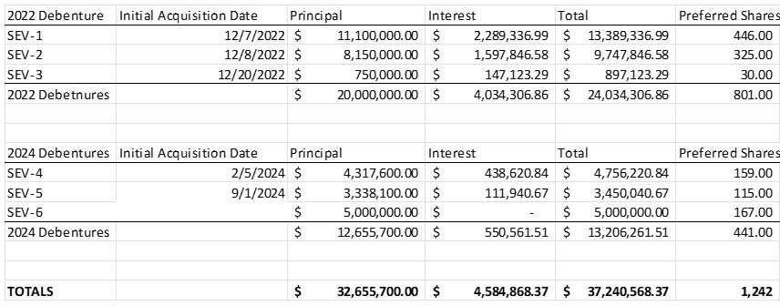

Exhibit 99.1


Sono Group N.V. pro forma condensed consolidated Balance Sheet and Statement of Income as of and for the nine months ended September 30, 2024

 |  |  |  |  | 2
TABLE OF CONTENTS
Proforma Condensed Consolidated Statements of Income (Loss) |  |  |  |  | 3
Proforma Condensed Consolidated Balance Sheets |  |  |  |  | 4
A. New Issuance of $5 Million Debenture Adjustment |  |  |  |  | 5
B. Conversion of all existing debt to preferred equity |  |  |  |  | 5

3

Proforma Condensed Consolidated Statements of Income (Loss)

 | Nine months ended | Pro Forma Adjustments |  | Pro Forma Combined
 | Nine months ended | mUSD 5 New | Debt to Equity | Pro Forma Combined
 | September 30, 2024 | mUSD 5 New | Debt to Equity | Following
 | September 30, 2024 | Convertible Debenture | Conversion Adjustments | Following
 | (unaudited) | Convertible Debenture | Conversion Adjustments | Recapitalization
 | (unaudited) | (A) | (B) | Recapitalization
Revenue | kEUR | kEUR | kEUR | kEUR
Revenue | - | - | - | -
Cost of goods sold | - | - | - | -
Gross loss | - | - | - | -
Cost of development expenses | (1,075) | - | - | (1,075)
Selling and distribution expenses | (437) | - | - | (437)
General and administrative expenses | (4,331) | - | - | (4,331)
Other operating (expenses)/income | 67 | - | - | 67
Gain/(loss) on deconsolidation/reconsolidation | 63,549 | - | - | 63,549
Operating Income/(Loss) | 57,773 | - | - | 57,773
Interest and similar income | 3,583 | - | - | 3,583
Interest and similar expenses | (4,944) | (552) | - | (5,496)
Income/(Loss) before tax | 56,414 | (552) | - | 55,860
Taxes on income | - | - | - | -
Deferred taxes on expense | - | - | - | -
Income/(Loss) for the period | 56,414 | (552) | - | 55,860

 |  |  |  |  | 4
Proforma Condensed Consolidated Balance Sheets
 |  | September 30, | Pro Forma Adjustments |  | Pro Forma Combined
 |  | September 30, | mUSD 5 New | Debt to Equity | Pro Forma Combined
 |  | 2024 | Convertible | Conversion | following
 |  | Unaudited | Debenture | Adjustments | Recapitalization
 |  |  | (A) | (B)
 |  | kEUR | kEUR | kEUR | kEUR
ASSETS
Noncurrent assets
Property, plant and equipment |  | 80 | - | - | 80
Right-of-use assets |  | 985 | - | - | 985
Other financial assets |  | 50 | - | - | 50
 |  | 1,115 | - | - | 1,115
 | Current assets
Work in progress |  | 178 | - | - | 178
Other financial assets |  | - | - | - | -
Other non-financial assets |  | 424 | - | - | 424
Cash and cash equivalents |  | 2,957 | 4,749 | - | 7,706
 |  | 3,559 | - | - | 8,308
 | Total assets | 4,674 | 4,749 | - | 9,423
EQUITY AND LIABILITIES
Equity
Subscribed capital |  | 10,844 | - | 36,990 | 47,834
Capital and other reserves |  | 287,904 | - | - | 287,904
Accumulated deficit |  | (327,924) | - | (552) | (328,476)
 | Total Equity | (29,176) | - | 36,438 | 7,262
Noncurrent liabilities
Financial liabilities |  | 938 | - | - | 938
 |  | 938 | - | - | 938
Current liabilities
Financial liabilities |  | 31,689 | 4,749 | (36,438) | -
Trade and other payables |  | 955 | - | - | 955
Other liabilities |  | 268 | - | - | 268
 |  | 32,912 | 4,749 | (36,438) | 1,223
 | Total equity and liabilities | 4,674 | 4,749 | - | 9,423

5

- New Issuance of $5 Million Debenture Adjustment

As part of its strategic financial restructuring, Sono Group N.V. has entered into a Securities Purchase Agreement with Yorkville to issue a new secured convertible debenture with a principal amount of $5.0 million, subject to Nasdaq approving the Company’s requested uplisting to The Nasdaq Capital Market. The funding will be completed immediately prior to the uplisting.

- Conversion of all existing debt to preferred equity

Sono Group N.V. signed an Exchange Agreement with Yorkville to convert the newly issued debenture, along with all other existing outstanding convertible debentures, into preferred equity. The total debt being exchanged amounts to approximately $37.2 million, including the $32.2 million of previously issued convertible debentures and the $5.0 million new debenture, subject to Nasdaq approving the Company’s requested uplisting to The Nasdaq Capital Market.

Under the agreement, this debt will be converted into 1,242 newly issued preferred shares, each with a nominal value of €300. These shares are convertible into 30,000 ordinary shares post-implementation of the reverse stock split. The conversion will be completed immediately prior to the uplisting, and the resulting equity adjustment will be $37.2 million.

